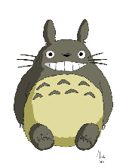
Hello Y3.
Today, we are going to be starting to write our trolls information booklet. It’s important that you not only use the skills you have been practising so far, but to also use your knowledge and understanding of other things that good writing includes, such as: full stops, capital letters, quality vocab, neat handwriting and a clear beginning, middle and end.
As always, drop us an email with your work or if you have any questions.
Miss Cartwright, Miss Dorr and Mrs. Warnes.
Maths  LO: Can I continue to use grid multiplication?  Mrs Warnes’ group: Can I divide by 2? | Morning maths challenge:  I think of a number. I subtract 25 and add 2. I then multiply by 2. My answer is 154, what was my number?  Well that certainly got me thinking! How about you?  We’re going to continue on our mission of grid multiplication. Familiarise yourself once more with the YouTube video from yesterday: https://www.youtube.com/watch?v=LTxql8_dXec&t=44s  Write out some top tips for completing grid method problems. What did you come up with?  Share some of your ideas with your friends in class. Are your top tips the same?  Complete the attached maths sheet and work through the problems.  Mrs Warnes’ maths group – see guidance and questions attached to work.
Additional maths (if the above maths work is completed). | Please use Mathletics daily and complete tasks related to what you have been learning in maths that day.  If you need your log-in, please email Miss Cartwright and she will get it to you ASAP.  If Mathletics is being slow (which it can sometimes due to traffic on the website), please use one of these websites for other KS2-friendly maths games:  https://www.topmarks.co.uk/maths-games/hit-the-button  https://mathsframe.co.uk/en/resources/category/22/most-popular  https://www.bbc.co.uk/bitesize/topics/zd2f7nb/articles/zn2y7nb  Y4: Please also keep completing the times table checker on MathsFrame:  https://mathsframe.co.uk/en/resources/resource/477/Multiplication-Tables-Check
English  LO: Can I write an information booklet all about trolls? | For the next three days (Wednesday, Thursday and Friday), you are going to be writing up your troll booklet  There are lots of different ways you can present your information and I welcome creative and individual ways of doing this. Go with how you feel you want to present it!  You could make a normal book, with a front cover, pages of information, including pictures and captions.  Or, you could make PowerPoint presentation if you are confident on a computer.  You could make a leaflet – this could be done on a piece of paper or on Microsoft Publisher.  However you present it, these are the things you need to include:  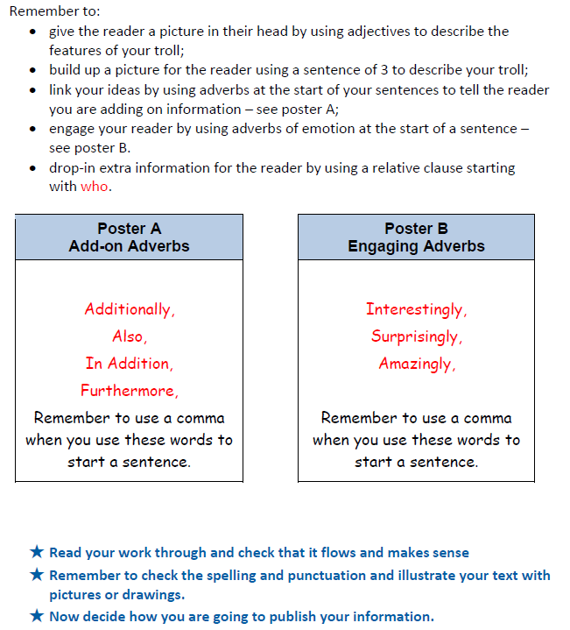
Spellings | Word list – ture/Miss Dorr’s list  Try to use your gu words in a sentence.  E.g., I went to the hospital, because I had a fracture in my arm.  Send me what you have learnt on the class email.
Reading | Spend some time reading your book. You can read in your head, but please also read to an adult.  Grown-ups – I will upload the list of questions we use in class so you can assess your child’s comprehension.  You can download the Libby app, which allows you to borrow books and e-books from your local library.  Those children who are reading banded books – use the Oxford Owl website to find ebooks to read. https://www.oxfordowl.co.uk/for-home/find-a-book/library-page/  Continue to fill in your reading records and completing the activities in your reading records.
Afternoon lessons: | RE –  We are going to be looking at Christianity for this half term.  Watch and listen to the video from Oak National Academy.  https://classroom.thenational.academy/lessons/who-was-jesus-6mv66c?step=2&activity=exit_quiz  In the video, the teacher asks you to create a story map of Jesus’ life.  Using what you learnt in the video, create a story map of Jesus’ life with 8 key events on it.  If you cannot access Oak National Academy, please do some personal research about Jesus’ life and identify the main events in his life with what you have found. Think about the bible stories that you know and use these as a guide.  If you are completing the task independently, please ensure that you use a child-friendly search engine such as Kiddle.  PSHE:  Watch and listen to the video from Oak National Academy.  https://classroom.thenational.academy/lessons/life-is-all-about-balance-crwk6r?step=1&activity=video  In the video, the teacher talks about how two people prepare for a race.  Who do you think is best prepared for the race? Why do you think that?  What did the other person do which didn’t help them win the race?  Create a prompt to use which will help you maintain a healthy lifestyle. Use the ideas from the video lesson, as well as some of your own.  If you cannot access Oak National Academy, please discuss with members of you family the best ways to train for a race/match/sports competition. Have a think about how they tie into living a healthy lifestyle. Create a prompt to use which will help you have a healthy and balanced lifestyle.
Please ensure that you email completed work to rowan@lyng.norfolk.sch.uk so I can provide feedback on certain pieces to ensure progression.
I will provide feedback via the class email.
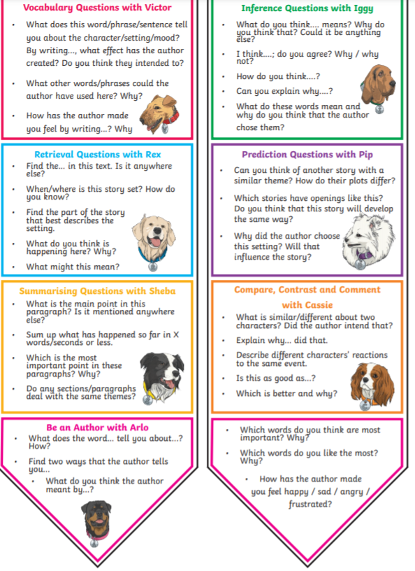

Maths –
Option 1 – Complete these questions
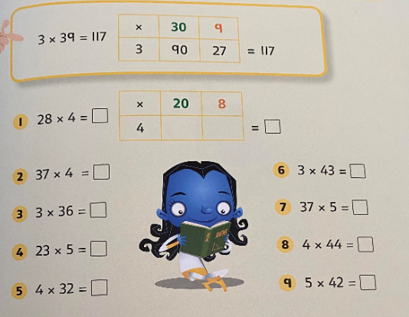

Option 2 – Complete the above questions as well as:
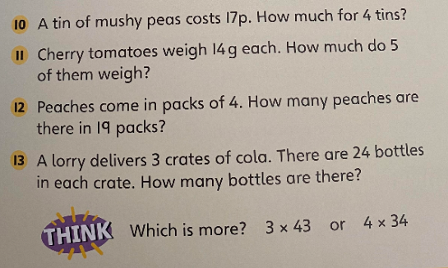

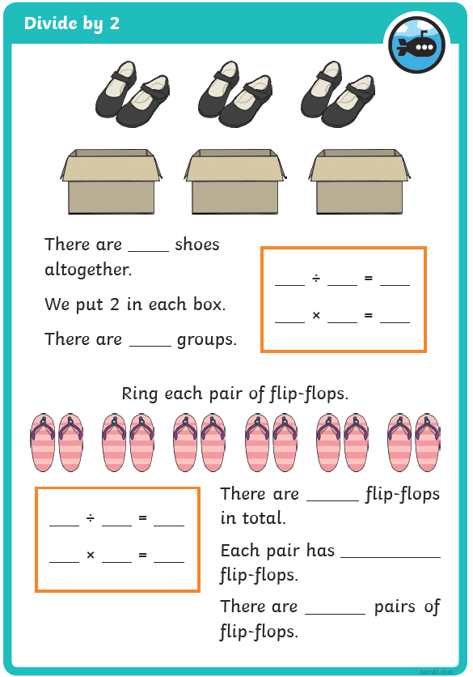
Mrs. Warnes’ maths group
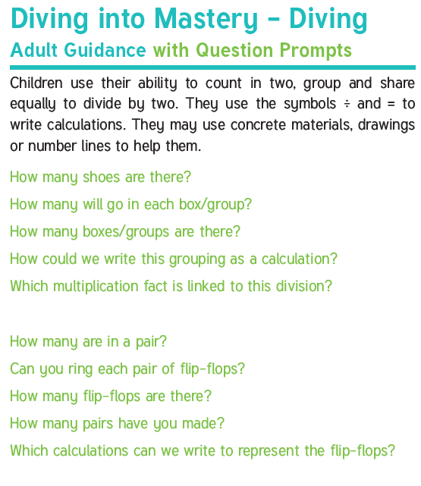

Spellings
Main spellings | Miss Dorr’s group
adventure  agriculture  capture  creature  culture  departure  feature  fixture  fracture  furniture  future | 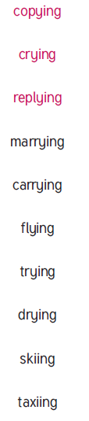

RE – Create a story map showing the key events from Jesus’ life.

Maintain a healthy lifestyle by…

