Wednesday 27th January 2021 YEAR 2
Enjoy doing the activities listed.
The order to do them in is suggested below but you can change them to suit you. Please e mail me any work, notes, photos or comments. Thank you.
MORNING  Let’s get started challenge | 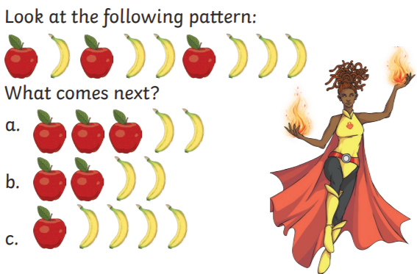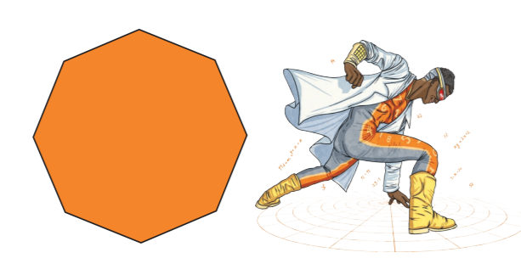  See below
Maths  Learning objective:  Can I subtract a one digit number from a two digit number using an empty number line?  Can I subtract a two digit number from a two digit number using an empty number line to help me? | Introduction:  - Yesterday we used a number line or 100 square to subtract 2 numbers.  - Today we will subtract using an empty number line.  First try 45 - 12 =  Look at the number you are subtracting i.e. 12.  12 can be subtracted by partitioning into  1 ten and 2 ones.  First subtract the ten.  Then subtract the ones.  Remember to go from right to left  -1 -1 -10  33 34 35 45  Now try the sums below using an empty number line.  If the number you are taking away is more than 20 you will need to do more than one jump of ten e.g. 25 will need 2 jumps of ten.  Additional challenge: try subtracting hundreds.  Activity:  Try the challenges below- go as far as you can but complete at least the first sheet.
English  Learning objective:  Can I create my own superhero fact file? | Introduction  - Did you know that we all have super powers? Some can be seen and some can’t.  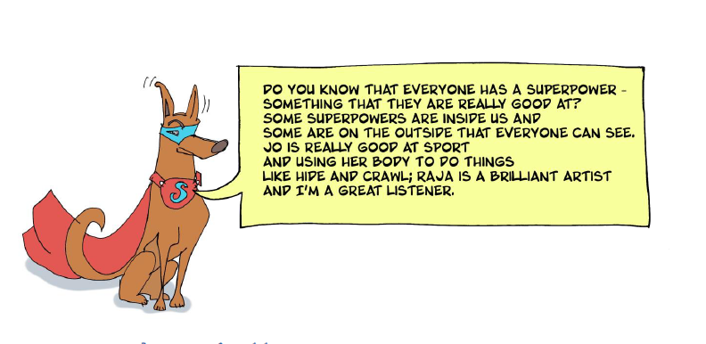  - If you were a super hero what would your name be?  - What would be your super powers?  - Read the sheet on page 9 to give you some ideas.  Activity  Write a super hero fact file about yourself.  (see sheet below)
Handwriting/ spellings/ grammar, punctuation or phonics  Learning objective:  Can I use exclamation marks at the end of a sentence? | Introduction:  - An exclamation mark is used in different ways to show surprise, strength , shouting or emphasis  - Read through this powerpoint  - https://www.twinkl.co.uk/resource/t-l-5574-using-exclamation-marks-presentation  - Then watch https://www.bbc.co.uk/bitesize/topics/z8x6cj6/articles/z3dcmsg  - Try the activity  Activity  - Complete the sheet – see below  - Do the quiz at the bottom of the Bitesize webpage you were using earlier.
 | Lunchtime!
AFTERNOON  Reading | Read at least 3 pages of a reading book.
PE | You have a choice - it may depend on the weather!  - Go for a walk or bike ride.  - Make up a new game or challenge .e.g. to throw balls into a bucket and get 6 out of 8 in. then challenge yourself to get more in or move further away!  - Do a cosmic yoga session https://www.youtube.com/user/CosmicKidsYoga  - Complete today’s Joe Wicks challenge  OR try something new!  https://www.nhs.uk/10-minute-shake-up/shake-ups
Story/ yoga/ mindfulness activity | Listen to some calming music
Additional notes for parents. | Well done! Half way through another week of home learning!

Please send your completed work to me at willow@lyng.norfolk.sch.uk so I can enjoy seeing what has been done and give top tips and feedback as necessary.

Let’s get started challenge

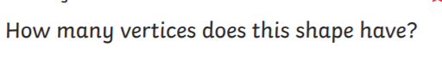

Maths Level 1 challenge:
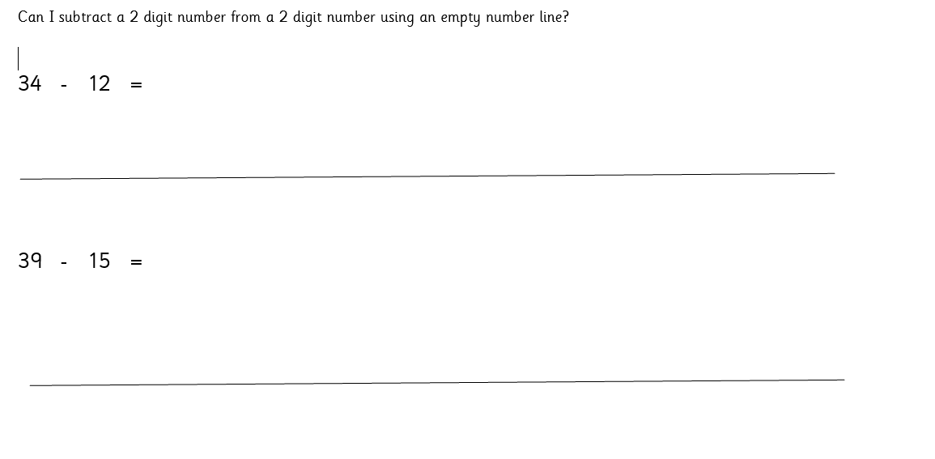

Level 2 challenge

Level 3 challenge
English Can I create my own superhero fact file?
Picture

Fact file
Superhero name

Super power

Superpowers

Superhero call

Other features

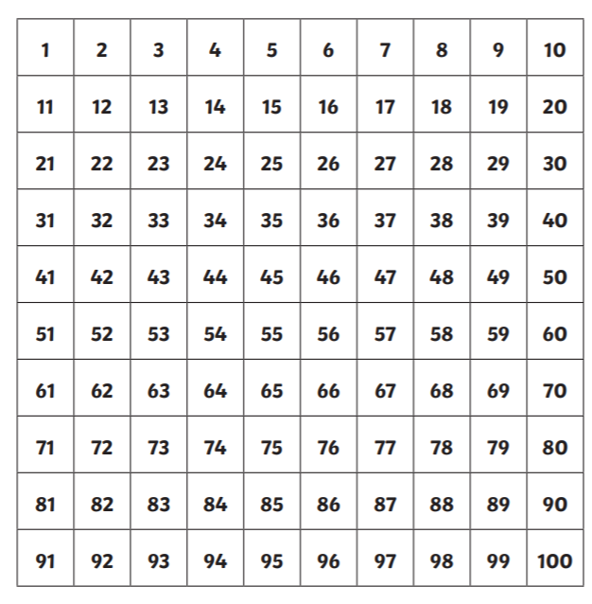

Punctuation
