Wednesday 27th January 2021 YEAR 1
Enjoy doing the activities listed.
The order to do them in is suggested below but you can change them to suit you. Please e mail me any work, notes, photos or comments. Thank you.
MORNING  Let’s get started challenge | Draw 3 triangles and count all the sides.  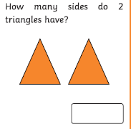  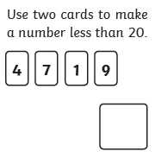  See below.
Maths  Learning objective:  Can I subtract a one digit number from a two digit number using an empty number line?  Can I subtract a two digit number from another two digit number using an empty number line? | Introduction:  - This week you are learning how to ‘subtract’ or ‘take away’. This called also be called ‘minus’  - What have you discovered happens when you subtract?  Yes – the answer is smaller than the number you started on.  TOP TIP: Remember when you take away 2 numbers you must always start with the biggest number.  - Recap by watching https://www.bbc.co.uk/bitesize/clips/z2xpvcw  - Yesterday we subtracted 2 numbers using a number line or 100 square.  - Today we will subtract using an empty number line.  - We will try  19 - 6 =  - First draw a line across a piece of paper. Look at the number you are subtracting i.e.6. This is 6 ones(no tens)  - At the left hand side write 13. Then make 6 jumps to represent the 6 ones and label as below.  -1 -1 -1 -1 -1 -1  13 14 15 16 17 18 19  - Now have a go – only do the first level to start with.  - For most of you that will be enough. If you want to go further try…..  34 - 12 =  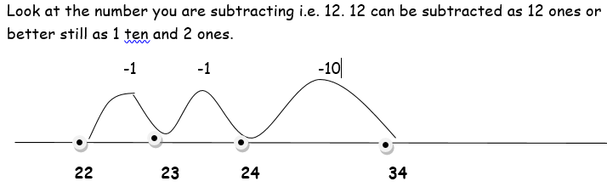  Now try the sums below using an empty number line.  Activity:  Try the challenges below- do what is best for you.
English  Learning objective:  Can I show that I have understood the story by answering the questions? | Introduction  - This week we have been reading a story about Sidney.  - Let’s see how much you can remember.  What sort of creature was Sidney?  Where did he live at the start of the story?  How did Sidney feel at the start of the story? Why do you think that?  What was Mrs Brown using to sweep the floor?  What song was she singing?  Who was Susie?  How did Sidney feel at the end of the story? Why do you think that?  TOP TIP: remember to read the story again or parts of it if you don’t know the answers.  Activity:  Answer the questions on page 8 of the pack.
Handwriting/ spellings or phonics  Learning objective:  Can I use the u-e sounds to read and spell? | Introduction:  - Recap these sounds against the clock. How long does it take you to say the sounds correctly? Can you beat Monday’s time?  - GET READY, GO!  ai ee igh oa oo  ay ea ie ow ue  a-e e-e i-e o-e  - How long did it take?  - Can you remember the spit digraphs we have learnt so far?  - You have learnt that the oo sound can be made by oo and ue.  - The same sound can also be made by u-e. We call this a split digraph because the ae has be split up by another letter e.g. tune  - Watch Mr. Thorne does phonics  https://www.youtube.com/watch?v=CQXnqp8g9WM  - Try reading these words:  June cube  tune tube  Activities – see below
 | Lunchtime!
AFTERNOON  Reading | Read at least 3 pages of your reading book.
PE | You have a choice - it may depend on the weather!  - Go for a walk or bike ride.  - Make up a new game or challenge e.g can I get the ball into the bucket 6 times out of 8. Can you improve?  - Do a cosmic yoga session https://www.youtube.com/user/CosmicKidsYoga  - Complete a Joe Wicks challenge  OR try something new!  https://www.nhs.uk/10-minute-shake-up/shake-ups
Story/ yoga/ mindfulness activity | Make your own spider using things you can find indoors  OR make a spider outside using things you can find in the garden.
Additional notes for parents. | Well done! Half way through another week of home learning!

Please send your completed work to me at willow@lyng.norfolk.sch.uk so I can enjoy seeing what has been done and give top tips and feedback as necessary.

Let’s get started challenge
Draw 3 triangles and count all the sides.

Maths Level 1 challenge:
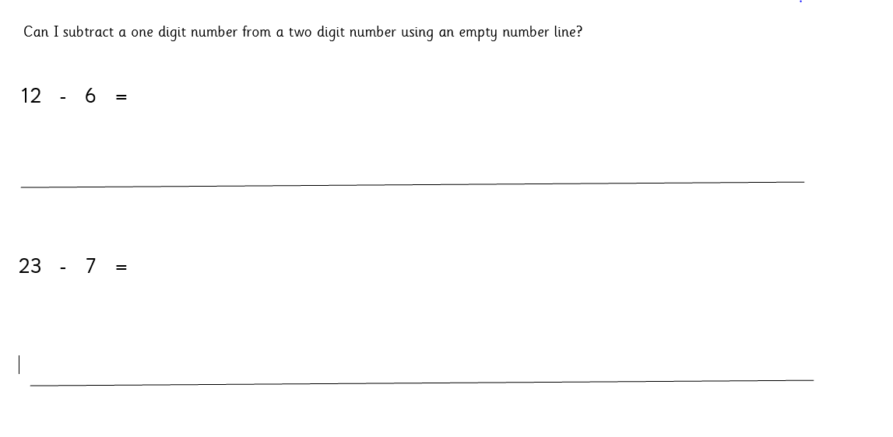
Maths level 2 challenge

Level 3 challenge

Phonics
Activity 1: writing
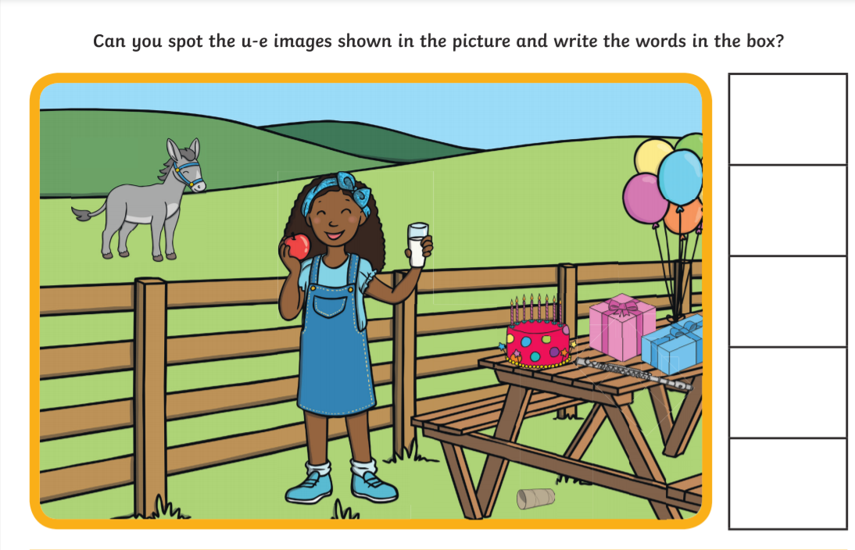

Answers below

