Wednesday 20th January 2021 YEAR 2
Enjoy doing the activities listed.
The order to do them in is suggested below but you can change them to suit you. Please e mail me any work, notes, photos or comments. Thank you.
MORNING  Let’s get started challenge | 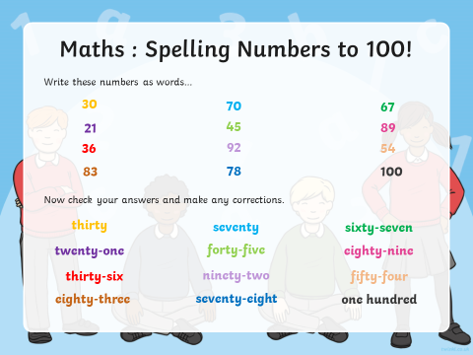  See below
Maths  Learning objective:  Can I add a one digit number to a two digit number using an empty number line?  Can I add a two digit number to a two digit number using an empty number line to help me? | Introduction:  - Yesterday we used a number line or 100 square to add 2 numbers.  - Today we will add using an empty number line.  First try 34 + 12 =  Look at the number you are adding on i.e. 12.  12 can be added on as 1 ten and 2 ones.  +10 +1 +1  34 44 45 46  - Next watch https://www.youtube.com/watch?v=XFNyCoMdfsE  - Now try the sums below using an empty number line.  - Additional challenge: try adding hundreds.  Activity:  Try the challenges below- go as far as you can but complete at least the first sheet.
English  Learning objective:  Can I write the middle of a story?  Can I use the sounds and spelling rules I know? | Introduction  - This week you are writing a story about some elves.  - First you planned your story then you wrote the story start.  - Read back your story start from yesterday. Are you happy with it?  - If you are happy then look at your story mountain for the middle of the story.  Activity  - Today you will be introducing your elves and saying how they help people.  - First say who they are. For example.  There lived 2 elves. One was called Smiley because he was always smiling. In fact his smile was so big it went from ear to ear. The other was……  - Now write a description for each. Say what they wore and what they were like. For example:  Smiley wore a short, stripy jumper and long, stripy trousers. Even his socks were stripy. Everything he wore was stripy and rainbow coloured.  - Next explain how they help people. For example:  Smiley was great at helping people and do you know how he did it? Well he …….  Each time your write  think it, say it, write it, check it.  Activity :  Write the middle part of your story ONLY  Remember to use your own ideas, not mine!
Handwriting/ spellings/ grammar, punctuation or phonics  Learning objective:  Can I use a capital letter for a person’s name? | Introduction:  - This week we are learning about capital letters, full stops and commas.  - Today we will be thinking about capital letters for names of people.  - Watch the video – Activity 3  https://www.bbc.co.uk/bitesize/articles/zh7bgwx  Activity  - Draw 3 vegetables and turn them into characters. First draw a face and then add clothes and accessories e.g. jewellery or a sports head band. Next colour in.  - Then think of a name e.g. Colin the carrot.  Remember their names should start with a capital letter.  Check your story work – do your character’s names all have capital letters?  Keep your characters for Friday.
 | Lunchtime!
AFTERNOON  Reading | Read at least 3 pages of a reading book. Or find some more ‘Funnybones’ stories online
PE | You have a choice - it may depend on the weather!  - Go for a walk or bike ride.  - Practise your ball skills in the garden- CAREFULLY!  - Do a cosmic yoga session https://www.youtube.com/user/CosmicKidsYoga  - Complete today’s Joe Wicks challenge
Story/ yoga/ mindfulness activity | Have a walk round your garden or look out whilst you are on a longer walk. What can you see that you have never noticed before, or which surprises you?
Additional notes for parents. | Well done! Half way through another week of home learning!  Next Monday, you will need 6 hardboiled eggs if you wish to take part in the science experiment.

Please send your completed work to me at willow@lyng.norfolk.sch.uk so I can enjoy seeing what has been done and give top tips and feedback as necessary.

Let’s get started challenge

Maths Level 1 challenge:
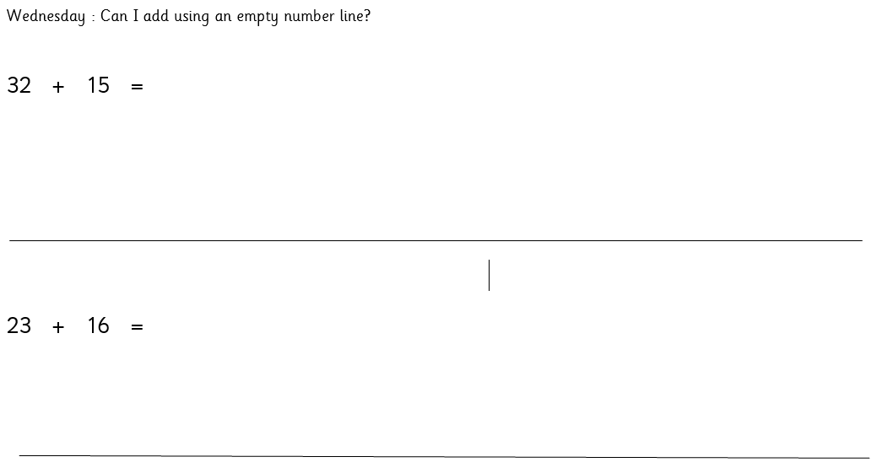
Level 2 challenge

Level 3 challenge

