Wednesday 12th January 2021 YEAR 2
Enjoy doing the activities listed.
The order to do them in is suggested below but you can change them to suit you. Please e mail me any work, notes, photos or comments. Thank you.
MORNING  Let’s get started challenge | How many jumps can you do in one minute?  What else can you do in one minute?
Maths  Learning objective:  Can I estimate numbers on a number line or 100 square?  Extension: Can I read scales where not all numbers on the scale are given and estimate points in between? | Introduction:  - You can use what you know about numbers and where they are in the number system to help you work out any missing numbers.  - Have a go! What are the missing numbers? How do you know?  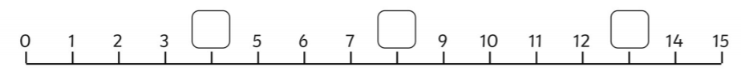  Top Tip: remember to explain clearly how you know.  For example 4 is missing because 4 is one more than 3 and one less than 5.  - It is harder to estimate when there are less numbers.  - Have a go! Show where 5 would be on the line below.  0 10 20 30 40  Top Tip: remember to explain clearly how you know.  For example: I know 5 is there because 5 is half of ten.  Activity:  Try the challenges below- go as far as you can but complete at least the first sheet.
English  Learning objective:  Can I find out the meanings of words? | Introduction  - This week we have read the story of ‘The Elves and The Shoemaker’ and answered some questions.  - Today we will be focussing on the meanings of words.  - Look through the story and see if you can spot the highlighted word kind- hearted.  - What does it mean?  - Now read through the story again and highlight other words which are new to you or you don’t understand their meaning.  - Talk to a grown up about what they mean.  - They may be able to show you how to use a dictionary – book or online.  Activity 1:  - Look at page 9 of the story pack.  - Can you match up the words and their meanings?  Top tip: a thesaurus is a book (can be accessed online) which helps you to find other words which mean something similar e.g. instead of kind-hearted you could use caring.  Activity 2:  Can you find other words for ‘saw’?  Fill in the chart (see below)  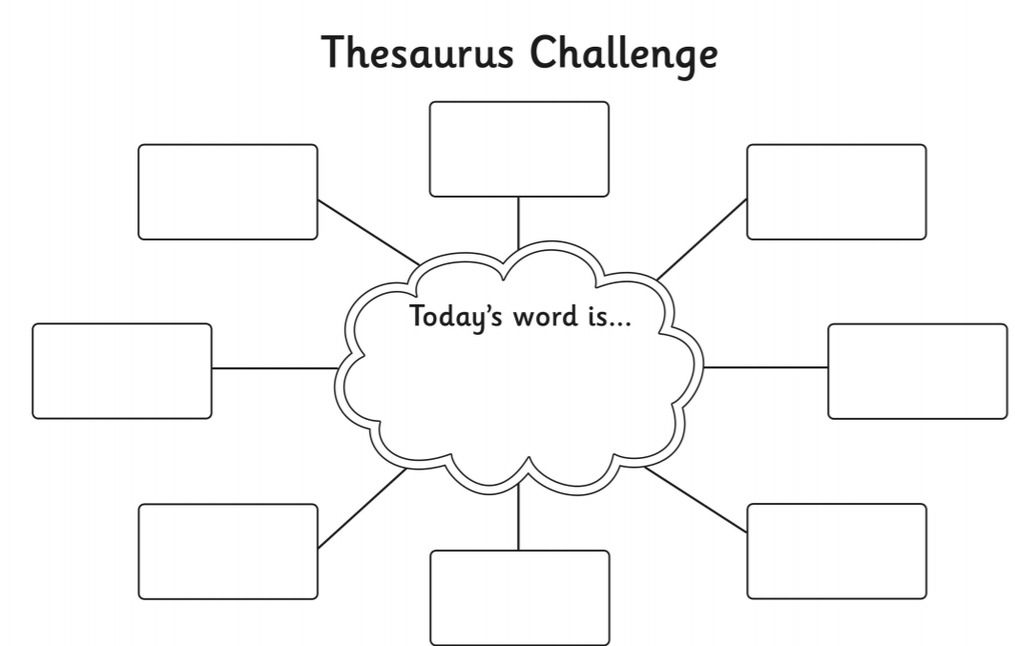
Handwriting/ spellings/ grammar or phonics  Learning objective:  Can I sort words into nouns, verbs and adjectives? | Introduction:  - In previous lessons we have learnt that words can be grouped into:  Nouns- names of things  Adjectives- describes a noun  Verbs – an action word  Activity  Look at page 10 of ‘The Elves and the shoemaker’ pack and complete the table.
 | Lunchtime!
AFTERNOON  Reading | Read at least 3 pages of a book.
PE | You have a choice - it may depend on the weather!  - Go for a walk or bike ride.  - Practise your ball skills in the garden- CAREFULLY!  - Do a cosmic yoga session https://www.youtube.com/user/CosmicKidsYoga  - Complete today’s Joe Wicks challenge
Story/ yoga/ mindfulness activity | Design some colourful clothes for the elves- see page 11 of your Elves and Shoemaker’ pack.
Additional notes for parents. | Well done! Half way through another week of home learning!

Please send your completed work to me at willow@lyng.norfolk.sch.uk so I can enjoy seeing what has been done and give top tips and feedback as necessary.

Let’s get started challenge

How many jumps can you do in 1 minute?

What else can you do in 1 minute?

Maths Level 1 challenge: 100 sqaure below
Can I estimate numbers on a number line or 100 square?
Extension: Can I read scales where not all numbers on the scale are given and estimate points in between?
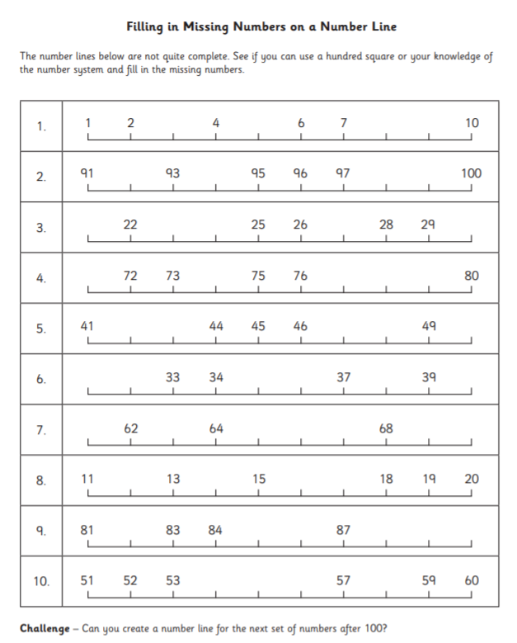

Level 2 challenge
Place 50 on each of the number lines below.

0 20 40 60 80 100

0 100 200 300 400 500

Challenge 3
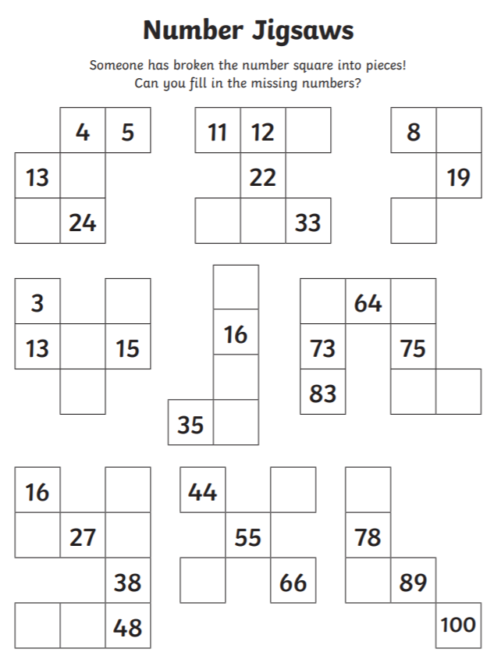
Extras!
