Wednesday 13th January 2021 YEAR 1
Enjoy doing the activities listed.
The order to do them in is suggested below but you can change them to suit you. Please e mail me any work, notes, photos or comments. Thank you.
MORNING  Let’s get started challenge | How many jumps can you do in one minute?  What else can you do in one minute?
Maths  Learning objective:  Can I use what I know about numbers to fill in missing numbers? | Introduction:  - You can use what you know about numbers and where they are in the number system to help you work out any missing numbers.  - Have a go! What are the missing numbers? How do you know?  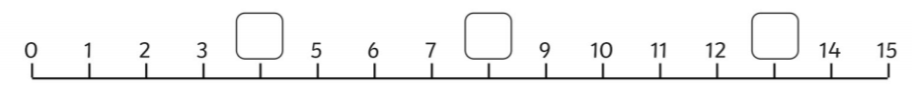  Top Tip: remember to explain clearly how you know.  For example 4 is missing because 4 is one more than 3 and one less than 5.  Activity:  Try the challenges below- go as far as you can but complete at least the first sheet.
English  Learning objective:  Can I find out the meanings of words? | Introduction  - This week we have read the story of ‘Pippety Skycap’ and answered some questions.  - Today we will be focussing on the meanings of words.  - Look through the story and see if you can spot the highlighted word soft.  - What does it mean?  - Now read through the story again and highlight these words sharp shiny  - Talk to a grown up about what they mean.  Activity 1:  - Complete pages 9-10 of the story pack.
Handwriting/ spellings or phonics  Learning objective:  Can I use the oa / ow sounds to read and spell? | Introduction:  - Remind yourself of the phase 3 sounds by watching, listening and joining in with  https://www.youtube.com/watch?v=ZXgfO1jSljQ  - Say these sounds aloud to an adult.  ai ee igh oa oo  recap  ay ea ie ow ue  Activities – see below
 | Lunchtime!
AFTERNOON  Reading | Read at least 3 pages of a book.
PE | You have a choice - it may depend on the weather!  - Go for a walk or bike ride.  - Practise your ball skills in the garden- CAREFULLY!  - Do a cosmic yoga session https://www.youtube.com/user/CosmicKidsYoga  - Complete today’s Joe Wicks challenge
Story/ yoga/ mindfulness activity | Draw Pippety using the story pack page 11
Additional notes for parents. | Well done! Half way through another week of home learning!

Please send your completed work to me at willow@lyng.norfolk.sch.uk so I can enjoy seeing what has been done and give top tips and feedback as necessary.

Let’s get started challenge

How many jumps can you do in 1 minute?

What else can you do in 1 minute?

Maths Level 1 challenge: 100 square below
Y1: Can I use what I know about numbers to fill in missing numbers?
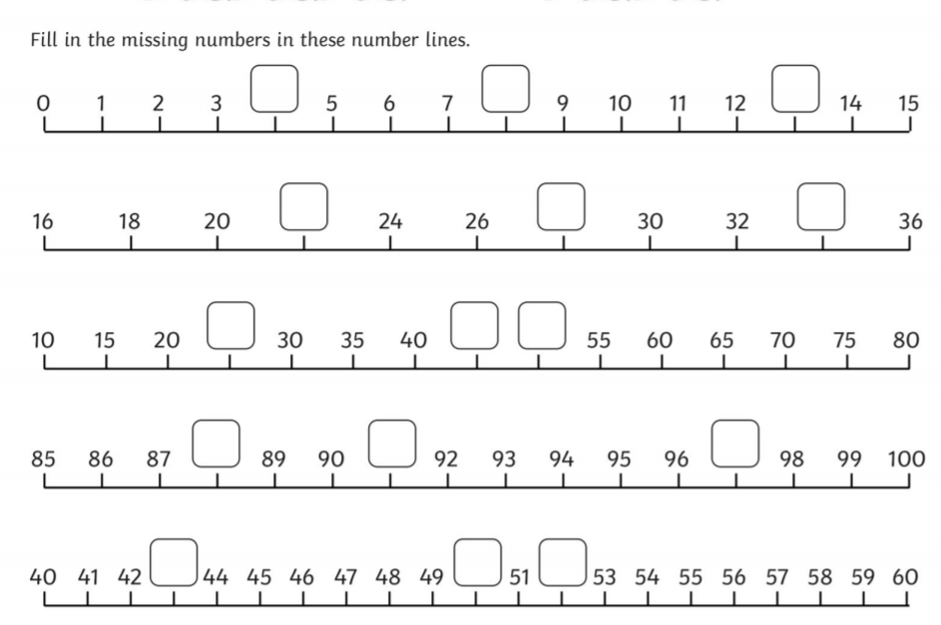

Maths level 2 challenge

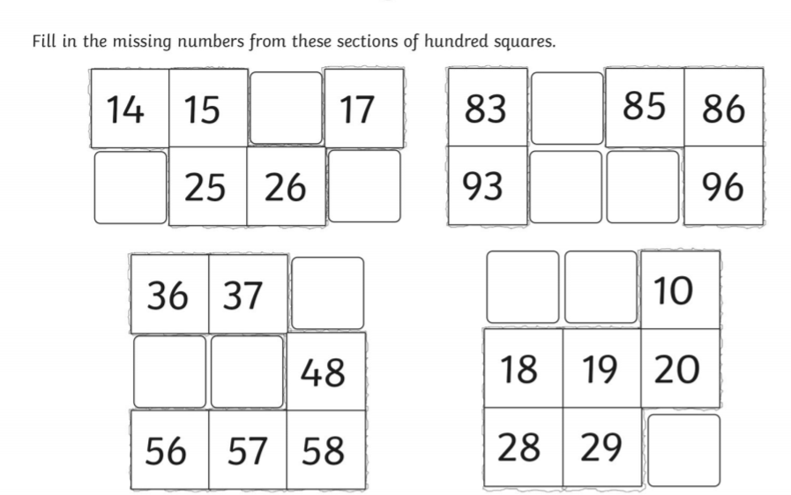
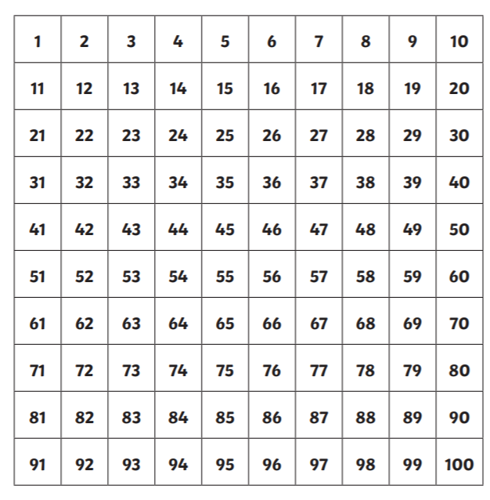

Phonics
Activity 1; reading
Read these words

coat float moat shoal throat

Now these
blow flow grow throw low

What do you notice about where the oa/ow sounds are in each line of words?

Generally oa is found in the middle of a word and ow at the end. Try and remember this spelling rule.

Activity 2:
- Download and complete the ow booklet from the school website - home learning page.
- OR write out the words containing ie (in blue above) twice and play a treasure hunt game or a snap game.

