Tuesday 26th January 2021 YEAR 2
Enjoy doing the activities listed.
The order to do them in is suggested below but you can change them to suit you. Please e mail me any work, notes, photos or comments. Thank you.
MORNING  Let’s get started challenge | 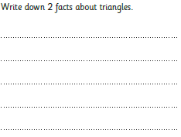  Make mind map for number 20. How many things can you say?  It is an even number  20  It is in the x2 table it has 2 tens and no ones  19 + 1  See below
Music  Music service | Introduction:  - Join in with music service sessions  https://www.norfolkmusichub.org.uk/site/ugly-bug-ball-resources/  Or https://www.bbc.co.uk/teach/school-radio/music-ks1-anansi-and-the-moss-covered-rock-1/zmn2qp3r
English  Learning objective:  Can I understand the meanings of new words?  Can I match the word to the correct meaning? | Introduction  - Yesterday you started a new pack of writing.  - You read fact files and a story.  - There were some words in the story which you may not know or might be unsure about.  - Read through the story’ Playground Rescue’ again and look at the words in bold.  - In the sentence ‘it was an ordinary day’ what does ordinary mean?  Remember you can use a dictionary to help you.  Activity  - Now do the vocabulary challenge on pages 5 and 6.
Handwriting/ spellings or phonics  Learning objective:  Can I learn the tricky words every and everybody? | Introduction:  - So far you have learnt these new words.  both mind find  cold kind  told behind  - Today’s words are:  every everybody  - First- read the words.  - Second- look at the words- what do you notice?  - Third- think about how you could remember them  Top Tip: you have learnt lots of different ways to remember words which we can’t sound out.  Activity  1. Choose a way which suits you best to remember those 2 new tricky words.  2. Write a sentence for each of those words.  When you have time go over the tricky words from last term which are:  door poor  floor  fast last  past  great break  steak  again Christmas
 | Lunchtime!
AFTERNOON  Reading | Read at least 3 pages of a reading book.
Topic  Learning objective:  Can I design a poster or make a tooth fairy?  Computing  Can I put the commands in the correct sequence so Robot can charge up on the big spot? | Introduction:  - Clue 4 is a tooth. What can you remember about teeth?  - Today we are going to learn how to keep our teeth clean.  - Watch the video  https://learnenglishkids.britishcouncil.org/how-videos/how-brush-your-teeth  - What are the most important things to remember?  - What happens to teeth when they fall out? Some of you may already have lost teeth. Does the tooth fairy come?  Activities. Choose ONE  - Make a tooth fairy to go in the special box that you decorated last week.  You can use whatever you want to make it e.g. a peg,  pipe cleaners, scraps of materials.  OR  - Design a poster to remind you how to look after your teeth.  OR  Complete the games on the website above.  OR  Read the story of ‘Dave and the Tooth Fairy’  Computing.  Introduction:  This lesson follows on from our last lesson on Algorithms. Can you remember what an algorithm is?  An Algorithm is a set of instructions, a sequence of commands that we give to a computer.  Activity:  Using the worksheet below can you correctly direct the robot to the big spot so he can charge up?  The commands you can use are 90° (quarter) turn left, 90° (quarter) turn right or forward.  Remember  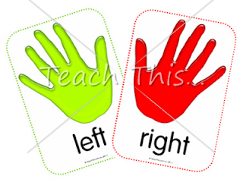 to look for the L in your hand for the left hand.  You can challenge yourself with the 3 levels or even make your own up.  Have Fun!
Story/ yoga/ mindfulness activity | Try some Yoga.  Here are some more yoga poses you can learn if you don’t know them already.  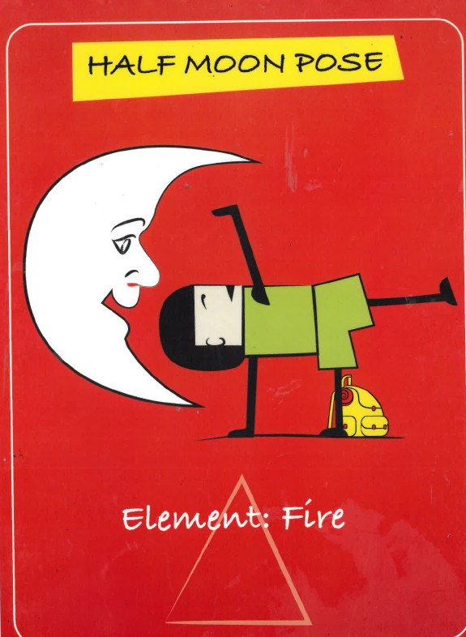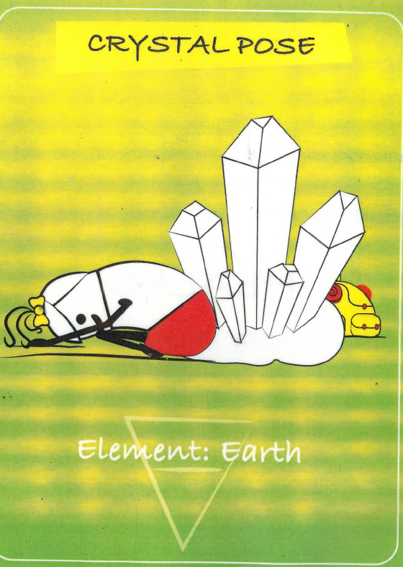  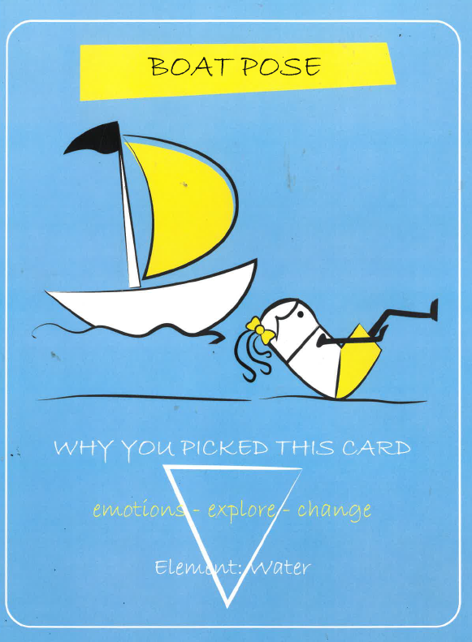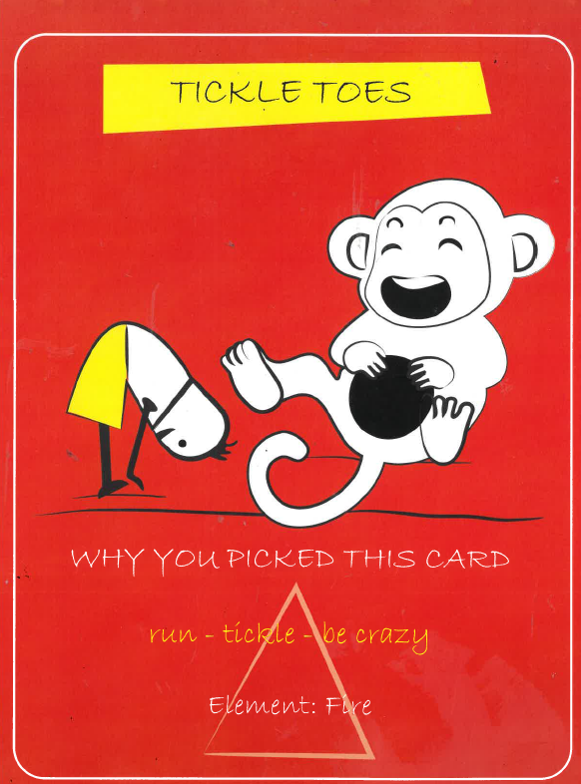  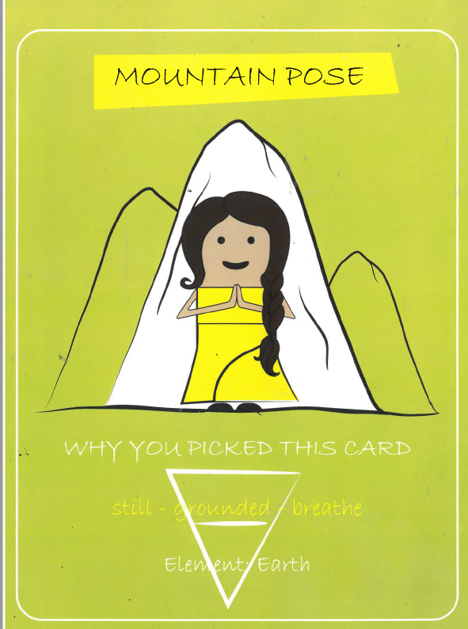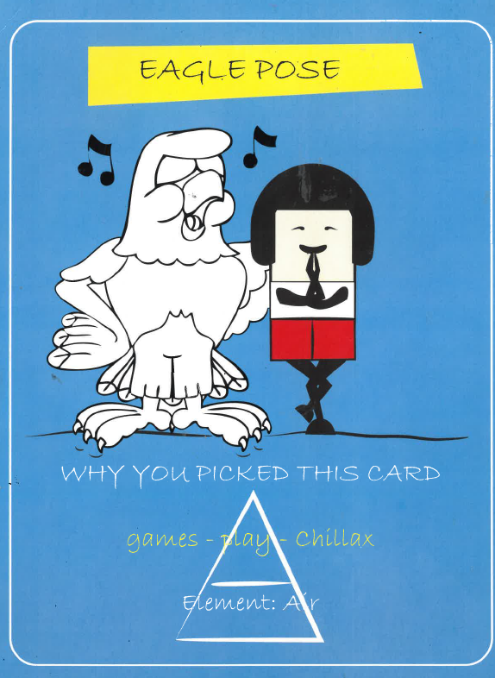
Additional notes for parents.

Please send your completed work to me at willow@lyng.norfolk.sch.uk so I can enjoy seeing what has been done and give top tips and feedback as necessary.

Let’s get started challenge

Computing choose your own level
