Tuesday 26th January 2021 YEAR 1
Enjoy doing the activities listed.
The order to do them in is suggested below but you can change them to suit you. Please e mail me any work, notes, photos or comments. Thank you.
MORNING  Let’s get started challenge | 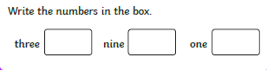  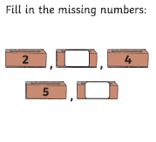  See below
Music | Introduction:  - Join in with music service sessions  https://www.norfolkmusichub.org.uk/site/ugly-bug-ball-resources/  THEY HAVE REQUESTED THAT YOU DON’T SHARE THE PASSWORD ON SOCIAL MEDIA  Or https://www.bbc.co.uk/teach/school-radio/music-ks1-anansi-and-the-moss-covered-rock-1/zmn2qp3  Activity: see website
English  Learning objective:  Can I match up the characters to what they said? | Introduction  - Today we will be thinking a bit more about the story you read yesterday. To remind yourself read it listen to it again.  - As you read or listen think about who is saying what  - Let’s have a quick quiz! The answers to the quiz are:  Sidney Mrs Brown Susie Stanley  Who said “I will come immediately”?  Who said “Help, please help me”?  Who said “I’m in the old flowerpot behind the spade”?  Who said “I’m in the red welly boot under the bench”?  Activity:  Now complete page 7 of your pack.  What do you think they all said at the end? You could write your own speech bubble.
Handwriting/ spellings or phonics  Learning objective:  Can I learn the tricky words your, one and they? | Introduction:  - So far we have learnt :  here come  where some  there  - Can you remember how to spell them? Have a quick check to see. If you have made any mistakes go over them again  - Today we will be learning some more of the tricky words we need to know:  one  they  your  - First- read the words.  - Second- look at the words- what do you notice?  - Third- think about how you could remember them.  Top Tip: there are different ways we can try and remember words which we can’t sound out. Can you remember the ways from the last 2 weeks?  - Another way is to look for words within words.  - What words that you already know can you see in  one  yes, you can see on one so you could remember it as on + e  - What words that you already know can you see in  they  yes, you can see the they so you could remember it as the+ y (it even has a little rhyme to it).  - What words that you already know can you see in  your  yes, you can see you your so you could remember it as you + r  - You may like this way or you may prefer one of the ways from last week – do whatever suits you best  Activity  1. Choose a way which suits you best to remember those 3 new tricky words.  2. Write a sentence for each of those words.
 | Lunchtime!
AFTERNOON  Reading | Read at least 3 pages of a book  OR listen to the story of ‘The Very Busy Spider’ https://www.youtube.com/watch?v=TfL0g-XRxnA
Topic  Learning objective:  Can I design a poster or make a tooth fairy?  Computing  Can I give a set of instructions to the robot using the right information and directions? | Introduction:  - Clue 4 is a tooth. What can you remember about teeth?  - Today we are going to learn how to keep our teeth clean.  - Watch the video  https://learnenglishkids.britishcouncil.org/how-videos/how-brush-your-teeth  - What are the most important things to remember?  - Think back to the algorithm that you wrote last week  - What happens to teeth when they fall out? Some of you may already have lost teeth. Does the tooth fairy come?  Activities. Choose ONE  - Make a tooth fairy to go in the special box that you decorated last week.  You can use whatever you want to make it e.g. a peg,  pipe cleaners, scraps of materials.  OR  - Design a poster to remind you how to look after your teeth.  OR  Complete the games on the website above.  OR  Read the story of ‘Dave and the Tooth Fairy’  Computing.  Introduction:  Following on from our last lesson on Algorithms (can you remember what this is?) An Algorithm is a set of instructions, a sequence of commands that we give to a computer.  Activity:  Using the worksheet below can you direct the robot across the board to the desk using only the commands?  Turn left, backwards, forwards, turn right.  Remember  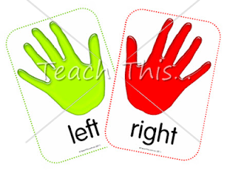 To look for the L in your hand for the left hand.  If you found that easy now have a go at your turn! Worksheet. You could practice on a grown up to see if it works.  Good Luck and have fun!
Story/ yoga/ mindfulness activity | Try some Yoga. Here are some yoga poses to try  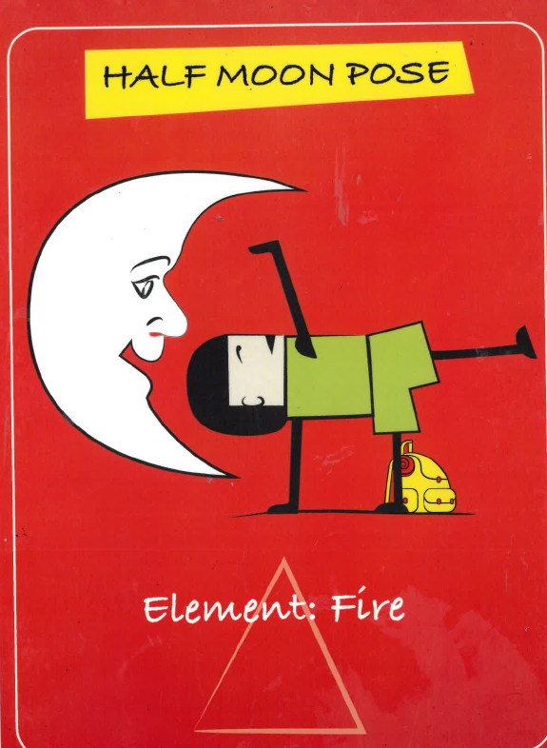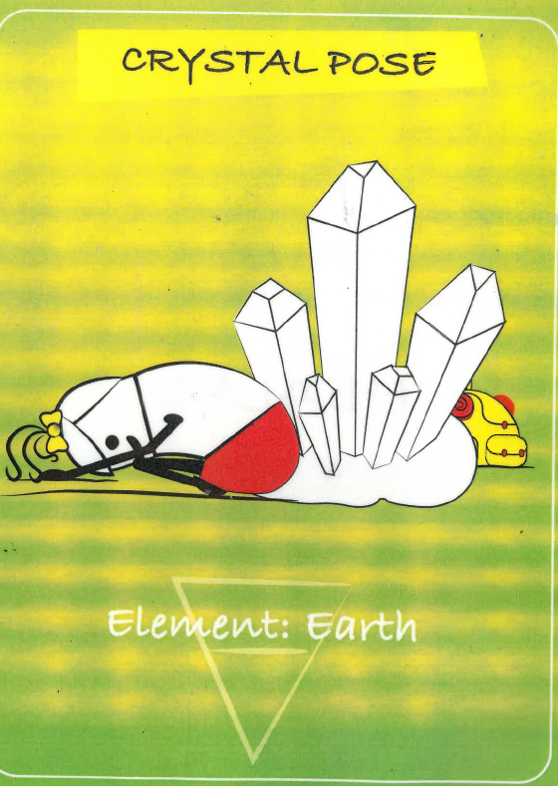  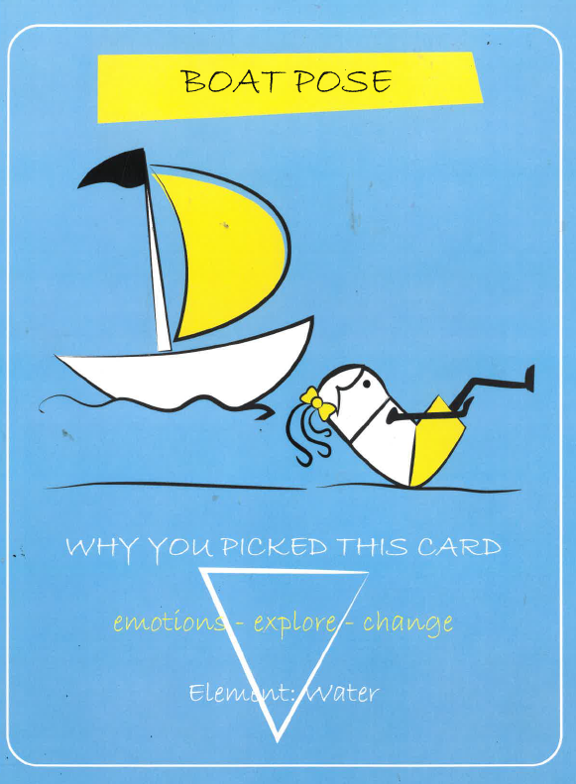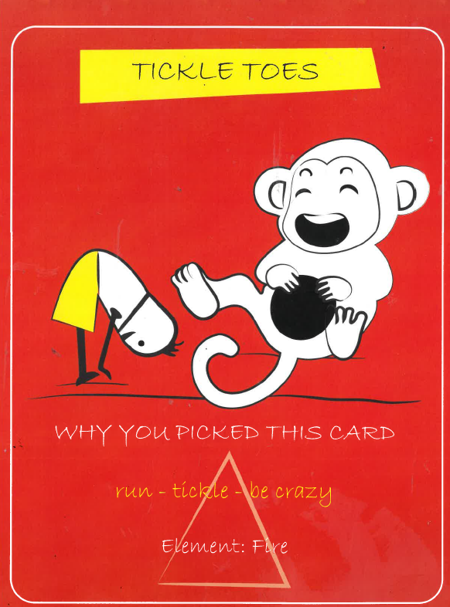  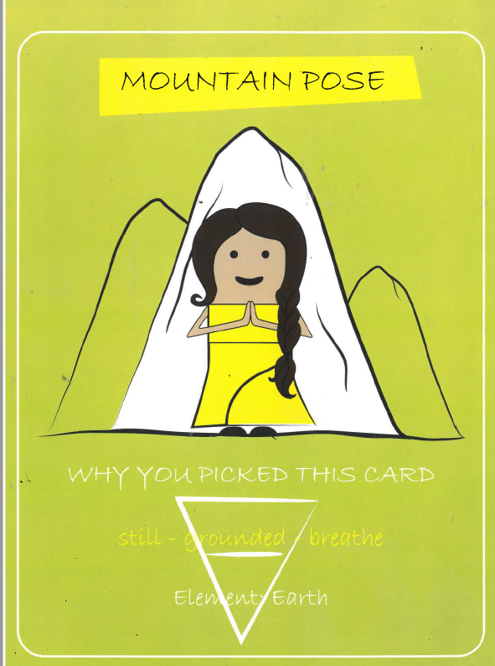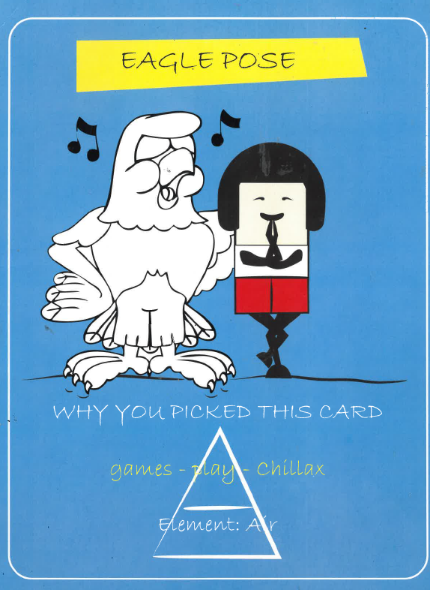
Additional notes for parents.

Please send your completed work to me at willow@lyng.norfolk.sch.uk so I can enjoy seeing what has been done and give top tips and feedback as necessary.

Let’s get started challenge

English
See story and activity pack.
Spellings- practise here if you would like to

Computing
