Tuesday 19th January 2021 YEAR 2
Enjoy doing the activities listed.
The order to do them in is suggested below but you can change them to suit you. Please e mail me any work, notes, photos or comments. Thank you.
MORNING  Let’s get started challenge | 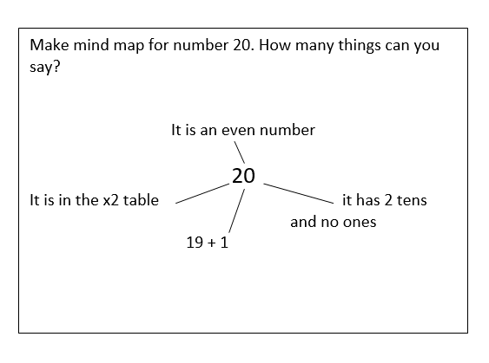  Make mind map for number 20. How many things can you say?  It is an even number  20  It is in the x2 table it has 2 tens and no ones  19 + 1  See below
Music  Learning objective:  See Music service | Introduction:  Join in with music service sessions  https://www.norfolkmusichub.org.uk/site/ugly-bug-ball-resources/  Mrs Rudd has sent a password via text  THEY HAVE REQUESTED THAT YOU DON’T SHARE THE PASSWORD ON SOCIAL MEDIA
English  Learning objective:  Can I write the start of a story about elves?  Can I use a story plan to help me?  Can I check it for capital letters full stops, commas? | Introduction  - Yesterday you made a story plan.  - Today you are going to write the start of your story ONLY. First look back at your story plan.  Activity  - The first sentence needs to open the story. For example:  Once upon a time OR In a land, far away OR In a quiet, dusty hut lived…..  Think about how you will start you story so that it captures the reader’s imagination. Say it aloud- does it make sense?  Now write it down and read it back to check it.  - The second sentence needs to introduce the characters. Think about who your characters are- what are they called. For example:  Snowy and Crystal lived in sparkly, icy cave.  Say it aloud- does it make sense?  Now write it down and read it back to check it.  Remember capital letters for their names.  - The next few sentences need to describe your characters. For example:  Sparkly and Snowy both wore blue, white, sparkly clothes. The only way you could tell them apart was by their hair. Sparkly had long, white hair that seemed to sparkle in the light, meanwhile Snowy had short, spiky white hair as if it was frozen.  Remember to add adjectives and separate them with a comma.  Say it aloud- does it make sense?  Now write it down and read it back to check it.  Each time your write  think it, say it, write it, check it.
Handwriting/ spellings or phonics  Learning objective:  Can I learn the tricky words both, cold, told? | Introduction:  - Today we will be learning some more of the tricky words we need to know.  both  cold  told  - First- read the words.  - Second- look at the words- what do you notice?  - Third- think about how you could remember them  Top Tip: there are different ways we can try and remember words which we can’t sound out. We learnt some last week.  - Look at this new way. It’s like a cone. It starts at the top with one letter and then builds a new letter each time.  c  c o  c o l  c o l d  - Try doing the same with both told.  - You may like this way or you may prefer one of the ways from last week – do whatever suits you best  Activity  1. Choose a way which suits you best to remember those 4 tricky words.  2. Write a sentence for each of those words.  When you have time go over the tricky words from last term which are:  door poor  floor  fast last  past  great break  steak  again Christmas
 | Lunchtime!
AFTERNOON  Reading | Read at least 3 pages of a reading book.  Or listen to a ‘Funnybones’ story  https://www.youtube.com/watch?app=desktop&v=sJodPwWCClQ
Topic  Learning objective:  Can I use what I know about parts of the body to create a skeleton using what I can find?  Computing  Can I write my own set of instructions for the Robot to get ready for school in the morning? | Introduction:  - Clue 3 is an x ray but which part of the body?  - This week we are naming parts of our bodies to see if we can find out.  - Have a go at this quiz- can you work out which part of the body are these x rays taken from?  .  Activities.  - Join in with this song http://supersimplelearning.com/songs/themes-series/halloween/the-skeleton-dance/  - Make your own body or skeleton. Use your imagination.  You could use straws, Meccano, Lego or even go outside and make one with sticks.  It could be flat or 3D. it could be still or you could make parts of the body e.g. legs move.  Have fun and send me some pictures.  Computing  Introduction:  - Today we are learning about Algorithms, this is step by step instructions we give to a computer so it can solve a problem or get something done.  Activity:  - Watch the BBC Bitesize clip on KS1 What is an algorithm?  https://www.bbc.co.uk/bitesize/topics/z3tbwmn/articles/z3whpv4  - Now can you write your own set of step by step instructions for the Robot to get ready for school in the morning?  See sheet below.
Story/ yoga/ mindfulness activity | Try some Yoga.  Here are some more yoga poses you can learn if you don’t know them already.  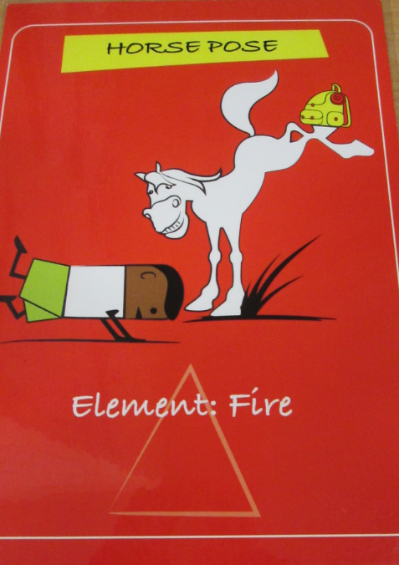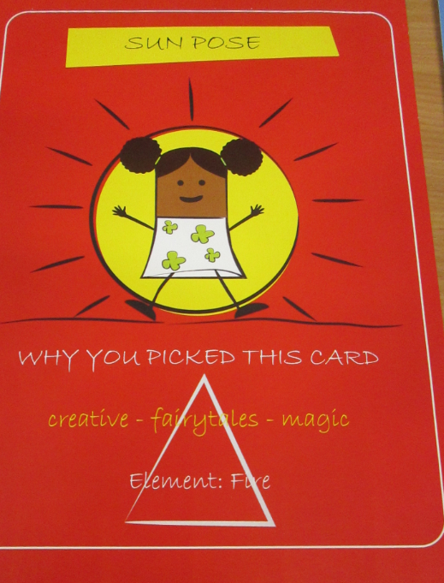  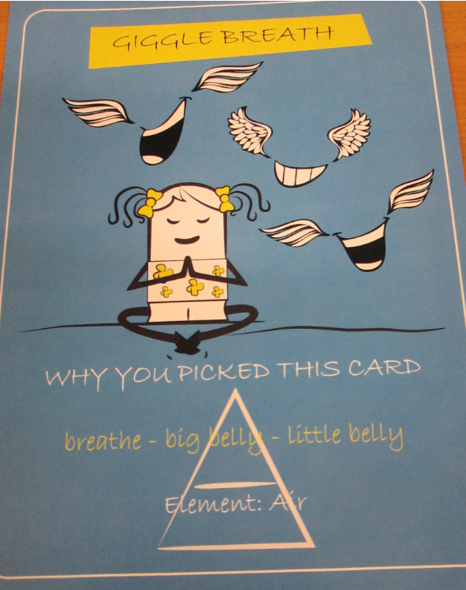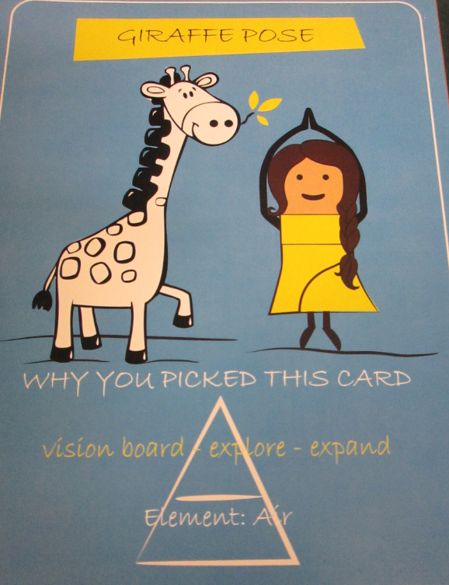  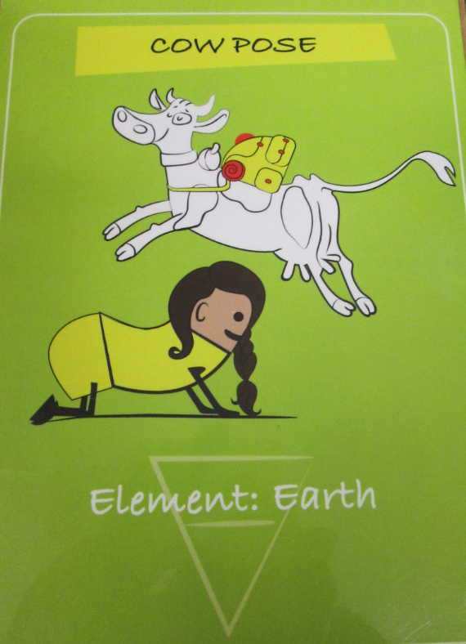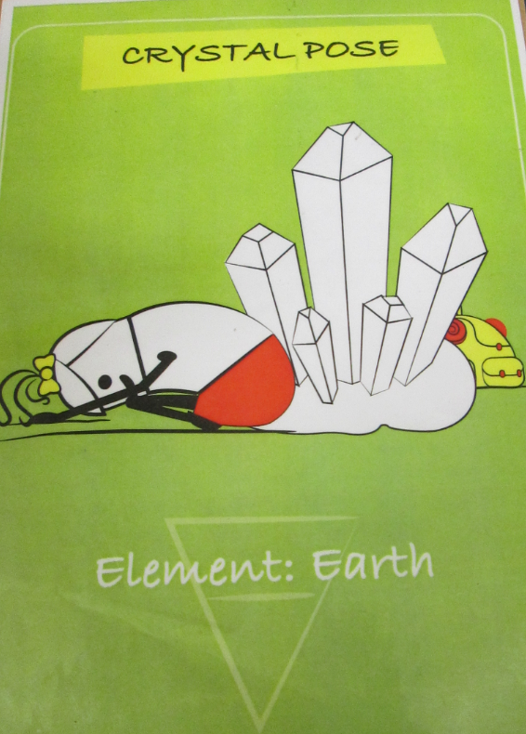
Additional notes for parents. | Next Monday, you will need 6 hardboiled eggs if you wish to take part in the science experiment.

Please send your completed work to me at willow@lyng.norfolk.sch.uk so I can enjoy seeing what has been done and give top tips and feedback as necessary.

Let’s get started challenge

Topic QUIZ
Can you guess which parts of the body these x rays show?

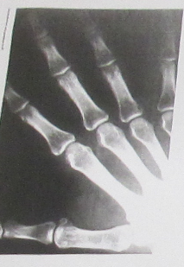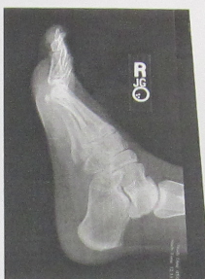

………………………………………………. …………………………………………………………………..
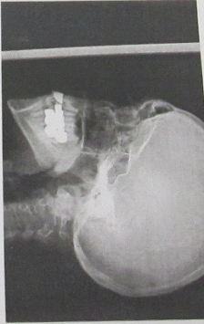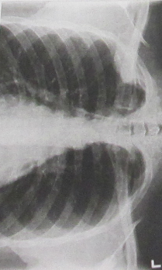

………………………………………………………….. …………………………………………………………….
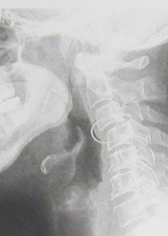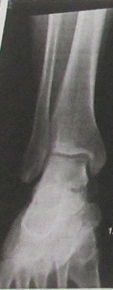

………………………………………………………. …………………………………………………………..

Computing

