Tuesday 19th January 2021 YEAR 1
Enjoy doing the activities listed.
The order to do them in is suggested below but you can change them to suit you. Please e mail me any work, notes, photos or comments. Thank you.
MORNING  Let’s get started challenge | 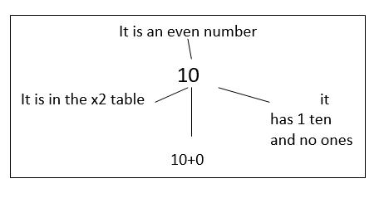  See below
Music  Learning objective  See music service | Introduction:  Join in with music service sessions  https://www.norfolkmusichub.org.uk/site/ugly-bug-ball-resources/  Mrs Rudd has sent you a password via text.  THEY HAVE REQUESTED THAT YOU DON’T SHARE THE PASSWORD ON SOCIAL MEDIA  Activity: see website
English  Learning objective:  Can I write a list of things that might be in a giant’s pocket?  Can I check my work by reading it back? | The story and activity pack is on the school website under Classes. The pages to be completed will be indicated on the daily notes. If you don’t have access to a printer your child can record their answers on paper.  Introduction  - Yesterday you read a poem about what Pippety had in his pocket. Can you remember any of the things he had?  - I wonder what you might find in a giant’s pocket.  TOP TIP: remember a pixie is small and a giant is really BIG!  - Share your ideas. Remember Think it, say it.  Activity:  - Draw what you think might be in a giant’s pocket on your own paper or using page 17.  - Now use your drawings to help you write a list on page 18.  Remember write it, check it.
Handwriting/ spellings or phonics  Learning objective:  Can I learn the tricky words come and some? | Introduction:  - Last week we learnt:  here  where  there  - Can you remember how to spell them? Have a quick check to see. If you have made any mistakes go over them again  - Today we will be learning some more of the tricky words we need to know:  some  come  - First- read the words.  - Second- look at the words- what do you notice?  - Third- think about how you could remember them.  Top Tip: there are different ways we can try and remember words which we can’t sound out. Can you remember the ways from last week?  - Look at this new way. It’s like a pyramid. It starts at the top with one letter and then builds a new letter each time.  c  c o  c o m  c o m e  - Try doing the same with some.  - You may like this way or you may prefer one of the ways from last week – do whatever suits you best  Activity  1. Choose a way which suits you best to remember those 2 new tricky words.  2. Write a sentence for each of those words.
 | Lunchtime!
AFTERNOON  Reading | Read at least 3 pages of a reading book.  Or listen to a ‘Funnybones’ story  https://www.youtube.com/watch?app=desktop&v=sJodPwWCClQ
Topic  Learning objective:  Can I use what I know about parts of the body to create a skeleton using what I can find?  Computing  Can I put the pictures in the right order to show the robot how to brush his teeth? | Introduction:  - Clue 3 is an x ray but which part of the body?  - This week we are naming parts of our bodies to see if we can find out.  - Have a go at this quiz- can you work out which part of the body are these x rays taken from?  See below  .  Activities.  - Join in with this song http://supersimplelearning.com/songs/themes-series/halloween/the-skeleton-dance/  - Make your own body or skeleton. Use your imagination.  You could use straws, Meccano, Lego or even go outside and make one with sticks.  It could be flat or 3D. It could be still or you could make parts of the body e.g. legs move.  Have fun and send me some pictures.  Computing.  Introduction:  - Robot needs to learn how to brush its teeth. It needs a step by step set of instructions on how to do this. This is called an Algorithm.  Activity  - Watch the BBC Bitesize clip on KS1 What is an algorithm?  https://www.bbc.co.uk/bitesize/topics/z3tbwmn/articles/z3whpv4  - Complete the worksheet. If you want to challenge yourself you could write your own set of simple instructions for the robot.  See below
Story/ yoga/ mindfulness activity | Try some Yoga. Here are some yoga poses to try  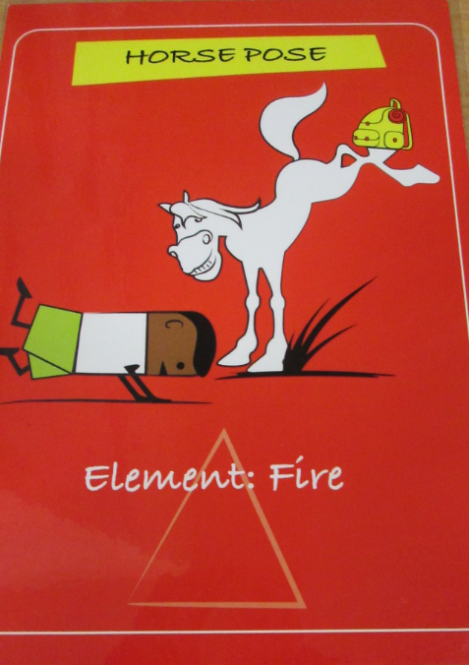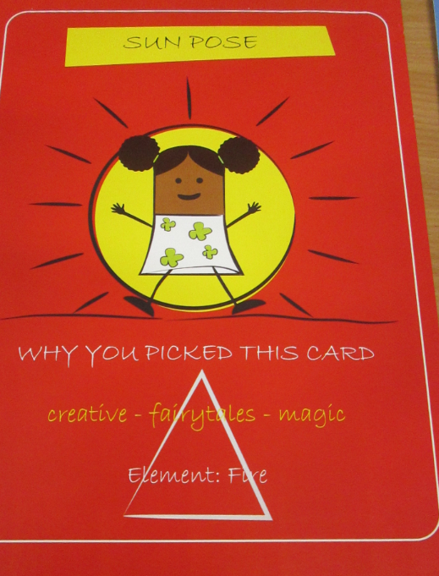  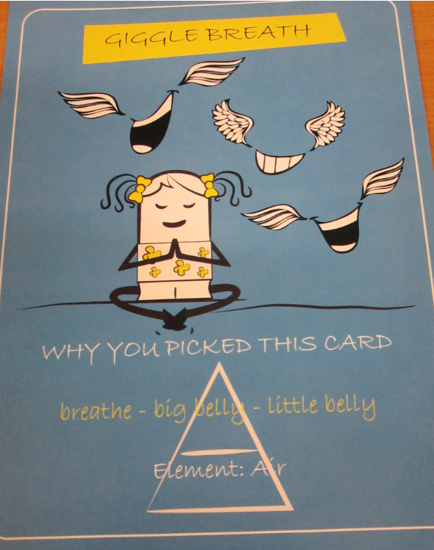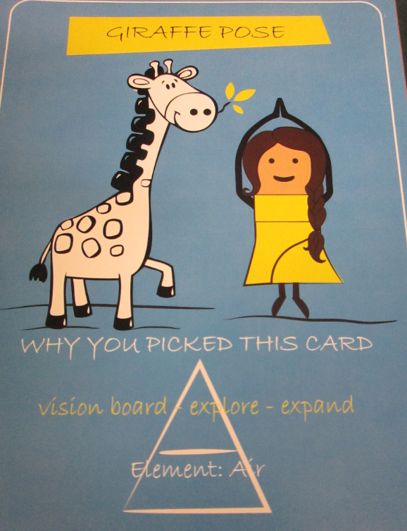  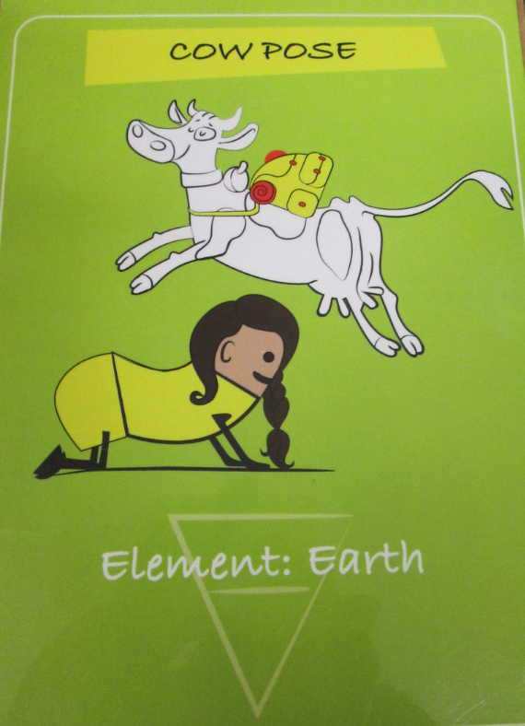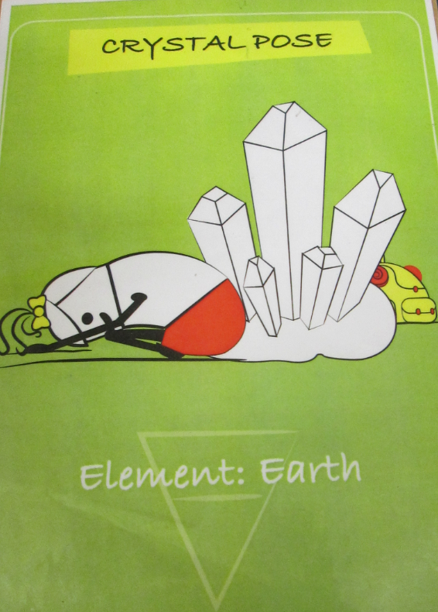
Additional notes for parents. | Next Monday, you will need 6 hardboiled eggs if you wish to take part in the science experiment.

Please send your completed work to me at willow@lyng.norfolk.sch.uk so I can enjoy seeing what has been done and give top tips and feedback as necessary.

Let’s get started challenge

English
See story and activity pack.
Spellings- practise here if you would like to

Topic QUIZ
Can you guess which parts of the body these x-rays show?

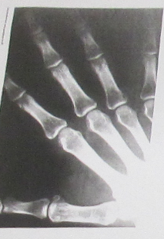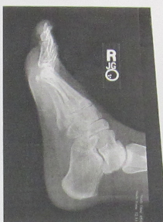

………………………………………………. …………………………………………………………………..
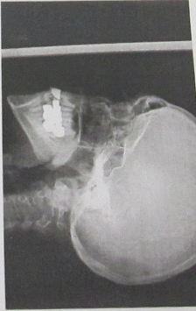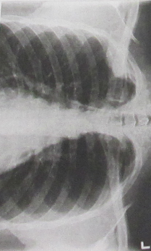

………………………………………………………….. …………………………………………………………….
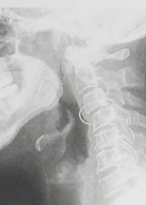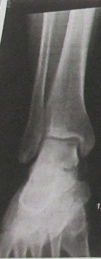

………………………………………………………. …………………………………………………………..
Computing
