Thursday 28th January 2021 YEAR 1
Enjoy doing the activities listed.
The order to do them in is suggested below but you can change them to suit you. Please e mail me any work, notes, photos or comments. Thank you.
MORNING  Let’s get started challenge | Start the morning with Joe Wicks
Maths  Learning objective:  Can I subtract two numbers using my own choice of method: a number line or a 100 square or an empty number line?  Extra challenge(ONLY FOR THOSE CONFIDENT IN SUBTRACTION)  Can I work out a missing number subtraction problem? | Introduction:  - This week we have learnt different ways to subtract.  - To subtract you can use a number line to 20  OR a 100 square  OR an empty number line  - Different people like different ways  - Today you are going to practice subtracting 2 numbers but you can choose the way that you prefer.  - Think about which way of subtracting that you liked best.  - If you are really confident in subtracting two numbers you could try the missing number challenge. See the instructions below.  Activity  Write some sums of your own.  TOP TIP: Remember don’t go above 100! You must have the biggest number first.  Additional challenge: check your subtraction sums by adding e.g. if 18 - 3 = 15 15 + 3 = 18  Or try missing numbers  - When we see a sum e.g 10 - = 4! We have to work out what the number is by counting back.  TOP TIP: You will need a number line or 100 square to help you  - Start at 10. Count back until you get to 4 and then stop. How many did you count back 6 so the missing number is 6. Use your hundred square to help you.
English  Learning objective:  Can I show that I understand new words? | Introduction  - Today you are going to look through the story and see if there are any words you don’t understand.  - Talk to a grown up about any words you are not sure about.  - Can you find these words:  ancient mumbled prey  - Now talk about what they mean.  Activity :  Complete page 9 of your pack.
Handwriting/ spellings or phonics  Learning objective:  Can I remember how to spell the tricky words they, one and your by completing an activity? | Introduction:  - So far you have learnt:  here some  where come  there  - Can you remember how to spell them? Have a quick check to see. If you have made any mistakes go over them again  - Now recap the tricky words for this week  your  they  one  - Can you spell them? Have a go. If you make any mistakes practise some more before you try the game.  Activity  Spot the mistake!  (worksheet below)
 | Lunchtime!
AFTERNOON  Reading | Read at least 3 pages of a book. You may have a spider story at home  Or listen and watch a story about Anansi the spider https://www.youtube.com/watch?v=3CIG6gfl_Xc
RE  (Mrs Watson)  Learning objective:  Can I learn about a welcoming ceremony in a Christian family? | Please work your way through the attached Powerpoint presentation (Mrs Watson)
Story/ yoga/ mindfulness activity | Go outside and look for signs that spring is on its way.  One of the class has spotted a bee. Can you see one?
Additional notes for parents.

Please send your completed work to me at willow@lyng.norfolk.sch.uk so I can enjoy seeing what has been done and give top tips and feedback as necessary.

Extra Maths: level 1 (only if you are confident in subtracting)
Can I work out a missing number subtraction problem?

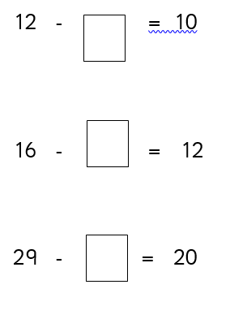

maths: level 2
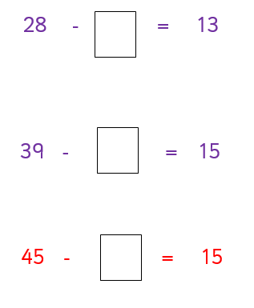

Phonics
Can I remember how to spell the tricky words they, one and your by completing an activity?

Spot the mistake in each row. Circle the spelling which is not correct.

they thye they they they

one one one oen one

your your your your yor

