Thursday 28th January 2021 YEAR 2
Enjoy doing the activities listed.
The order to do them in is suggested below but you can change them to suit you. Please e mail me any work, notes, photos or comment. Thank you.
MORNING  Let’s get started challenge | Start the morning with Joe Wicks
Maths  Learning objective:  Can I subtract using partitioning?  Additional challenge: Can I estimate an answer first? | Introduction:  - Today you will be subtracting by partitioning using what you know about tens and ones.  For example:  29 - 14 =  20 9 10 4  first break the numbers into tens and ones  20 - 10 = 10  then subtract the tens  9 - 4 = 5  next subtract the ones  10 + 5 = 15  next add the tens and ones answers  Activity  Try the worksheets below. Choose your own level of challenge.  Additional challenge: estimate your answer first by rounding to the nearest ten.  e.g. 29 nearest ten is 30  14 nearest ten is 10  30-10 =20 so the answer should be around 20  Remember numbers ending in 1,2,3,4 round to the ten below. Numbers ending in 5,6,7,8, or 9 round to the next ten.
English  Learning objective:  Can I create a superhero symbol for myself?  Can I explain to others what it means? | Introduction  - Did you know that most superheroes have capes and some have belts, cuffs and even crowns or hats?  - They also have special symbols which decorate their clothes and show who they are.  - Look at the picture on page 10 and read the labels.  - Now can you work out the symbols?  - If you had a superhero symbol what would it be? Remind yourself of your superpowers from your fact file yesterday as this might help you. It might be the first letter of your name and something you are really good at.  Activity  - Draw your symbol on page 11.  - Explain your symbol on the lines at the bottom of page 11.
Handwriting/ spellings or phonics  Learning objective:  Can I remember and use the tricky words every and everybody? | Introduction:  - Today we will be finding out if you can remember the spelling words you have learnt so far.  - Test yourself on:  both mind behind  cold kind every  told find everybody  - If you are still finding these spellings tricky practise them again.  - If you are confident in them embed your understanding of them by playing a game.  Activity  Spot the mistake!  (worksheet below)
 | Lunchtime!
AFTERNOON  Reading | Read at least 3 pages of a book.
RE  (Mrs Watson)  Learning objective:  Can I learn about a welcoming ceremony in a Christian family? | Please work your way through the attached Powerpoint presentation (Mrs Watson)
Story/ yoga/ mindfulness activity | Go outside and look for signs that spring is on its way.  One of the class has spotted a bee. Can you see one?
Additional notes for parents. | You will need paper, card or cardboard for the English task tomorrow.

Please send your completed work to me at willow@lyng.norfolk.sch.uk so I can enjoy seeing what has been done and give top tips and feedback as necessary.

Maths: level 1
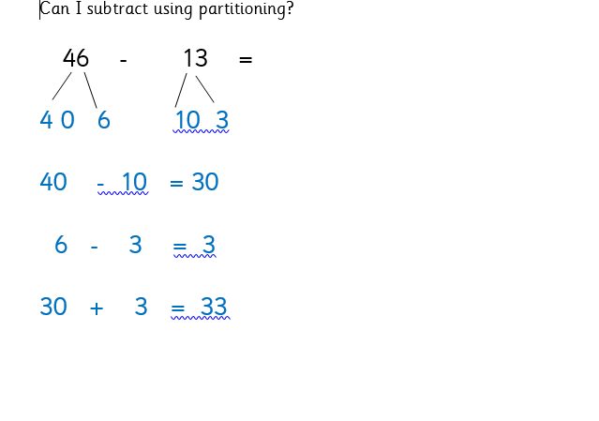
48 - 15 =

Maths: level 2

58 - 34 =

99 - 45 =

spellings
Can I remember how to spell the tricky words by completing an activity?

Spot the mistake in each row. Circle the spelling which is not correct.

every every evrey every

everybodee everybody everybody

mind mind midn mind

kind kind kind kiind

find fndi find find

both both boht both

cold clod cold cold

