Thursday 21st January 2021 YEAR 2
Enjoy doing the activities listed.
The order to do them in is suggested below but you can change them to suit you. Please e mail me any work, notes, photos or comment. Thank you.
MORNING  Let’s get started challenge | Start the morning with Joe Wicks
Maths  Learning objective:  Can I add using partitioning?  Additional challenge: Can I estimate an answer first? | Introduction:  Today we will be adding by partitioning using what you know about tens and ones.  For example:  23 + 14 =  20 3 10 4  first break the numbers into tens and ones  20 + 10 = 30  then add the tens  3 + 4 = 7  next add the ones  30 + 7 = 37  next add the tens and ones answers  Activity  Try the worksheets below. Choose your own level of challenge.  Additional challenge: estimate your answer first by rounding to the nearest ten.  e.g. 23 nearest ten is 20  14 nearest ten is 10  20 + 10 = 30 so the answer should be around 30  Remember numbers ending in 1,2,3,4 round to the ten below. Numbers ending in 5,6,7,8, or 9 then round to the next ten.
English  Learning objective:  Can I write the end of the story?  Can I read it back to check it makes sense? | Introduction  - This week you are writing a story about some elves.  - First you planned your story then you wrote the story start. Yesterday you wrote the middle of the story.  - Read your story so far. Are you happy with it?  - If you are, look at your story mountain for the end of the story.  Activity  - Today you will thinking about how your story ends. Is it happy or sad? Also think about what happens to the characters in the story and the elves. Were they able to help?  - Good stories may end in different ways:  - By asking a question e.g. what would they do next?  - With some speech e.g. “Thank you so much” exclaimed…..  - With a cliff hanger – what might happen next The elves skipped happily down the lane but they didn’t see……  - With humour  - A general comment e.g. And that’s a whole new story  Each time your write  Think it, say it, write it, check it.  Activity :  Write the end part of your story.  Remember to use your own ideas, not mine!  Read I through- does it make sense?  Send it to me.
Handwriting/ spellings or phonics  Learning objective:  Can I remember and use the tricky words I have learnt? | Introduction:  - Today we will be finding out if you can remember the spelling words you learnt so far  - Test yourself on:  both mind behind told  cold kind both  told find cold  - If you are still finding these spellings tricky practise them again.  - If you are confident in them embed your understanding of them by playing a game.  Activity  - Bingo- see below  Ask a grown up or a brother and sister to call out the words. Read them carefully and when you have them all ticked off shout BINGO
 | Lunchtime!
AFTERNOON  Reading | Read at least 3 pages of a book.
RE  (Mrs Watson)  Learning objective:  Can I recognize that I belong to different groups? | Introduction  - We all belong to different kinds of families and to different groups  - You have already thought about your family and drawn pictures  - We also belong to other groups. What groups do you belong to (maybe not at the moment but usually e.g. swimming).  - By completing the tasks today you will be able to show how you express your sense of belonging in different ways including places you go to, people you meet and the clothes and objects you have.  Activity  - 'Read and discuss the Belonging powerpoint with your grown up.  - Complete the Belonging activity sheet by drawing yourself in the middle, surrounded by a picture in each box of a group you belong to.  - To extend this activity, write how you show you belong to that group, e.g. I make a promise, and I wear a uniform, (a parent could scribe).  See sheet below  Powerpoint – can be found on school website -classes- willow Class page
Story/ yoga/ mindfulness activity | Cosmic yoga
Additional notes for parents. | Next Monday, you will need 6 hardboiled eggs if you wish to take part in the science experiment.

Please send your completed work to me at willow@lyng.norfolk.sch.uk so I can enjoy seeing what has been done and give top tips and feedback as necessary.

Maths: level 1
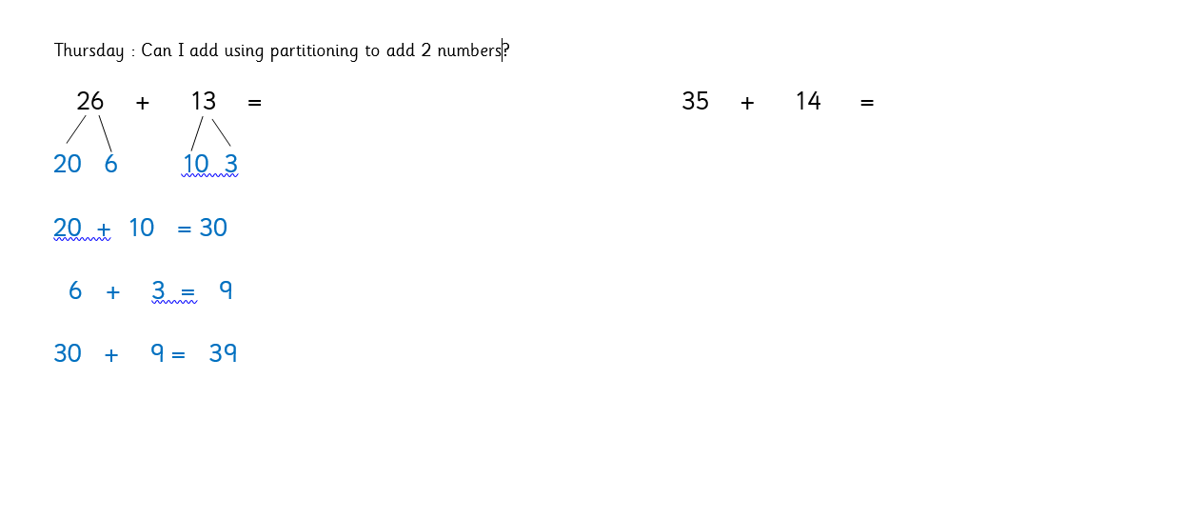
Maths: level 2

Spellings bingo

mind | cold | behind | told
kind | told | find

RE

