Thursday 21st January 2021 YEAR 1
Enjoy doing the activities listed.
The order to do them in is suggested below but you can change them to suit you. Please e mail me any work, notes, photos or comments. Thank you.
MORNING  Let’s get started challenge | Start the morning with Joe Wicks
Maths  Learning objective:  Can I add two numbers together using my own choice of method: a number line or a 100 square or an empty number line?  Can I work out a missing number addition problem? | Introduction:  - This week we have learnt different ways to add.  - To add you can use a number line to 20  OR a 100 square  OR an empty number line  - Different people like different ways  - Today you are going to practise adding 2 numbers but you can choose the way that you prefer.  - Think about which way of adding that you liked best.  - If you are really confident in adding two numbers you could try the missing number challenge. See the instructions below.  Activity  Write some sums of your own. Remember don’t go above 100!  Additional challenge: check your addition sums by subtracting e.g. if 15 + 3 = 18 18 - 3 = 15  Or try missing numbers  - When we see a sum e.g. 6 + = 10 we don’t add 6 + 10 and put the answer in the box! We have to work out what the number is by counting on.  TOP TIP: You will need a number line or 100 square to help you  - Start at 6. Count on until you get to 10 and then stop. How many did you count on 4 so the missing number is 4? Use your hundred square to help you.
English  Learning objective:  Can you write about all the things you found for your rainbow?  Can you use what you know about sounds and spelling rules to help you? | Introduction  - Yesterday you created a rainbow. Look back at your rainbow work or photo. Remind yourself of what you found.  - What did you find first? Think it, say it.  - Now write it on page 20.  - Next check it.  Activity :  Complete the sheet on page 20
Handwriting/ spellings or phonics  Learning objective:  Can I learn the tricky words come and some? | Introduction:  - Last week we learnt:  here  where  there  - Can you remember how to spell them? Have a quick check to see. If you have made any mistakes go over them again  - Now recap the tricky words for this week:  some  come  - Can you spell them? Have a go. If you make any mistakes practise some more before you try the game.  Activity  Bingo: one person calls out the words and the other ticks them off. Don’t forget to shout BINGO! When you have ticked them all off.  Now swap using the other bingo card.
 | Lunchtime!
AFTERNOON  Reading | Read at least 3 pages of a book.
RE  (Mrs Watson)  Learning objective:  Can I recognize that I belong to different groups? | Introduction  - We all belong to different kinds of families and to different groups  - You have already thought about your family and drawn pictures  - We also belong to other groups. What groups do you belong to (maybe not at the moment but usually e.g. swimming).  - By completing the tasks today you will be able to show how you express your sense of belonging in different ways including places you go to, people you meet and the clothes and objects you have.  Activity  - 'Read and discuss the Belonging powerpoint with your grown up.  - Complete the Belonging activity sheet by drawing yourself in the middle, surrounded by a picture in each box of a group you belong to.  - To extend this activity, write how you show you belong to that group, e.g. I make a promise, and I wear a uniform, (a parent could scribe).  See sheet below  Powerpoint – can be found on school website -classes- willow Class page
Story/ yoga/ mindfulness activity | Cosmic yoga
Additional notes for parents. | Next Monday, you will need 6 hardboiled eggs if you wish to take part in the science experiment.

Please send your completed work to me at willow@lyng.norfolk.sch.uk so I can enjoy seeing what has been done and give top tips and feedback as necessary.

come | some | there
where | here

come | some | there
where | here

Maths ONLY FOR THOSE CONFIDENT IN ADDITION (see teacher notes above)

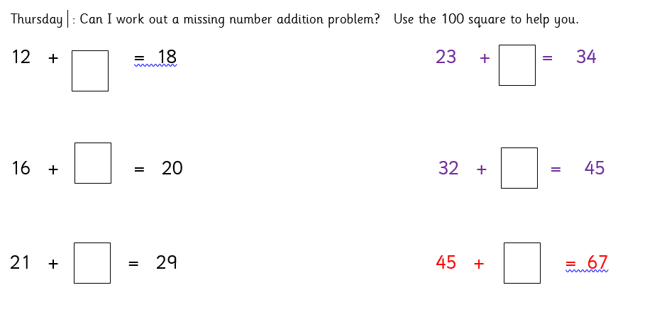

RE
