Hi Year 4
It’s the start of a brand new week. Here are all your lessons for today.
Looking forward to seeing what you learn.
Miss Cartwright, Miss Dorr and Mrs. Warnes.
Maths  LO: Can I use a mixture of methods to solve multiplication and division problems? | Morning maths problem:  How many ways can you make 2400?  Try to use all four operations: =, -, x and ÷
Times table practise:
8 x tables.
- Listen to an 8 times table song on YouTube
- Chant them forwards and backwards
- How do they link with other tables?
- Do you notice a pattern?
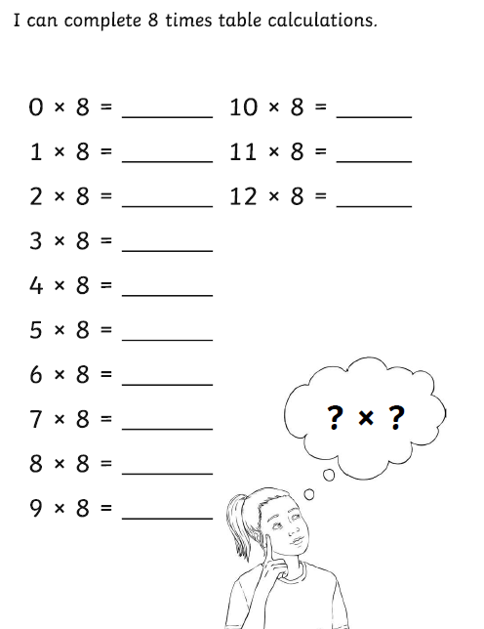
Try to do this everyday!
Learning (remember to go onto Mathletics or play another maths game too):
We are going to continue to work on methods of multiplication and division this week.
You can draw upon what you learnt last week, as well as employ mental maths too!
Please complete the following problems using what you have learnt over the last week, as well as some mental maths:
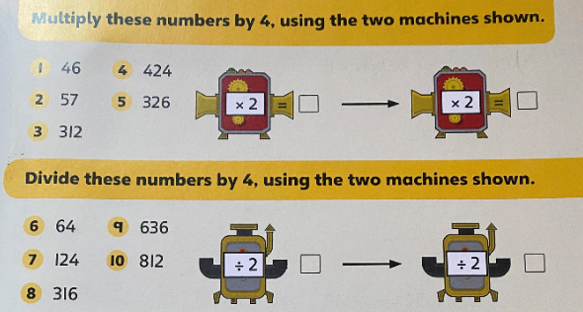

English  LO: Can I complete a cold task, involving writing a log? | We are starting a new unit of writing this week about a journey an alien planet.  We always begin a new unit of work with a ‘cold task’ – this is so we can assess what we already know and see how far we have come at the end of the unit.  Your cold task for today:  Is to write your own log for a trip you’ve taken to the alien planet. Write about why you’re there, what you’ve seen and how you’re feeling.  Success criteria:  - Date to show when you’re in space  - Full stops, capital letters and commas  - Use of senses to describe setting  - Quality vocab
Spellings  LO: Can I use look, say, cover, write, check to practise a set of spellings? | Anti- prefix  Miss Dorr’s group: adding –ing,-ed, -er, -est and –y to words ending with an e, with a consonant before it.  Read all of your spellings aloud. Do you recognise any of them? Which ones don’t you know?  Once you have done this, complete a ‘look, say, cover, write, check’ task.  You look at the word.  Say the word aloud.  Cover up the word so you can’t see it!  Write the word, trying to spell it correctly.  Check to see if you got it correct!  Send me what you have learnt on the class email.
Reading | Spend some time reading your book. You can read in your head, but please also read to an adult.  Grown-ups – I will upload the list of questions we use in class so you can assess your child’s comprehension.  You can download the Libby app, which allows you to borrow books and e-books from your local library.  Those children who are reading banded books – use the Oxford Owl website to find eBooks to read. https://www.oxfordowl.co.uk/for-home/find-a-book/library-page/  Oak National Academy also have an online library which may be of use: https://library.thenational.academy/  Continue to fill in your reading records and completing the activities in your reading records.
Afternoon lessons:  LO: Can I explain how oxygen is transported around the body? | Topic:  Today, we are going to be learning about how humans transport oxygen around their bodies.  Please follow the Oak National Academy lesson to support your learning on this.  https://classroom.thenational.academy/lessons/how-is-oxygen-transported-around-our-bodies-60vk6r  Please don’t worry about completing the quiz at the start of the lesson. It contains questions about the skeleton and teeth. We won’t be covering these areas until after February half term.  Or to get to it via the homepage, please follow these instructions:  - Lessons  - Subjects  - Key Stage 2  - Science  - Human Anatomy  - Lesson 5 – how is oxygen transported around our bodies?  If you cannot access Oak National Academy, please do some personal research about the human circulatory system.  Find out about what happens when we breathe and how this keeps us alive and well.  You could also find out about the different components of blood.  As an extra challenge, you could have a go at drawing a body, showing the veins and where they lead.  If you are doing this research independently, do make sure that you are using a child-safe search engine such as Kiddle.

Please ensure that you email completed work to rowan@lyng.norfolk.sch.uk so I can provide feedback on certain pieces to ensure progression.
I will provide feedback via the class email.

Spellings –
Miss Dorr’s
- Hiking
- Hiked
- Hiker
- Nicer
- Nicest
- Shiny
- Being
- Shining
- Scary
- Scaring
Anti
- Antifreeze
- Antisocial
- Anticlockwise
- Antibody
- Antibiotic
- Antidote
- Antiseptic
- Antibacterial
- Anticlimax

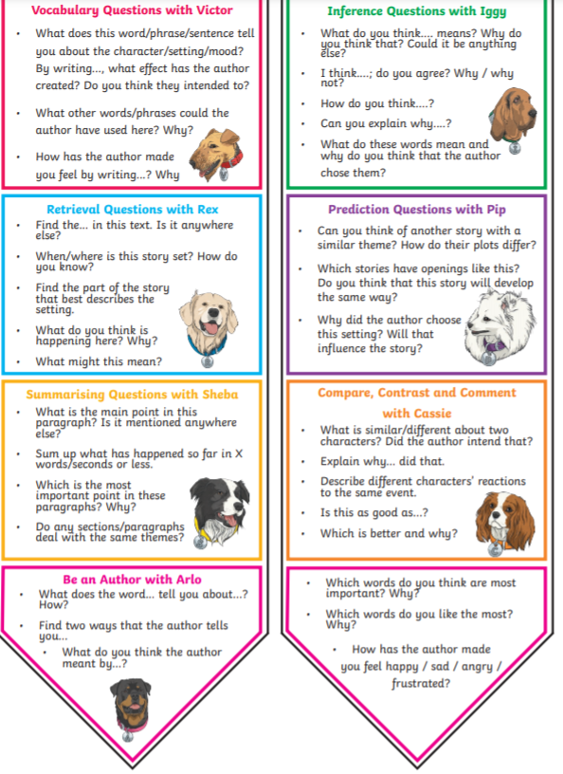
Reading questions -

