Monday 25th January 2021 YEAR 2
Enjoy doing the activities listed.
The order to do them in is suggested below but you can change them to suit you. Please e mail me any work, notes, photos or comments. Thank you.
MORNING  Let’s get started challenge | Join Joe wicks for his new daily workouts!
Maths  Learning objective:  Can I subtract 2 numbers using a 100 square?  Extension: can I use what I know about tens and ones to make a shortcut? | Introduction:  - This week we will be recapping subtraction. We will be exploring different ways and then in future you can choose the way which suits you best.  Remember there are some top tips for subtracting:  - The biggest number always comes first.  - The answer will always be smaller than the number you started with.  - You can use what you know about place value and number facts to help you.  - You can check an answer by adding.  Today use a 100 square (see below). Try  24 - 5 =  Remember put your finger on the first number then count bck carefully but don’t count the number you started on!  Now try  25 - 12 =  Use what you know about 10 less and 1 less to subtract using a shortcut.  For example: for 25 - 12 first break the number into 1 ten and 2 ones. Then subtract 1 ten by moving up a square and 2 then subtract 2 ones by moving back 2 squares to the left. Do the worksheet below.  Additional challenge: work out the sums mentally.  Activity- see sheets below
English  Learning objective:  Can I read the superhero fact files and the story ’Playground rescue’ and show my understanding by answering the questions? | The ‘Superheroes’ story and activity pack is on the school website under classes.  Introduction  - This week we start a new pack called ‘Superheroes’. This story and the activities which go with it will last for 2 weeks.  - Today, start by reading the fact files on page 3 of the pack.  - Talk about each of the characters and what they were good at.  Activity:  Read the story ‘Playground rescue’ on page 4 and 5.  Next think about what you liked about the story etc. fill in the worksheet below.
Handwriting/ spellings, grammar, punctuation or phonics  Learning objective:  Can I use question marks at the end of a sentence? | Introduction  - I have noticed that some children have forgotten to use a question mark when they are writing a question.  - Today we will recap how to do this.  - Watch video https://www.bbc.co.uk/bitesize/topics/z8x6cj6/articles/zcm3qhv  - Then try the activity on the webpage  Activities  Complete the sheets below
 | Lunchtime!
AFTERNOON  Reading | Read at least 3 pages of a book.
Topic  Learning objective:  Can I say how I could find out which drinks are good for my teeth and which are not so good? | Introduction:  - None of the bodies from last week matched the photo!  - So we need to look at the next clue.  - Clue 4: 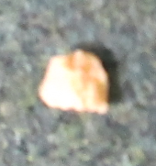 a tooth!  - If we could find out who the tooth belonged to we may be able to find the owner of the box.  - Have you lost a tooth? Could it be yours?  - WASH YOUR HANDS before the next activity.  - Find a mirror and look at your teeth.  Have you got any gaps? The tooth in the box is very  small.  Are they all the same? Look closely at the teeth at  the front and the teeth at the back.  - Discuss how some teeth are small and some are bigger. Discuss different names – milk/ adult/ molars etc.  Molars – at back- help us to chew  Canine – at side- help us to tear  Incisor- front- help us to bite  - What do teeth do – chew, help with speaking etc.  - What do we need to do to keep our teeth healthy?  - What might harm our teeth?  We are going to set up an experiment to see what happens to our teeth if we don’t look after them. You will need to keep watch over the next few days.  We are using eggs because they have a similar material in the shell to our teeth.  Activities.  - Set up the experiment.  - Get 6 hard- boiled eggs.  - Put eggs into 6 clear beakers  - Add a different drink to each cup - milk, tea, coke, fruit juice, blackcurrant squash, water or vinegar  - Predict what might happen  - Start to fill in the sheet below. You will need to complete it later in the week when you can.
Story/ yoga/ mindfulness activity/ songs | Sing a song about teeth  https://learnenglishkids.britishcouncil.org/songs/tooth-family
Additional notes for parents. | Be kind to yourselves! Do what you can!

Please send your completed work to me at willow@lyng.norfolk.sch.uk so I can enjoy seeing what has been done and give top tips and feedback as necessary.

Let’s get started challenge- Joe wicks

Maths:
The 100 square is here to use if you need it.

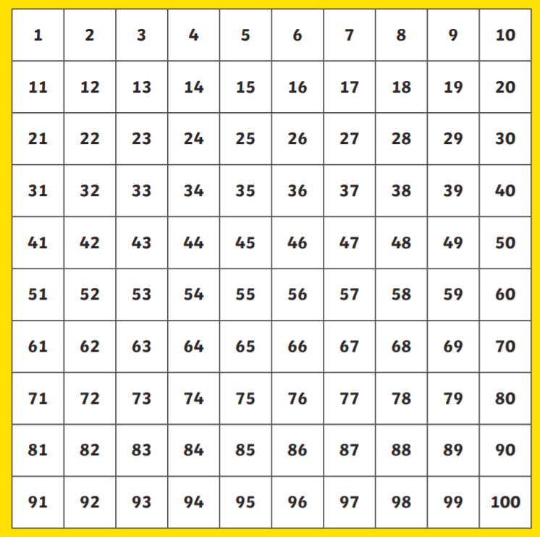

Level 1 challenge

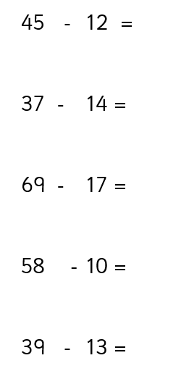
Maths: Level 2 challenge
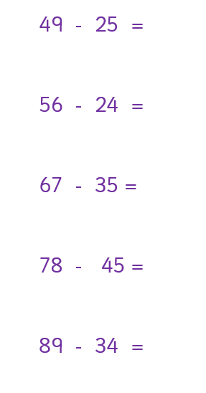

Level 3!
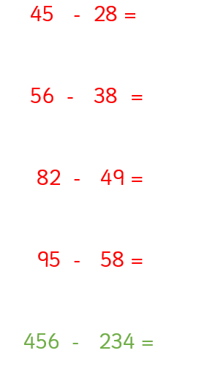

English
Can I read the superhero fact files and the story ’Playground rescue’ and show my understanding by answering the questions?

- What were Jo Awesome’s super powers?

………………………………………………………………………………………………………………………………………………

- Whose superpower was Art?

………………………………………………………………………………………………………………………………………………

- Which superhero was a dog?

…………………………………………………………………………………………………………………………………………………

- What was Jo playing in her backyard?

………………………………………………………………………………………………………………………………..

- Which word tells you that it wasn’t a real goal she was playing in?

………………………………………………………………………………………………………………………………….

- ‘One of his enormous ears had flopped over his eye, his favourite squeaky bacon toy was trapped beneath a podgy paw and his droopy eyelids flickered as he chased wasps in his dreams’

Circle or colour in the adjectives in this sentence.

- What was the problem at the park?

………………………………………………………………………………………………………………………………………….

- How did they all feel at the end? Why do you think that?

………………………………………………………………………………………………………………………………….

Because ……………………………………………………………………………………………………………………..

Punctuation
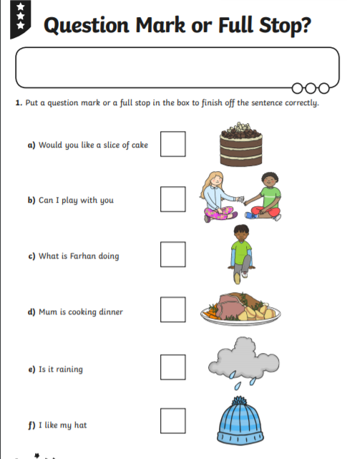
Now write your own question:

…………………………………………………………………………………………………………………………………………

Topic
