Monday 25th January 2021 YEAR 1
Enjoy doing the activities listed.
The order to do them in is suggested below but you can change them to suit you. Please e mail me any work, notes, photos or comments. Thank you.
MORNING  Let’s get started challenge | Start the day with Joe Wicks!
Maths  Learning objective:  Can I subtract a one digit number from a two digit number using a number line /100 square?  Challenge: Can I subtract a 2 digit number from a 2 digit number using a 100 square? | This week we will be recapping subtraction. We will be exploring different ways of subtracting or taking away and then you can choose the way which suits you best.  First watch https://www.bbc.co.uk/bitesize/topics/zwv39j6/articles/ztpmrwx  Then https://classroom.thenational.academy/lessons/to-subtract-by-counting-back-using-a-number-line-cgr36d  TOP TIP: remember subtraction can also be called take away, minus, less than. When 2 numbers are subtracted the answer always gets SMALLER! Always check your answer to make sure it is!  Today we will subtract using a number line (see below). Try  14 - 6 =  Remember put your finger on the first number then count back carefully but don’t count the number you started on!  Now try  28 - 9 =  This time use a 100 square (see below) Remember to to go up and back to a new line as you count past 21.  Now try  27 - 12 =  TOP TIP: Remember to count carefully as the second number gets bigger  Now try the sums below using a 100 square, they start easy and get harder! Do the challenge that is right for you.  Additional challenge: Use what you know about 10 less and 1 less from last week to subtract using a shortcut  So for 27 – 12, first break the number into 1 ten and 2 ones. Then subtract 1 ten by moving up a square and 2 then subtract 2 ones by moving back to squares to the left. Do the purple and red sums  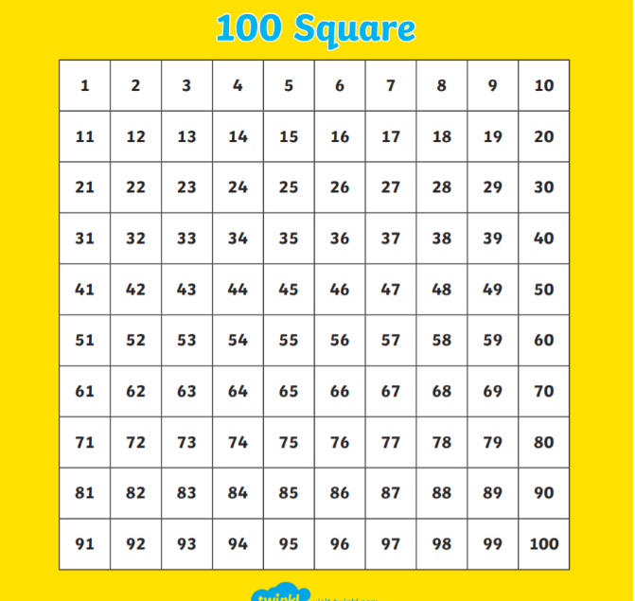
English  Learning objective:  Can I read or listen to the story ‘Sidney the Spider’? | Today we start a new story. The story and activity pack is on the school website under classes. .  Introduction  - This week we are starting a new story. It is called ‘Sidney Spider’.  - Do you like spiders? Some people don’t but we will be finding out more facts about spiders as well as reading a story over the next few weeks.  - Can you think of any other stories you know about spiders?  Activity:  - Read or listen to the story on pages 3 and 4.  - Talk about the story. Then fill in your thoughts about the story on pages 5 and 6.  I look forward to hearing your thoughts about the story.
Handwriting/ spellings or phonics  Learning objective:  Can I use the o-e sounds to read and spell? | Introduction:  - Recap these sounds against the clock. How long does it take you to say the sounds correctly?  - GET READY, GO!  ai ee igh oa oo  ay ea ie ow ue  a-e e-e i-e  - How long did it take?  - Repeat- can you do it even quicker – if you make a mistake you must go back to the start!  - You have learnt that the oa sound can be made by oa and ow.  - Can you remember the spelling rule?  - Write the words for these pictures to remind yourself  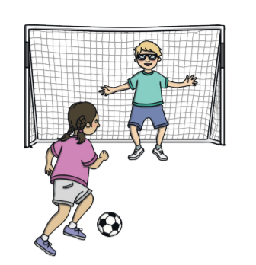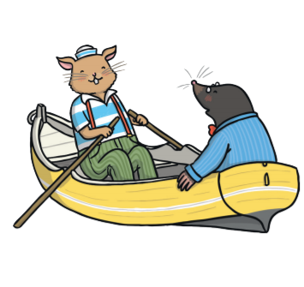  ……………………………….. ……………………………….  - The same sound can also be made by o-e. we call this a split digraph because the oe has be split up by another letter e.g. smoke  - Watch Mr. Thorne does phonics https://www.youtube.com/watch?v=VpTIpkgU1fY  - Try reading these words:  hope those  broke dome  hole choke  Activities – see below
 | Lunchtime!
AFTERNOON  Reading | Read at least 3 pages of a book.
Topic  Learning objective:  Can I talk about my teeth?  Can I say which drinks are good for my teeth and which are not?  Can I give ideas for drinks to use in the experiment? | Introduction:  - None of bodies from last week matched the photo!  - So we need to look at the next clue.  - Clue 4: 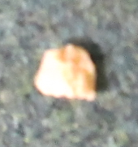 a tooth!  - If we could find out who the tooth belonged to we may be able to find the owner of the box.  - Have you lost a tooth? Could it be yours?  - WASH YOUR HANDS before the next activity.  - Find a mirror and look at your teeth.  Have you got any gaps? The tooth in the box is very  small.  Are they all the same? Look closely at the teeth at  the front and the teeth at the back.  - Discuss how some teeth are small and some are bigger. Discuss different names – milk/ adult/ molars etc  Molars – at back- help us to chew  Canine – at side- help us to tear  Incisor- front- help us to bite  - What do teeth do – chew, help with speaking etc  - What do we need to do to keep our teeth healthy?  - What might harm our teeth?  We are going to set up an experiment to see what happens to our teeth if we don’t look after them. You will need to keep watch over the next few days.  We are using eggs because they have a similar material in the shell to our teeth.  Activities.  - Set up the experiment.  - Get 6 hard- boiled eggs.  - Put eggs into 6 clear beakers  - Add a different drink to each cup - milk, tea, coke, fruit juice, blackcurrant squash, water or vinegar  - Predict what might happen  - Start to fill in the sheet below. You will need to complete it later in the week when you can.
Story/ yoga/ mindfulness activity/ songs | Sing a song about teeth  https://learnenglishkids.britishcouncil.org/songs/tooth-family
Additional notes for parents. | Be kind to yourselves! Do what you can!

Please send your completed work to me at willow@lyng.norfolk.sch.uk so I can enjoy seeing what has been done and give top tips and feedback as necessary.

Let’s get started challenge: Joe Wicks

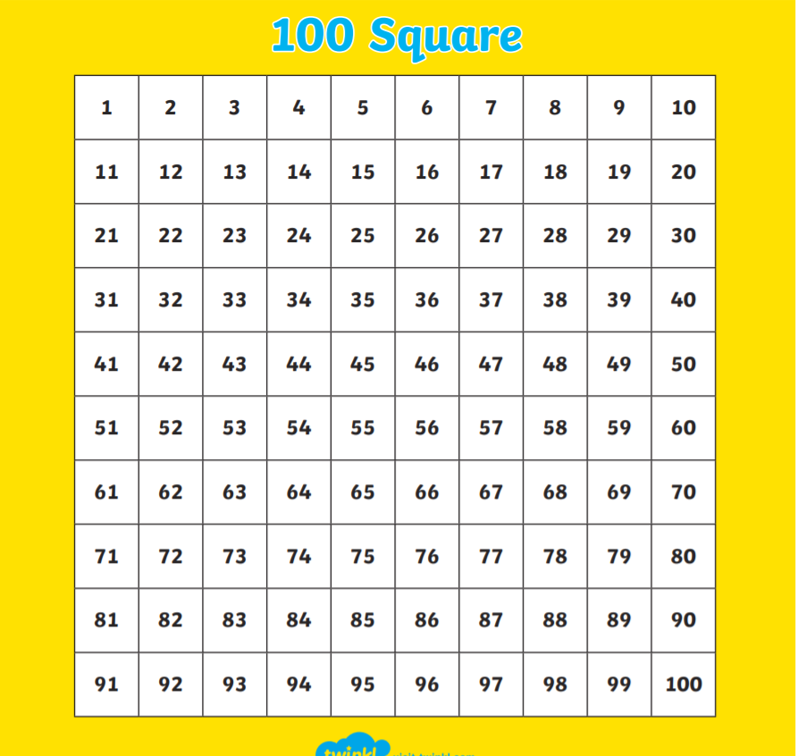

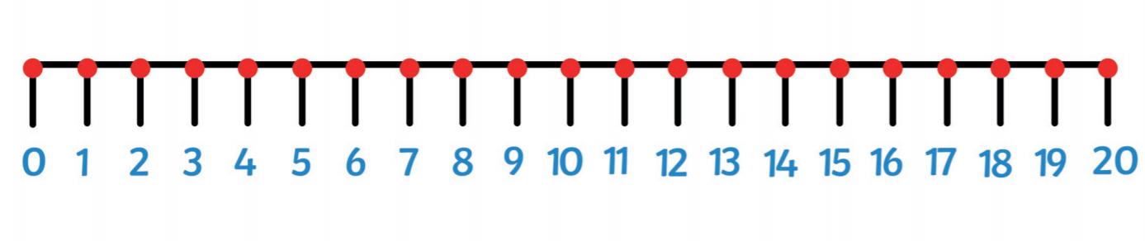

Maths: level 1 challenge
Monday: Can I subtract a one digit number from a two digit number using a number line?

11 - 6 =

14 - 3 =

17 - 5 =

19 - 3 =

20 - 10 =

Maths: Level 2 challenge
Monday: Can I subtract a one digit number from a two digit number using a 100 square?

28 - 4 =

29 - 8 =

36 - 5 =

38 - 9 =

45 - 7 =

52 - 8 =

Maths Level 3 additional challenge
Can I subtract a two digit number from a two digit number using shortcuts on a 100 square?
24 - 12 =

36 - 11 =

48 - 15 =

58 - 16 =

English
See story and activity pack.

Phonics
Activity 1: writing

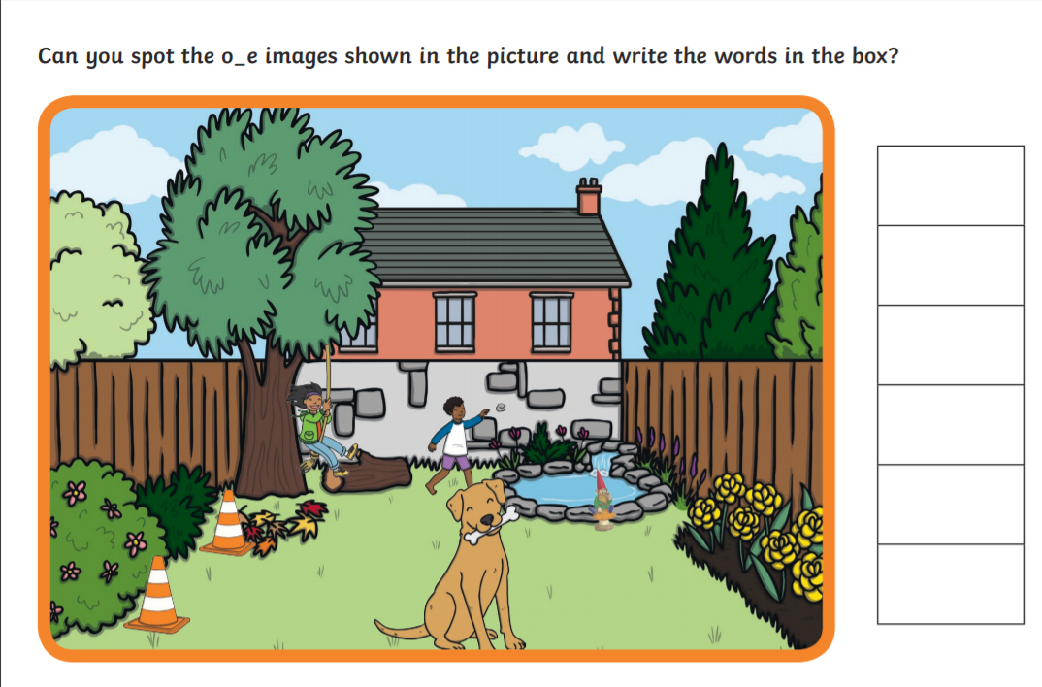

The answers are below

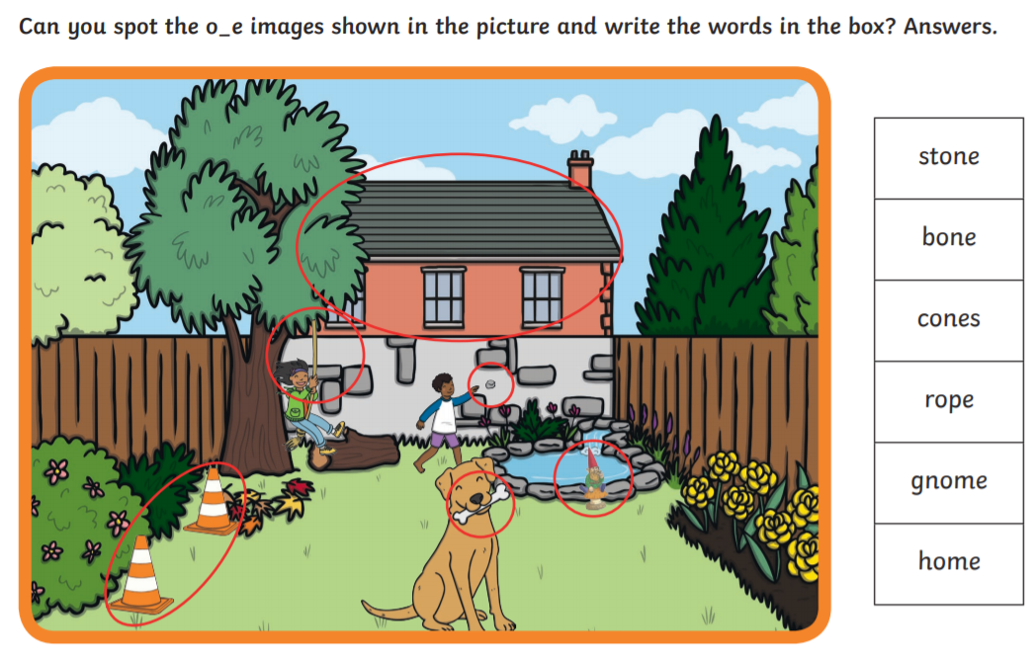

Topic

