Monday 1st February 2021 YEAR 2
Enjoy doing the activities listed.
The order to do them in is suggested below but you can change them to suit you. Please send me any work, photos or comments via Tapestry. Thank you.
MORNING  Let’s get started challenge | Have a change from Joe by trying out these! Make a choice to suit you and how you are feeling!  https://imoves.com/the-imovement
Maths  Learning objective:  All children  Can I write a repeated addition and a multiplication sum for each picture problem?  Some children  Can I learn the x2 table? | This week we will be counting in groups of 2, 5 and 10 and seeing the link between repeated addition and multiplication  To get an idea watch this FIRST teaching video:  https://www.bbc.co.uk/bitesize/articles/zv48cmn  Introduction  - Today we will be looking at counting in groups of 2 and the x2 table.  - First practice counting on in twos.  Repeat it until you are confident  0 2 4 6 8 10 12 14 16 18 20 22 24  - What do you notice about the final digit in each number?  TOP TIP: when counting in groups of 2 the final digit will  always be 0 2 4 6 or 8  - If you are not sure look at it on a 100 square and complete the pattern (see sheet in work below)  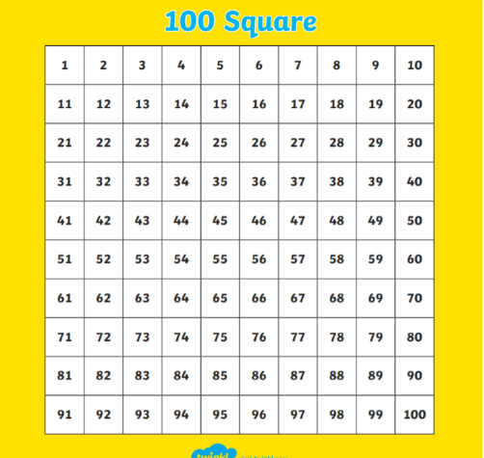  - Look at this question: How many socks altogether?  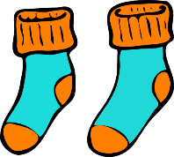  We can work it out by counting aloud in twos  - BUT…. how can we show it as a sum?  We could write  2 + 2 + 2 = 6  OR we could write it as 3 x 2 = 6  Remember: the first number is the number of groups (in this case pairs) and the second number is the number in each group.  - You can also show it like this  +2 +2 +2  0 2 4 6  or as pattern know as an array  3 rows of 2  - Try writing 2 sums for this problem.  First write a repeated addition sum and then write a multiplication sum.  How many socks?  Does your answer look like this:  2 + 2 + 2 + 2 = 8  4 x 2 = 8  Now can you show it on a number line and as an array?  Activities  All children  - Write sums for the pictures as you doing above (see work below).  Most children  - Watch https://www.bbc.co.uk/bitesize/topics/zqbg87h/articles/zc7ygdm  - try the activities on the same page  - learn x2 table using mathletics  go to explore  then videos  then scroll down to x2 song  or this movement times table song!  https://www.bbc.co.uk/teach/supermovers/ks1-maths-the-2-times-table-with-bridget-the-lioness/zrrx92p
English  Learning objective:  Can I write my own verses to finish the poem? | Last week we started a new pack, ‘’Superheroes. The activity pack is on the school website under classes for last Monday 25th January.  Introduction  - Last week you read about some Superheroes and even made your own superhero fact file, symbol and cuffs.  - Imagine your superpower is listening. What would you like to be able to hear?  If I had one I would love to hear what the birds are singing to each other.  - Read the first 2 verses of the poem on page 14 of your ‘Superhero’ pack.  Activity:  Now write 4 verses of your own using your own paper of by filling in the sheet. Use your imagination!
Handwriting/ spellings, grammar, punctuation or phonics  Learning objective:  Can I find out how to use inverted commas? | Introduction  - I have noticed that when you were writing your stories last week some children wrote what the characters were saying. This is called SPEECH.  - When we are writing speech we show that someone is talking through using speech marks. The tem for these is INVERTED COMMAS  - “ ” They look like 66 and 99.  - Today we will find out a little more before practising using them on Wednesday.  Activities  Listen to a song which a class has created by a class https://www.youtube.com/watch?app=desktop&v=k7TZ7lyALjg  Then watch how to write with inverted commas https://www.youtube.com/watch?v=d1HWaT6494w
 | Lunchtime!
AFTERNOON  Reading | Read at least 3 pages of a book or go online to find a story (see reading notes on school website).
Topic  Learning objective:  Can I guess which objects have been magnified?  Y1 : Can I say which part of the body I use to see with? | Introduction:  - Nobody’s tooth seemed to match either so to try again to find the owner of the box we need to look at another clue.  - Clue 5: 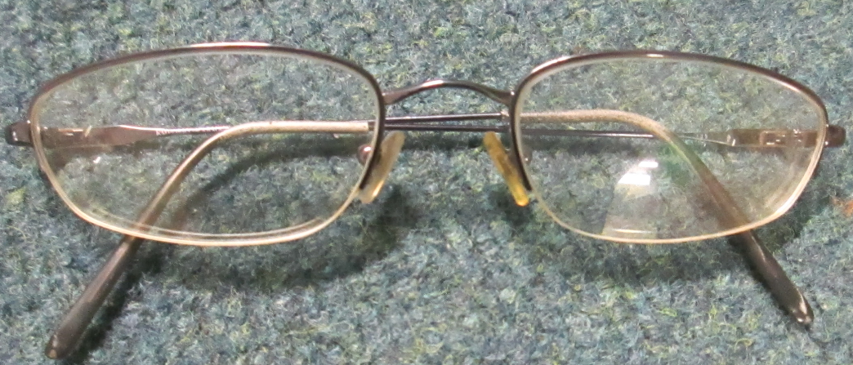 a pair of glasses!  - If we could find out who the glasses belonged to we may be able to find the owner of the box.  - Do you wear glasses? Could they be yours?  - Do any of your family wear glasses? Could it be them?  - Why might you wear glasses? If you were finding it difficult to see you would go to an opticians to have them checked using a sight chart like this  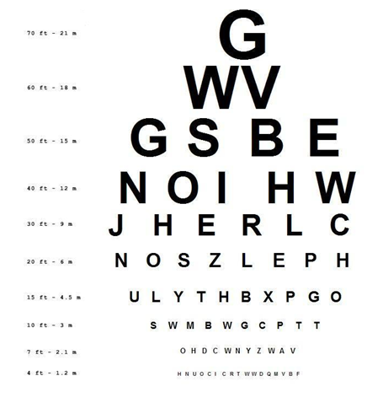  - You may be able to download one from the internet and try it out!  - Now let’s think just about EYES  - Not only can we use glasses to help us see better but also a magnifying glass. A magnifying glass helps us to see things in a lot of detail.  Activity.  Complete the sheet below  If you have a magnifying glass use it to look carefully a things inside or outside
Story/ yoga/ mindfulness activity/ songs | Be kind to yourselves! Do what you can!
Additional notes for parents. | If you have any pipe cleaners and crafty materials you could use them in Tuesday’s topic lesson.

.

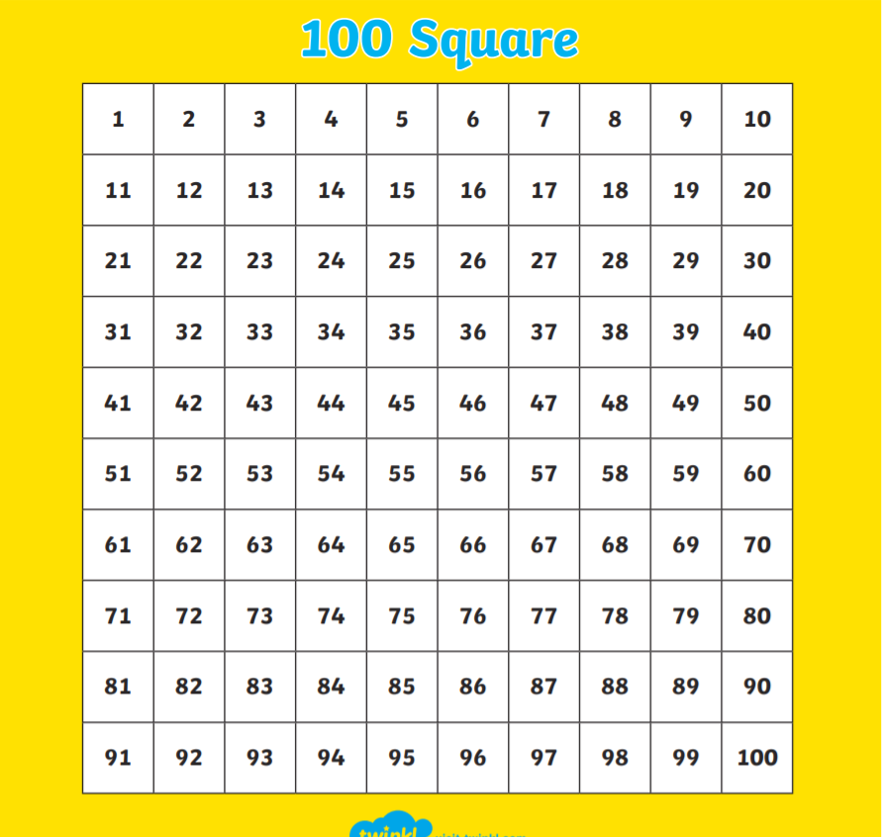

Maths: level 1 challenge
Can I write a repeated addition and a multiplication sum for each picture problem?

How many socks? Here is an example.

2 + 2 + 2 + 2 = 8

4 x 2 = 8

Now your turn.

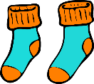

Draw the socks to match this sum: 7 x 2 =14

Maths: Level 2 challenge
Mathletics – learn x 2 table

Topic

