Monday 1st February 2021 YEAR 1
Enjoy doing the activities listed.
The order to do them in is suggested below but you can change them to suit you. Please send me any work, photos or comments via Tapestry. Thank you.
MORNING  Let’s get started challenge | Have a change from Joe by trying out these! Make a choice to suit you and how you are feeling!  https://imoves.com/the-imovement
Maths  Learning objective:  All children  Can I count in groups of 2 to at least 20?  Some children  Can I use what I know about counting in twos to solve problems? | This week we will be counting forwards in groups of 2, 5 and 10. This will help you with multiplication in year 2.  For this lesson you may find it useful to have somethings to count with e.g. buttons, counters or even pairs of socks!  Introduction  - We can count in ones but it is much quicker to count in groups. Today we will be counting in groups of 2  - First we will learn how to count in twos and the numbers you land on and then you can use what you have learnt.  - Use the number line to count in twos.  - Start at 0 and each time make a jump of 2.  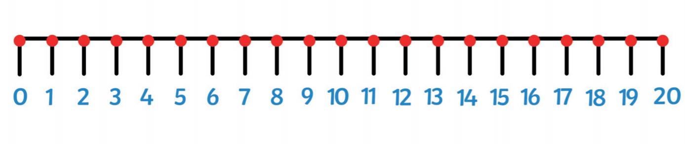  - Can you continue counting in jumps of 2 on the number line below?  Top tip: make sure you miss a number out each time.  - What numbers do you land on? Say them lots of times until they are fixed in your head.  - Now turn the number line over. Can you still say the numbers you would land on if you counted in twos?  Go to activity 1  OR  - If you would like another challenge try the same thing on a 100 square. This time colour the squares that you land on.  - What do you notice?  Top tip: when you count in twos the last digit will always be  0 2 4 6 or 8  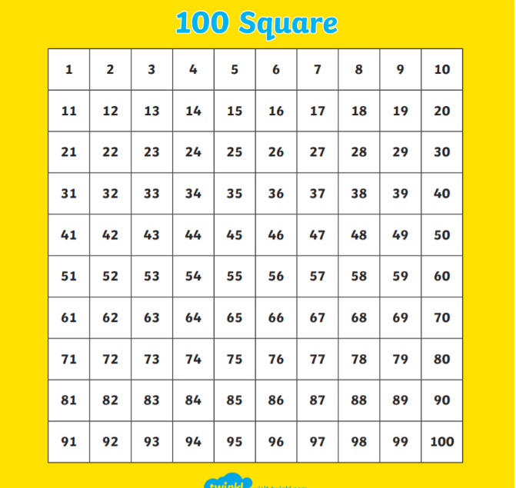  Activities  All children  - Watch https://www.bbc.co.uk/bitesize/articles/zkjv382  - Get out some socks and put them into pairs. Count the number of socks each time by counting in twos  Or put objects into groups of 2 and count them.  - Practise counting aloud in twos 0 2 4 6 etc.  - Try the first maths challenge below.  Some children (if you are confident in counting in twos)  - You may like to extend your learning further by watching the second video  - Try the sheets below.
English  Learning objective:  Can I write at least one sentence with a capital letter and a full stop? | Last week we start a new story, ‘Sidney Spider’. The story and activity pack is on the school website under classes. .  Introduction  - Last week we started a new story- ‘Sidney Spider’.  - We read a story and looked at a poem/ song.  - Today and tomorrow we will be looking at another type of writing i.e. a letter and thinking about how to write in sentences.  - Have you ever written a letter e.g. to Father Christmas?  - Have you ever received a letter?  - On page 11 of the ‘Sidney the Spider’ pack Sidney has written a ‘Thank You’ letter to his spider friends. Read the letter with a grown up.  What has he forgotten to do? Yes he has forgotten to write in sentences with a capital letter at the start and a full stop at the end. (Don’t put the punctuation today until we have learnt a bit more)  - Let’s remind ourselves how to write in sentences by doing the activities below. https://www.bbc.co.uk/bitesize/articles/zdh2dp3  Activity:  - Watch the video on https://www.bbc.co.uk/bitesize/articles/zdh2dp3  - Try activity 1 on the same webpage.  (If you would like to you could try activity 2).  - Now have a go at writing your own sentences about this picture.  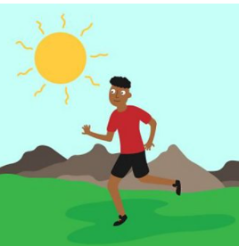  Remember  Capital letter to start.  Full stop to finish  Check it makes sense.  You can write on your own paper or use the guidelines below
Handwriting/ spellings or phonics  Learning objective:  Can I use the or sound to read and spell? | Introduction:  - Recap these sounds by cutting up the sound cards below and sorting them into sound groups e.g. ai/ay/a-e.  Top tip keep these cards for another day  ai ee igh oa oo  ay ea ie ow ue  a-e e-e i-e o-e u-e  - The or sound can be made by or  - Try reading these words:  short fork cork  - What do you notice about where the or sound is in the word? Yes it is in the middle. Try and remember this spelling rule.  Activities –  - Watch Mr Thorne does phonics – or sound to recap  https://www.youtube.com/watch?v=33kvsqyOYdg  - Complete the sheet below  Can you find the or sounds in the writing? Read carefully and highlight all the words with or in.  - Write the words for these pictures:  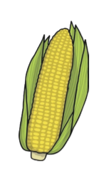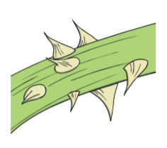  ………………………… ………………………. ……………………..
 | Lunchtime!
AFTERNOON  Reading | Read at least 3 pages of a book.
Topic  Learning objective:  Can I guess which objects have been magnified?  Y1: Can I say which part of the body I use to see with? | Introduction:  - Nobody’s tooth seemed to match either so to try again to find the owner of the box we need to look at another clue.  - Clue 5: 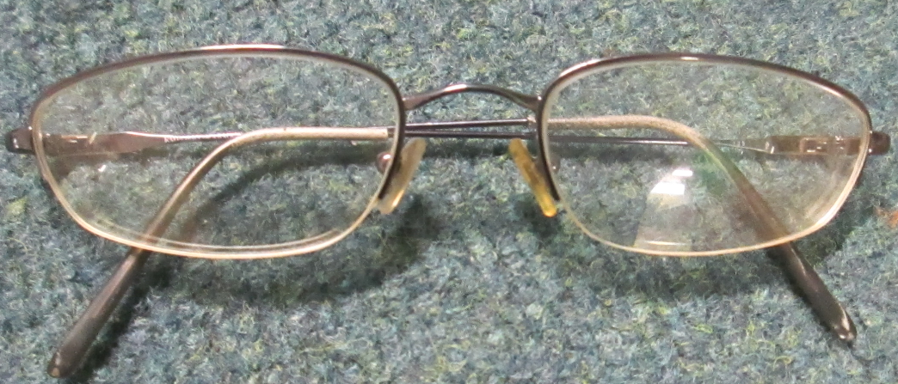 a pair of glasses!  - If we could find out who the glasses belonged to we may be able to find the owner of the box.  - Do you wear glasses? Could they be yours?  - Do any of your family wear glasses? Could it be them?  - Why might you wear glasses? If you were finding it difficult to see you would go to an opticians to have them checked using a sight chart like this  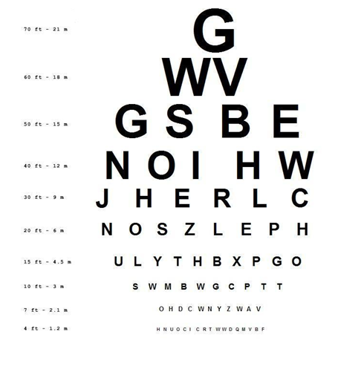  - You may be able to download one from the internet and try it out!  - Now let’s think just about EYES  - Not only can we use glasses to help us see better but also a magnifying glass. A magnifying glass helps us to see things in a lot of detail.  Activity.  - Watch this brief introduction to SIGHT:  https://www.bbc.co.uk/bitesize/clips/z2yd2p3  - Complete the sheet below  If you have a magnifying glass use it to look carefully at things inside or outside
Story/ yoga/ mindfulness activity/ songs | Be kind to yourselves! Do what you can!
Additional notes for parents. | If you have any pipe cleaners and crafty materials you could use them in Tuesday’s topic lesson.

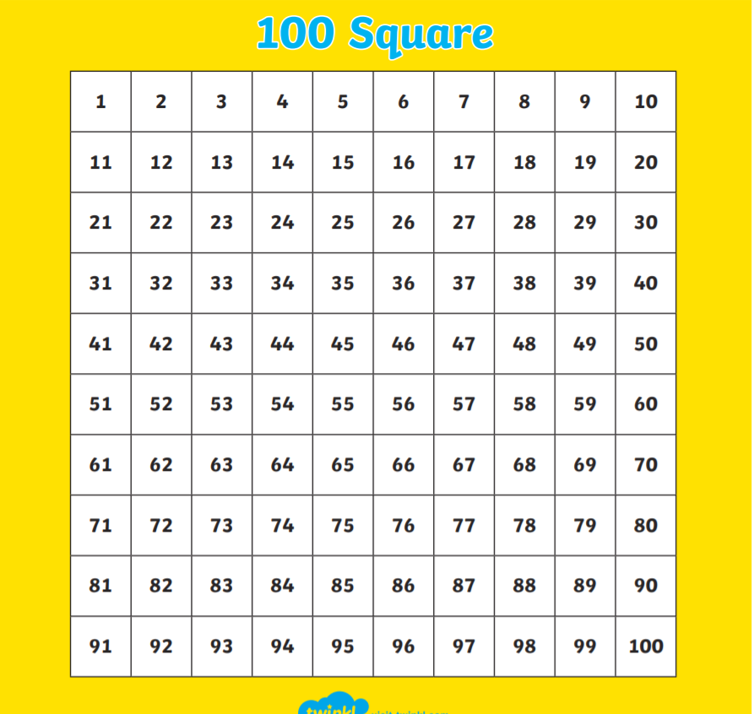

Maths: level 1 challenge
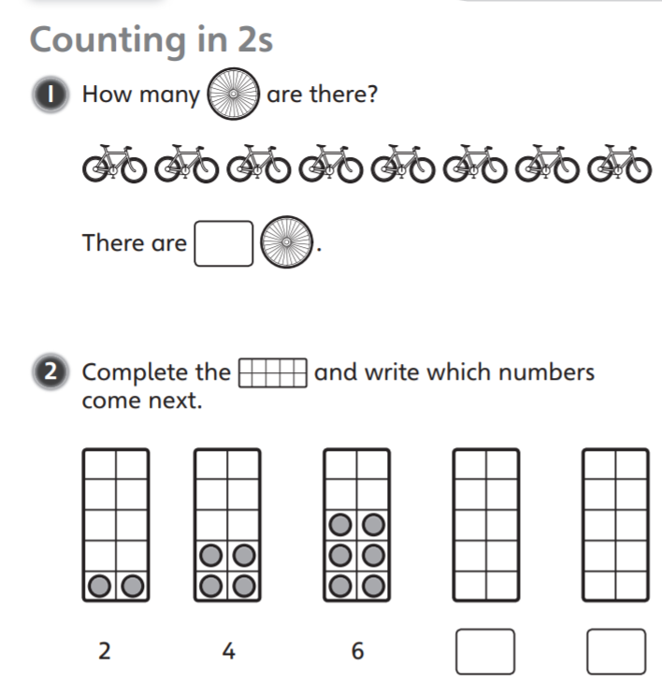

Maths: Level 2 challenge
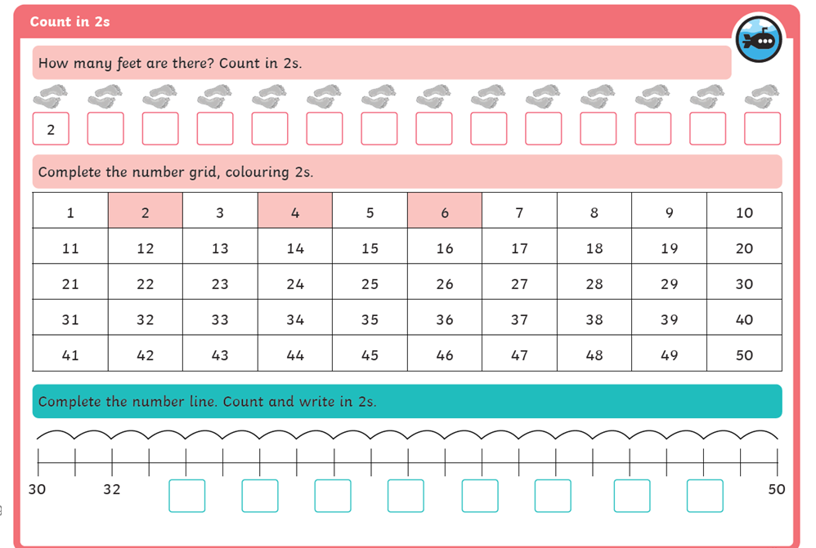

English
Can I write at least one sentence with a capital letter and a full stop?

_____________________________________________________________________________

_____________________________________________________________________________

_____________________________________________________________________________

______________________________________________________________________________

Phonics
Activity 1: sorting into groups

ai ee igh

oa oo ay

ea ie ow

ue a-e e-e

i-e o-e u-e

Topic

