W/c 25.01.21
Miss Dorr’s letters and sounds
Over this week I would like you to look at ur, er and ir.
Think about this ‘ur’ sound – Can you think of any words with this ‘ur’ sound in? You could write them down into a list, can you think of 3?
Here are some that I have come up with –
- Fur
- Burn
- Surf
- Turn
- Hurt
- Curl
Have a go at writing them – this could be done by doing write, cover and check, in different colours or you go outside and write them with chalk, sticks or stones.
Once you have done this, have a go at putting 2 words into a sentence(s), remember everything that you need to include! You could also draw a picture to go with your sentence.
Think about this ‘er’ sound – Can you think of any words with this ‘er’ sound in? Write them in a list, can you think of 5?
Here are some that I have come up with –
- Dinner
- Farmer
- Summer
- Under
- Cover
- Finger
- Her
- Winter
Have a go at writing the ‘er’ words which I came up with, you can add them to your list if they are different! Now you should have a long list of ‘er’ words – can you draw a picture next to every word showing what they mean. Make sure you add lots of colour!
Think about this ‘ir’ sound – Can you think of any words with this ‘ir’ sound in? Write them down into a list, how many can you think of?
Here are some that I have come up with –
- First
- Shirt
- Skirt
- Bird
- Girl
- Dirty
- Stir
See if you can put the words ‘bird’ and ‘first’ into a sentence(s).
I have attached a sheet for you to have a go at – write down what the picture is of in the box next to it, remember it will have one of the three sounds which we have learnt this week.
You can also go onto ‘phonics play’ once you are on, click ‘resources’ and you then can either pick ‘buried treasure’ or ‘dragons den’ once you have picked the game, click on phase 5 and then the ‘ir’ sound. Here is a link to the website - https://www.phonicsplay.co.uk/
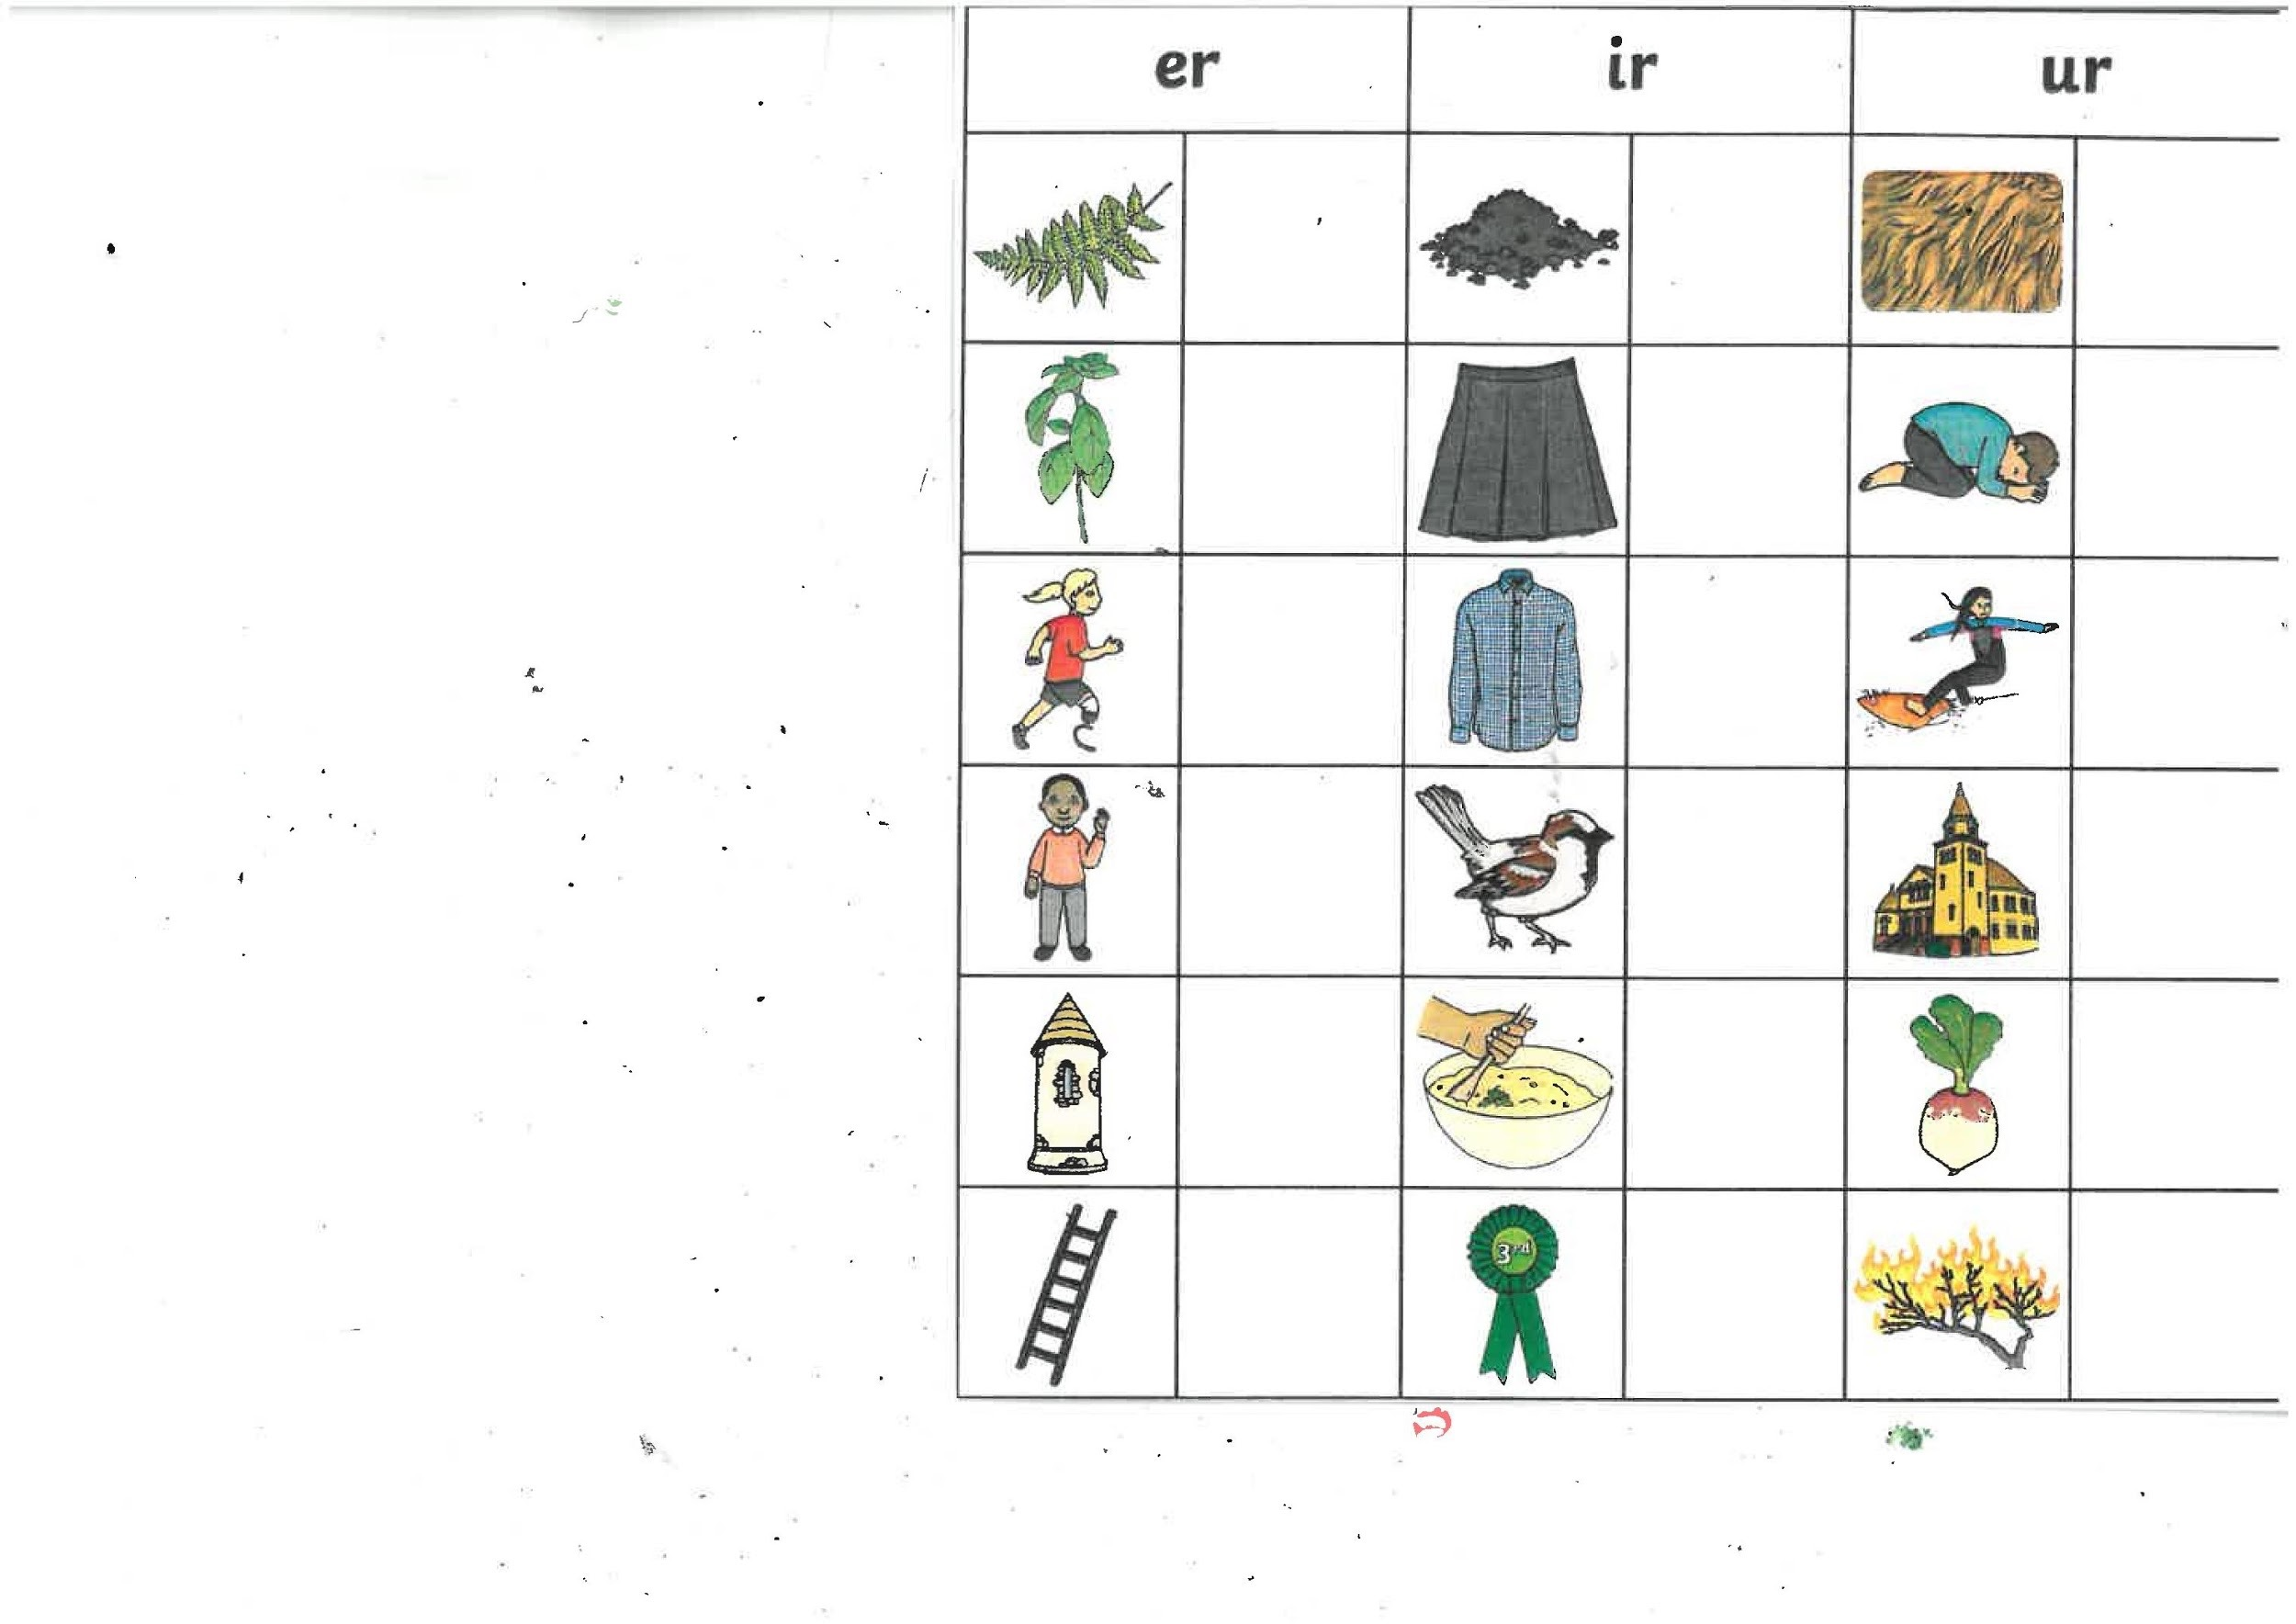
Please send what you have done to the Rowan class email so that I can see what you have been doing. Miss Dorr ☺

