Friday 29th January 2021 YEAR 1
Enjoy doing the activities listed.
The order to do them in is suggested below but you can change them to suit you. Please e mail me any work, notes, photos or comments. Thank you.
MORNING  Let’s get started challenge | 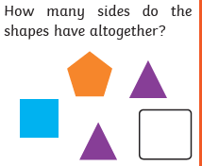
Maths  Learning objective:  Can I show my understanding of subtraction by completing some activities? | Introduction:  - What have you learnt so far about subtraction? Answer these questions:  What happens to the answer?  What is another word for subtracting?  Can subtracting be done in any order e.g. is 2- 1 the same as 1-2?  - Challenge day! Now put your knowledge into action.  TOP TIP: Remember to use a number line, 100 square or an empty number line to help you.  Activities  Try the rest of the activities and the quiz on  https://www.bbc.co.uk/bitesize/topics/zwv39j6/articles/ztpmrwx  or  https://www.bbc.co.uk/games/embed/karate-cats-2?exitGameUrl=https%3A%2F%2Fbbc.co.uk%2Fbitesize%2Farticles%2Fzf4sscw  choose addition and subtraction
English  Learning objective:  Can I sing the song ‘Incy Wincy Spider’ and make up some actions to go with it? | Introduction  - In the story Mrs Brown liked to sing a song ‘Incy Wincy Spider’.  - Do you know the words?  - Do you know any other songs about spiders?  Activity :  - Read the poem on page 10  - Listen to the song.  - Make up some actions to go with it.  - If you would like to complete the picture below.
Handwriting/ spellings or phonics  Learning objective:  Can I use my sound and spelling knowledge to play a game? | Introduction:  - Recap these sounds against the clock. How long does it take you to say the sounds correctly? Can you beat Monday’s time?  - GET READY, GO!  ai ee igh oa oo  ay ea ie ow ue  a-e e-e i-e o-e u-e  - Write out each sound on a piece of paper. Now put them into sound families – all the ai sounds together etc. you should have 5 piles.  - Talk to a grown up about the spelling rules you remember.  Activities – choose the sounds that you are least confident in to practise.  http://www.ictgames.com/mobilePage/forestPhonics/index.html
 | Lunchtime!
AFTERNOON  Reading | Choose one of your own books to read or read a book online.
FOREST SCHOOLS | It is good to be outside for many reasons. It helps us to keep our minds and bodies healthy.  Being outside can also present challenges we may not get inside so it is good to help us with building confidence, perseverance and solving problems.  Can you think what you like most about being outside with nature?  You may have some ideas of things you would like to do, such as build a den.  Here are some suggestions for the next 3 weeks which you can pick and choose from depending on the weather.  - Create a hanging ice sculpture.  Choose a container e.g. an old ice cream container and put some water in it.  Now add a piece of string so that the string is partly in the water and partly hanging over the side.  Collect some pieces from your garden eg delicate leaves, interesting sticks and put them in your water.  Put it outside to freeze overnight. (If the temperature doesn’t go low enough you may have to put it in the freezer).  Then carefully take it out and hang in a tree.  - Make a bird cake.  Don’t worry, no baking is required. This quick and easy treat is packed full of energy to keep birds going, especially important in cold weather. Design your own recipe or use whatever’s to hand.  Ideal ingredients  - sunflower hearts  - peanut pieces and other bird seed mixes  - dried fruits softened with water  - crumbled or grated cheese  - cooked rice and other leftovers  - breadcrumbs.  Don’t’ use  - uncooked rice  - nuts  Method  - Combine your chosen ingredients in a bowl and add softened lard or dripping  - Mix together into a firm paste. For best results you’ll need to get your hands in there – a great activity for kids, if a bit messy!  - Pierce the bottom of a clean yoghurt pot and poke a length of string through  - Knot securely on the inside of the pot so that it hangs upside down like a bell  - Fill with the fat mixture and hang outside  - Pretend to be an nature pirate  How much hidden loot can you fit in your miniature treasure chest? Search for tiny natural items in your garden and see who can fit the most inside a matchbox or other small container. Look out for mini discarded snail shells, tiny twigs, small shiny pebbles and little petals and leaves. Set a time limit and see who will be the winner!  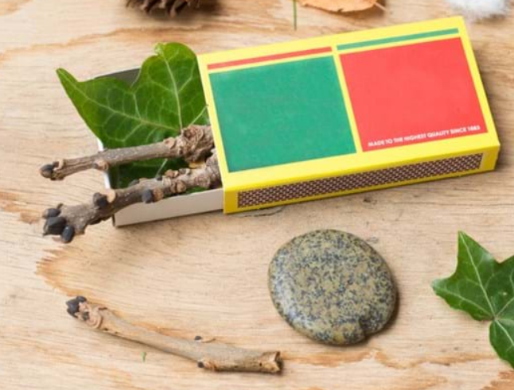  https://www.woodlandtrust.org.uk/blog/2020/03/nature-detectives/  or take part in the RSPB Big Garden Birdwatch  https://www.rspb.org.uk/get-involved/activities/birdwatch/
Additional notes for parents. | Enjoy your weekend!  This weekend is the Big Garden Birdwatch organised by the RSPB  You may like to take part https://www.rspb.org.uk/get-involved/activities/birdwatch/  Check the egg experiment!

Please send your completed work to me at willow@lyng.norfolk.sch.uk so I can enjoy seeing what has been done and give top tips and feedback as necessary.

Let’s get started challenge
English
