w.c.6.7.20
Hello Willow Class children and parents.
It looks like we all enjoyed being creative last week inside and out. In school we made some very colourful Maasai jewelry and even tried making mini Maasai mud huts which was very messy and not as easy as we thought!
I have also seen some super photos of you being creative.
Next week we are focusing on African music and masks. It is also Art Week on Bitesize Daily Online with music, drama and art themed lessons. On Thursday the English national Opera shows how singing can help your well-being and on Friday find out how to get creative using classical music.
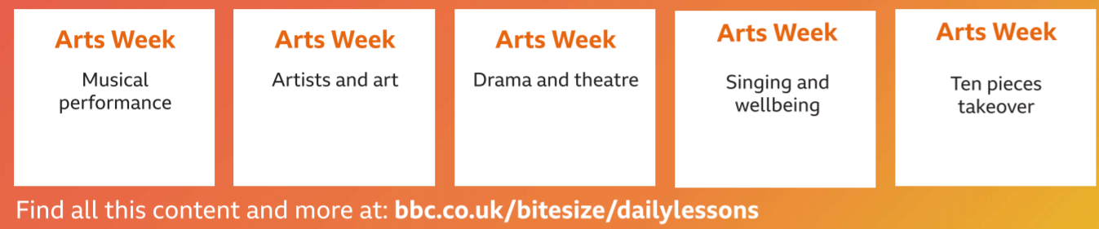
You may like to dip in and see some live sessions. It may even inspire some music making with your home made junk musical instruments!

Good Luck with your music making next week. I look forward to hearing all about it.

Best wishes
Mrs Tebbutt

