Maths – see the attached pictures for an example of how to solve the problems.  **Please also encourage your child to access Mathletics daily on top of the work set** | Monday | Daily practise of a times table of your choice – choose a table that you find tricky.  Roman Numerals booklet Nero’s Numbers  And  One of the Roman Numeral challenges.
 | Tuesday | Daily practise of a times table of your choice – choose a table that you find tricky.  Roman Numerals booklet Nero’s Sundial (both pages)  And  One of the Roman Numeral challenges.
 | Wednesday | Daily practise of a times table of your choice – choose a table that you find tricky.  Roman Numerals booklet Roman Numerals Match  And  One of the Roman Numeral challenges.
 | Thursday | Daily practise of a times table of your choice – choose a table that you find tricky.  Roman Numerals booklet Agrippa’s Vases  And  One of the Roman Numeral challenges.
 | Friday | Daily practise of a times table of your choice – choose a table that you find tricky.  1 round of Maths Frame times tables check. Note down your score.  Roman Numerals booklet Be The Teacher  And  One of the Roman Numeral challenges.
Spellings | Throughout the week | Please learn the tricky words we would have learnt in Summer 1 and Summer 2  Ideas: Use in sentences, find meanings in a dictionary, use an online word search generator to create a word search.  Summer 1 Summer 2  though notice quarter length library famous describe mention answer appear actually extreme February certain height history imagine increase interest important
English  **Please also encourage your child to read daily either independently or to an adult or older sibling** | Monday | Order the list on p. 2 and add your own ideas to it.  Complete the tasks on pages 3 and 4.
 | Tuesday | Complete the simile tasks on pages 5 -7
 | Wednesday | Complete the metaphor tasks on pages 7 -9
 | Thursday | Eye spy poems pages 9-10
 | Friday | ‘I didn’t know I’d miss’ poem pages 10 – 11.
Topic/PSCHE | Geography | https://www.youtube.com/watch?v=rJrVP43MZYI  Watch the video about fjords in Norway.  Imagine you are on holiday in Norway. Write a letter or a postcard to a friend or family member telling them what a fjord is and what they look like.  Design a picture on the front of a fjord for the front of your postcard.
 | Science | https://www.bbc.co.uk/iplayer/episode/p089zkjn/bitesize-79-year-olds-week-9-2-fossils  Watch David Attenborough’s lesson about fossils. Write down anything interesting that you find.  Can you draw some pictures of fossils? Or try and find a fossil in the garden or on the beach?
PE | Activity 1 | Joe Wicks workout
 | Activity 2 | Cosmic Kids Yoga – the favourites in my hub have been Pokémon, Minecraft and Harry Potter!
 | Activity 3 | Real PE:  The website address is: home.jasmineactive.com  Parent email: parent@lyngcofepr-1.com  Password: lyngcofepr
Art/Crafts | Activity 1 | Research the artist Edvard Munch and have a look at some of his paintings.  Can you recreate your own ‘The Scream’ painting?  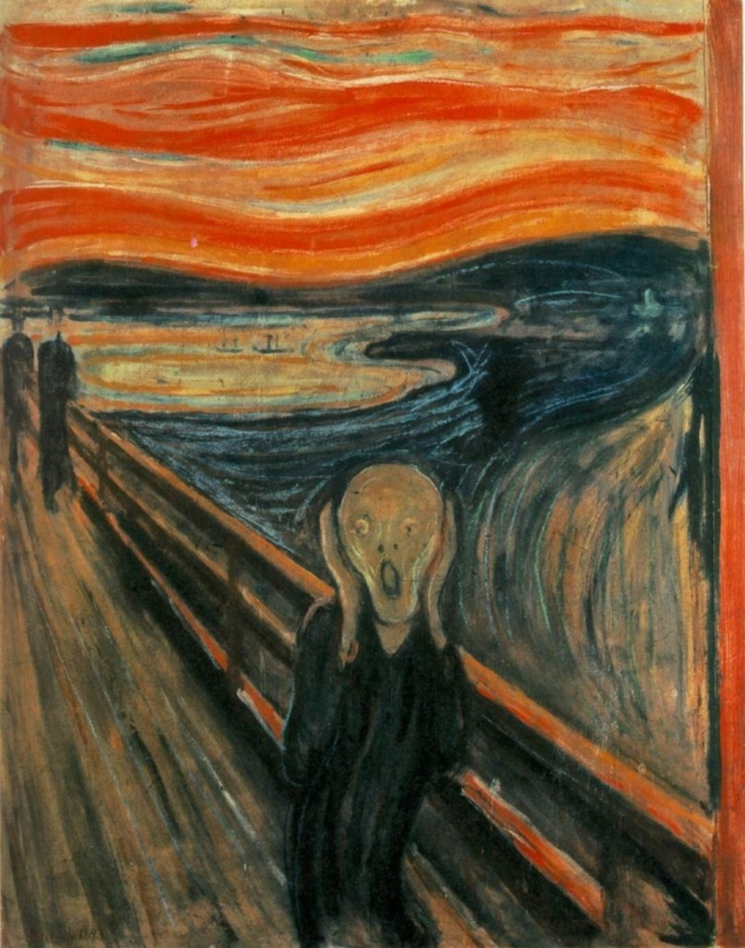
 | Activity 2 | https://www.nhm.ac.uk/discover/craft.html  Complete one of the craft activities from the Natural History Museum.

