Maths | Monday | This week we will be recapping multiplication. Today x2 table.  We will be exploring different ways of working out multiplication sums and then in future you can choose the way which suits you best. Here are some different ways to work out multiplication:  - 3 x 2 =6 is the same as 2+2+2 =6  +2 +2 +2  0 2 4 6  - Arrays 3 rows of 2  - Know your x2 table by heart!  - X 2 is the same as doubling  - Remember x2 table answers will always end in 0, 2, 4, 6,8  - It can be done in any order i.e 3 x 2 = 6 2 x 3 = 6  - It can be checked by dividing e.g. 3 x 2 = 6 6 ÷ 2 = 3  Watch https://www.bbc.co.uk/bitesize/topics/zqbg87h/articles/zc7ygdm or x2 song on mathletics  Now test your knowledge by doing Bitesize activities (above) or mathletics activities  Additional challenge: Use what you know about partitioning to work out a problem beyond 12 x 2  e.g. 24 x 2 =  20 x 2 = 20  2 x 2 = 4  20 + 4 = 24
Maths | Tuesday | Today x5 table.  Here are some different ways to work out multiplication:  - 3 x 5 =15 is the same as 5+5+5 =15  +5 +5 +5  0 5 10 15  - Arrays 3 rows of 5  - Know your x5 table by heart!  - Remember x5 answers will always end in 5 or 0.  - It can be done in any order.  - It can be checked by dividing.  Watch https://www.bbc.co.uk/bitesize/topics/zqbg87h/articles/zw8qxfr or x5 song on mathletics  Now test your knowledge by doing Bitesize activities (above) or mathletics activities  Additional challenge: Use what you know about partitioning to work out a problem beyond 12 x 5  e.g. 23 x 5 =  20 x 5 = 100  3 x 5 = 15  100 + 15 = 115
Maths | Wednesday | Today x10 table.  Here are some different ways to work out multiplication:  - 3 x 10 =30 is the same as 10 +10 +10 =30  +10 +10 +10  0 10 20 30  - Arrays 3 rows of 10  - Know your x10 table by heart!  - Remember x10 answers will always end in 0.  - It can be done in any order.  - It can be checked by dividing.  Watch https://www.bbc.co.uk/bitesize/topics/zqbg87h/articles/zq3rk2p or x10 song on mathletics  Now test your knowledge by doing Bitesize activities (above) or mathletics activities  Additional challenge: Use what you know about partitioning to work out a problem beyond 12 x 10  e.g. 23 x 10 =  20 x 10 = 200  3 x 10 = 30  200 + 30 = 230
Maths | Thursday | Today learn x2 x5 and x10 table off by heart to 12 of each number e.g. 12 x 2 =  Then test yourself against the clock with the loop cards (need to download from school website). Cut each card out and play like dominoes.  Or https://www.twinkl.co.uk/go/resource/multiplication-tables-check-practice-tg-ga-190
Maths | Friday | Challenge day! (sent in by one of the class)  Think of any number. Then double it, then add 10, then divide it by 2, then take away the number you started with.  What is the answer?  Try other numbers.  What do you notice about the number each time?
English  **Please also encourage your child to read daily | Monday | This week we start a new unit: ‘Superheroes!’ Today read pages 3-5. (not the vocabulary challenge)  Discuss superheroes you have read about or seen in films.
English  **Please also encourage your child to read daily | Tuesday | Today the focus will be vocabulary or new words.  Read the new words in sentences at the bottom of page 5 and the top of page 6. Can you work out the meanings by reading the words in context?  Now try matching the word to the correct meaning at the bottom of page 6
English  **Please also encourage your child to read daily | Wednesday | Read the story again or listen to https://soundcloud.com/talkforwriting/playground/s-UJObMpzawKu  What did you think about the story? Fill in your thoughts on page 7.
English  **Please also encourage your child to read daily | Thursday | Today answer the questions on page 8. Remember to answer in complete sentences.
English  **Please also encourage your child to read daily | Friday | Enjoy reading your own books. Maybe you have some stories about superheroes, or maybe you would like to find out more about Kenya or even real life heroes.  There are lots of stories set in Africa. You may like to explore Anansi stories e.g. https://www.youtube.com/watch?v=3CIG6gfl_Xc
contractions | Monday | This week we will recap contractions. Contractions are 2 words which can merge together and some letters are replaced with an apostrophe.  Watch this video to find out more https://www.bbc.co.uk/bitesize/articles/zjwcsk7  Now play the game on ‘small town superheroes’ (go to the Steve section) to complete activity 1.
contractions | Tuesday | To recap contractions watch https://www.youtube.com/watch?v=IJyy4A-rjB4  Today go back to the website from Monday and try activity 2.
contractions | Wednesday | Today go back to the same website and try activity 3.
contractions | Thursday | What can you remember about spelling, punctuation and grammar? Try the activity mat below.
contractions | Friday | Spelling practice – (see spelling box below)
Topic/  Science | Topic 1 | This week we are going to find out about African music and masks.  First listen to some African music e.g. https://www.youtube.com/watch?reload=9&v=W05LPtVm5hY&safe=active  Shut your eyes and picture an African scene in your mind.  In Africa they play many instruments.  Listen to the drums and watch the dancing in this clip  https://www.bbc.co.uk/bitesize/clips/zn6d7ty  Then watch the PowerPoint (download from school website)  Next make your own instrument using recycled materials from around your house or garden, (remember to check first that these can be used and are safe to use). For example you could make a drum. First find a container e.g. an empty tissue box or ice cream container. Next find something to cover it with e.g. some cling film. After that find something to hit it with e.g. a stick and then carefully tap out a beat.  You may have to improve your drum if it doesn’t work very well.
Topic/  Science | Topic 2 | Masks are very important to African culture. Today find out what they look like. Ask a grown up to help you research masks on the internet. Remember how to be safe on the internet.
PE | Activity 1 | Joe Wicks workouthttps://www.youtube.com/channel/UCAxW1XT0iEJo0TYlRfn6rYQ
PE | Activity 2 | Cosmic Kids Yoga https://www.youtube.com/user/CosmicKidsYoga
PE | Activity 3 | Real PE see below
Art/Crafts | Activity 1 | Make a musical instrument – see topic activity 1.
Art/Crafts | Activity 2 | Make a mask using the colours, patterns and shapes you have found out about in your topic activity. You could use paper, card, a paper plate or even a clean milk container (see below)

Weekly spellings
Recap spellings from whole year

REAL P.E.
The website address is: home.jasmineactive.com
Parent email: parent@lyngcofepr-1.com
Password: lyngcofepr

child
children
wild
climb
most
only
even
pass
grass
class
sure

find
kind
mind
behind
both
cold
told
every
everybody
water
half
because
after
sure
could
should
would
who
whole
any
many
people

pretty
beautiful
father
hour
move
prove
improve
clothes
busy
door
floor
poor
fast
last
past
great
break
steak
again
Christmas

Go on a senses walk.
How many things can you see, hear, feel or smell?

Additional maths challenges:
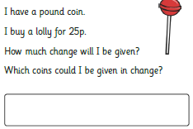
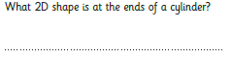
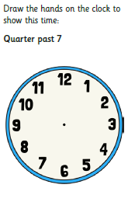

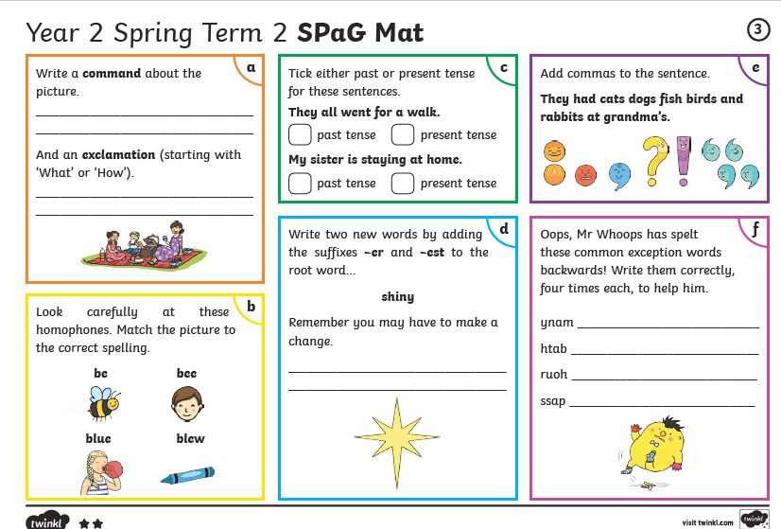
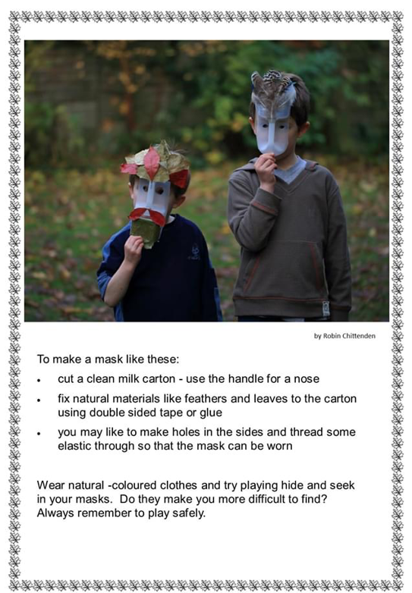
Be careful there are no sharp edges!

