Maths | Monday | This week we will be recapping counting in groups. This will help you in Year 2 to learn your times tables.  Today we will be counting in groups of 2.  Look at the pattern  0 2 4 6 8 10 12 14 16 18 20 22 24  What do you notice about the pattern? What is the last digit when you start counting at 0?  When we count in groups of 2 starting at 0 the last digit is always 0. 2, 4, 6, or 8.  Can you say the pattern aloud? Try saying it in different ways until it is firmly in your memory.  For example, can you say it softly, loudly, angrily, excitedly? Make it fun!  Try now activities below – choose your level!
Maths | Tuesday | Today we will be counting in groups of 10.  Look at the pattern  0 10 20 30 40 50 60 70 80 90 100  What do you notice about the pattern? What is the last digit when you start counting at 0?  When we count in groups of 10 starting at 0 the last digit is always 0.  Can you say the pattern aloud? Try writing it down until it is fixed in your memory.  Try now activities below – choose your level!
Maths | Wednesday | Today we will be counting in groups of 5.  Look at the pattern  0 5 10 15 20 25 30 35 40 45 50 55 60  What do you notice about the pattern? What is the last digit when you start counting at 0?  When we count in groups of 5 starting at 0 the last digit is always 0 or 5.  Can you say the pattern aloud? Try making up some exercises to fix it in your memory e.g. jumping, clapping.  Try now activities below – choose your level!
Maths | Thursday | Today revise counting in groups of 2, 5 and 10.  Watch https://www.youtube.com/watch?v=7AnoVea8UCM&t=55s  Now can you fill in the missing numbers?  First watch https://www.youtube.com/watch?v=Koyb_7No6k8  Then try the activities below.
Maths | Friday | Challenge day! www.nrich.org.uk  Clapping Times  Age 5 to 7  For this activity, you'll need to work with a partner, so the first thing to do is find a friend!  Together count from 1 up to 20, clapping on each number, but clapping more loudly and speaking loudly on the numbers in the two times table, and quietly on the other numbers.  Now clap the five times table together up to about 30, so this time you are clapping more loudly and speaking loudly on the multiples of five and quietly on the others.  If one of you claps the twos in this way and one of you claps the fives, at the same time, can you predict what you would hear?  Which numbers would be quiet?  Which numbers would be fairly loud and which would be very loud?  Now try it - what did you hear?  Were you right?  Choose another pair of tables and repeat what you have just done.  How about the twos and tens?  Why not try the fives and tens?  Each time predict what you will hear before you clap - which numbers will be loud, which fairly loud and which quiet?
English  **Please also encourage your child to read daily | Monday | This week we are starting a new unit: ‘Brian Bear’s Picnic’.  Today read the story on pages 3 and 4.  Talk about the story and fill in the sheet on page 5 or write your thoughts on your own paper or sticky notes.
English  **Please also encourage your child to read daily | Tuesday | Read the story again or listen to it https://soundcloud.com/talkforwriting/brian/s-Tdy7BXbHz4i  Today match up who said what on page 6.
English  **Please also encourage your child to read daily | Wednesday | Quiz time! Think about the story. Can you answer the questions on page 7?
English  **Please also encourage your child to read daily | Thursday | Word challenge today! Can you learn the meanings of some new words?  Try exploring the words together on page 8.
English  **Please also encourage your child to read daily | Friday | Enjoy reading your own books. Maybe you would like to find out more about Kenya or read one of the many stories set in Africa. You may like to explore Anansi stories e.g. https://www.youtube.com/watch?v=3CIG6gfl_Xc
Phonics | Monday | Recap n sound. Read these words: never noisy ninety nine  Notice what sound n is making in each word.  Can you use the words ninety or nine to help you write the words for these numbers:  9 19 29 90 99
Phonics | Tuesday | Yesterday the words we looked at had n in them.  Some words have a g before the n which doesn’t make a sound. It is called a silent letter. Try reading these words. Remember not to say g!  gnaw gnat gnome  Try one of the activities below.
Phonics | Wednesday | So far we know that n and gn can make the n sound.  Some words have a k before the n which doesn’t make a sound. It is called a silent letter. Try reading these words. Remember not to say k!  knee knock knight  Try one of the activities below.
Phonics | Thursday | What can you remember about spelling, punctuation and grammar? Try the activity mat below.
Phonics | Friday | Spelling practice – (see spelling box below)
Topic/  Science | Topic 1 | This week we are going to find out about African music and masks.  First listen to some African music e.g. https://www.youtube.com/watch?reload=9&v=W05LPtVm5hY&safe=active  Shut your eyes and picture an African scene in your mind.  In Africa they play many instruments.  Listen to the drums and watch the dancing in this clip  https://www.bbc.co.uk/bitesize/clips/zn6d7ty  Then look at the PowerPoint (download from school website)  Next make your own instrument using recycled materials from around your house or garden, (remember to check first that these can be used and are safe to use). For example you could make a drum. First find a container e.g. an empty tissue box or ice cream container. Next find something to cover it with e.g. some cling film. After that find something to hit it with e.g. a stick and then carefully tap out a beat.  You may have to improve your drum if it doesn’t work very well.
Topic/  Science | Topic 2 | Masks are very important to African culture. Today find out what they look like. Ask a grown up to help you research masks on the internet. Remember how to be safe on the internet.
PE | Activity 1 | Joe Wicks workouthttps://www.youtube.com/channel/UCAxW1XT0iEJo0TYlRfn6rYQ
PE | Activity 2 | Cosmic Kids Yoga https://www.youtube.com/user/CosmicKidsYoga
PE | Activity 3 | Real PE see below
Art/Crafts | Activity 1 | Make a musical instrument – see topic activity 1.
Art/Crafts | Activity 2 | Make a mask using the colours, patterns and shapes you have found out about in your topic activity. You could use paper, card, a paper plate or even a clean milk container (see below).

Weekly spellings
Recap spellings from whole year.
REAL P.E.
The website address is: home.jasmineactive.com
Parent email: parent@lyngcofepr-1.com
Password: lyngcofepr
of
was
has
his
you
no
go
so
by
my

the
a
do
to
me
she
he
we
I
is

are
friend
once
house
our
others
love
school

today
ask
put
push
pull
full
says
were

your
they
here
there
where
come
some
one

Go on a senses walk.
How many things can you see, hear, feel or smell?
hut.

Additional maths challenges:
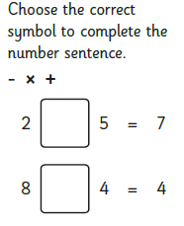
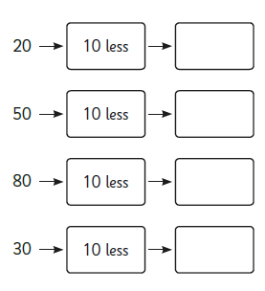
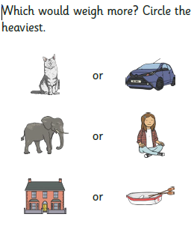
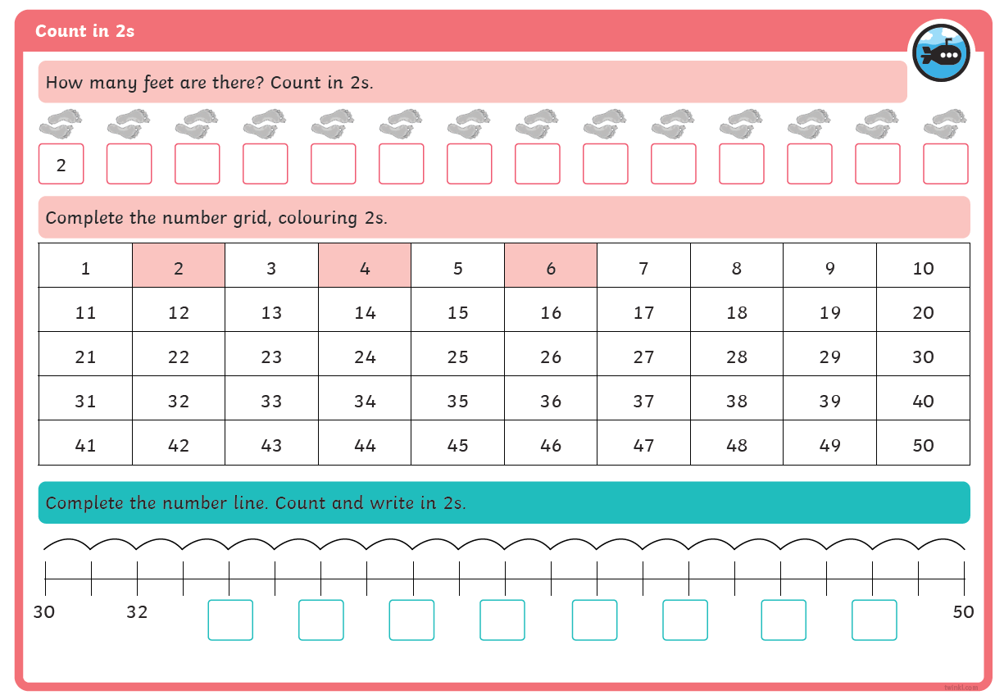
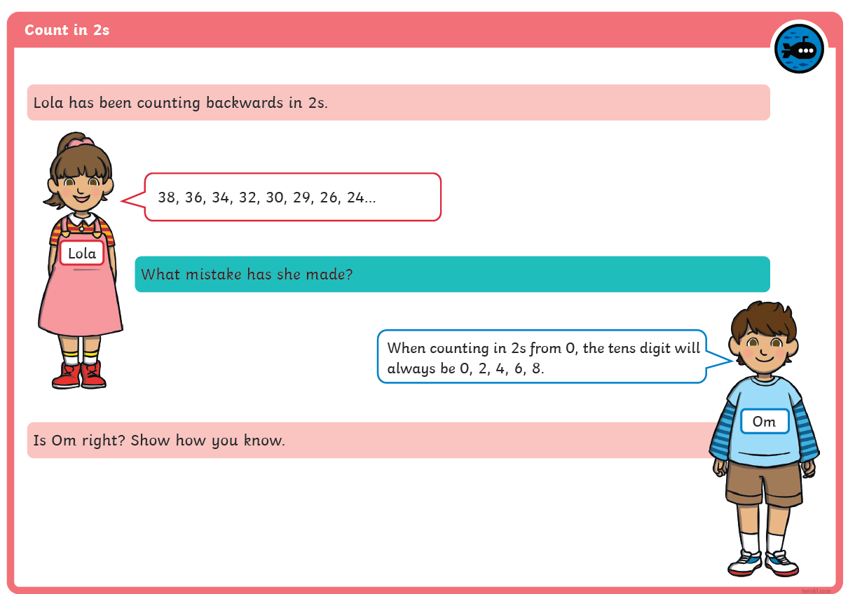
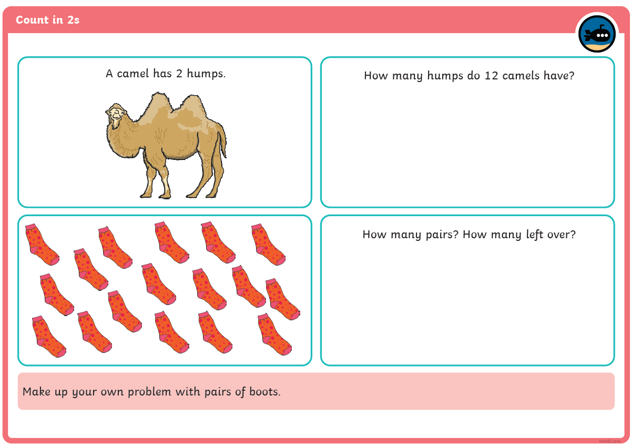
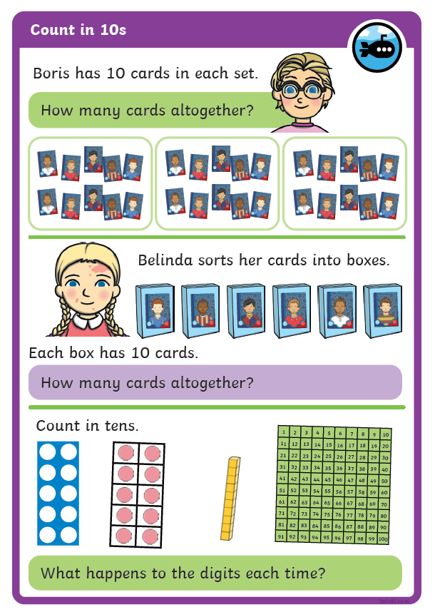
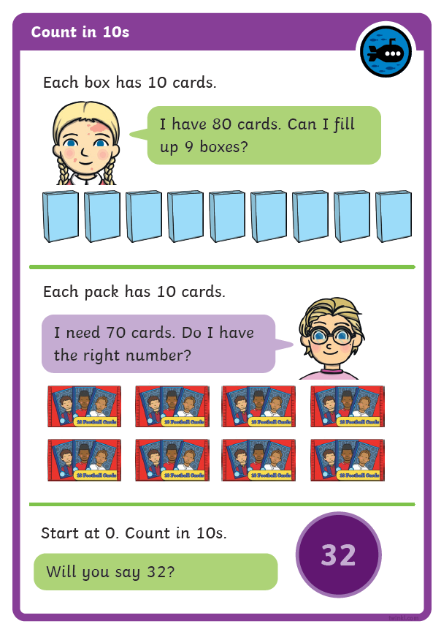
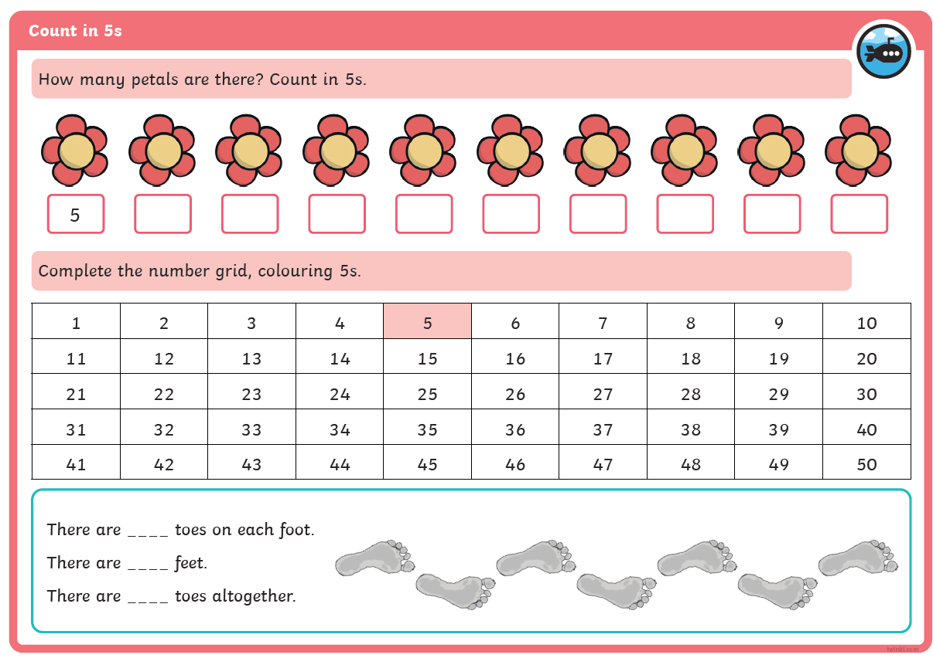
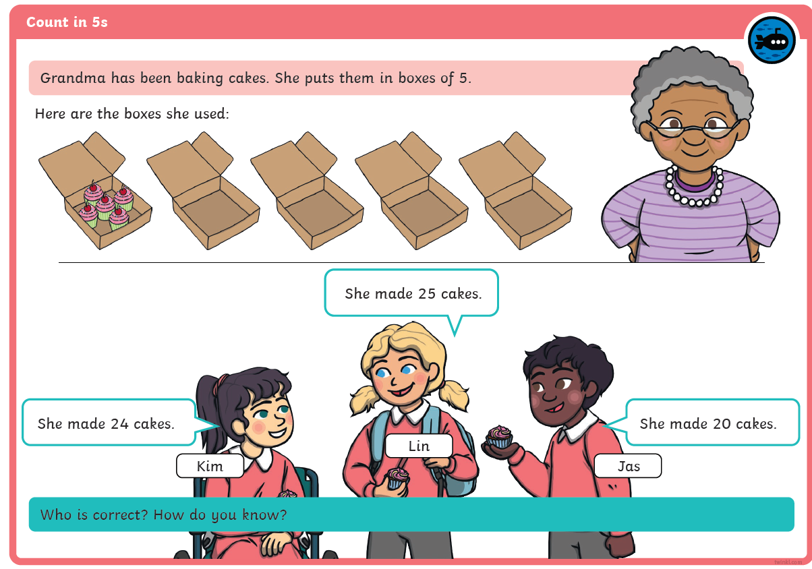
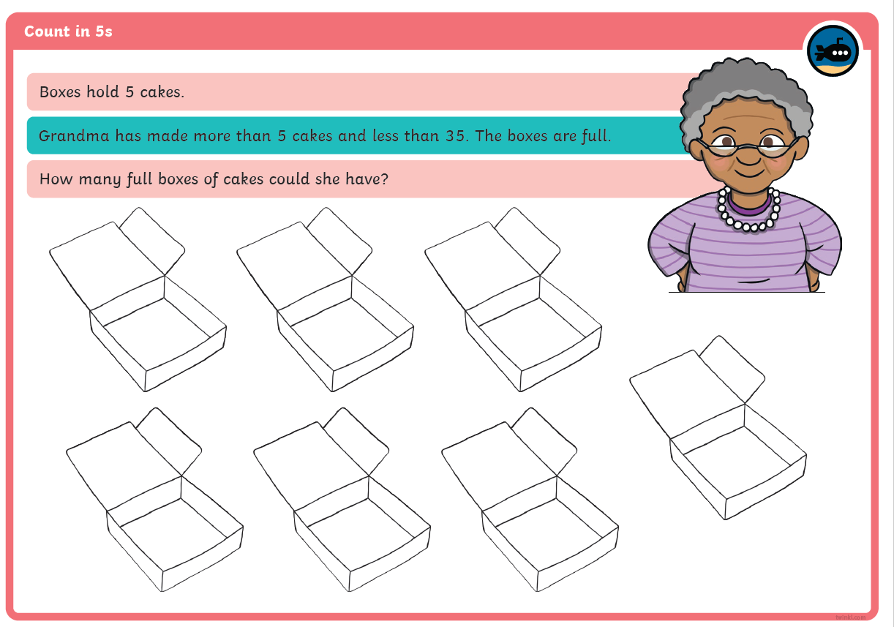
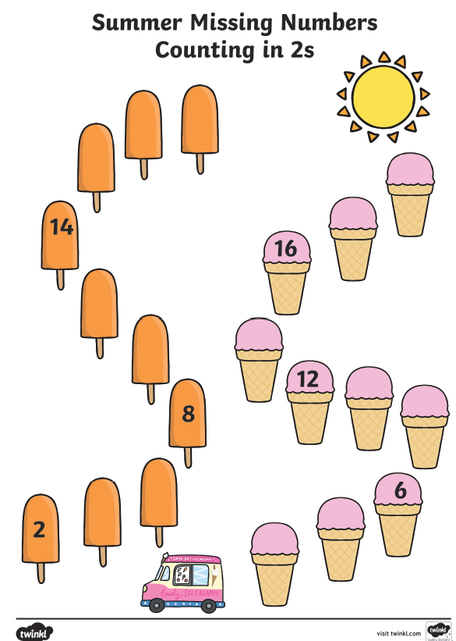
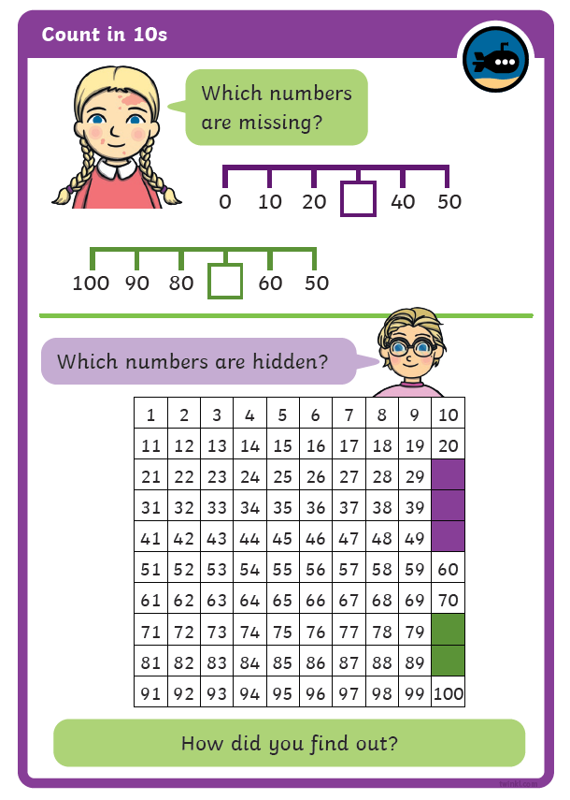
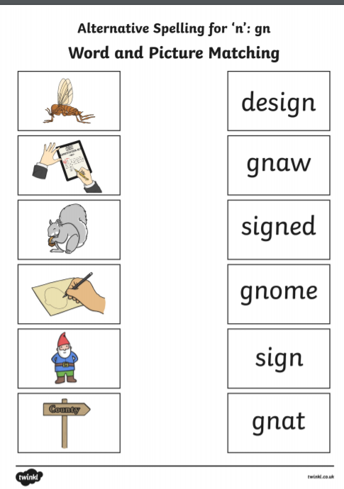
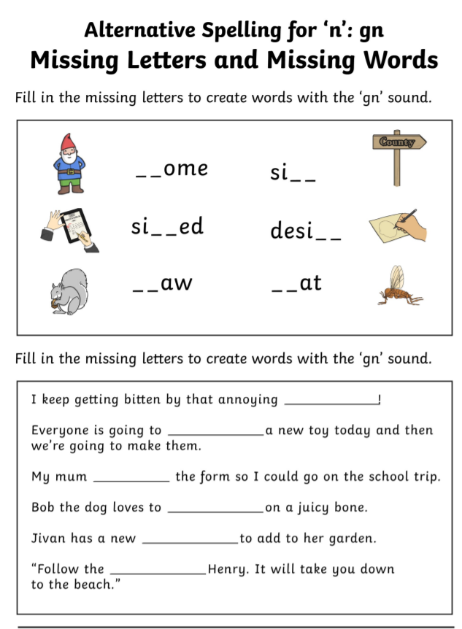
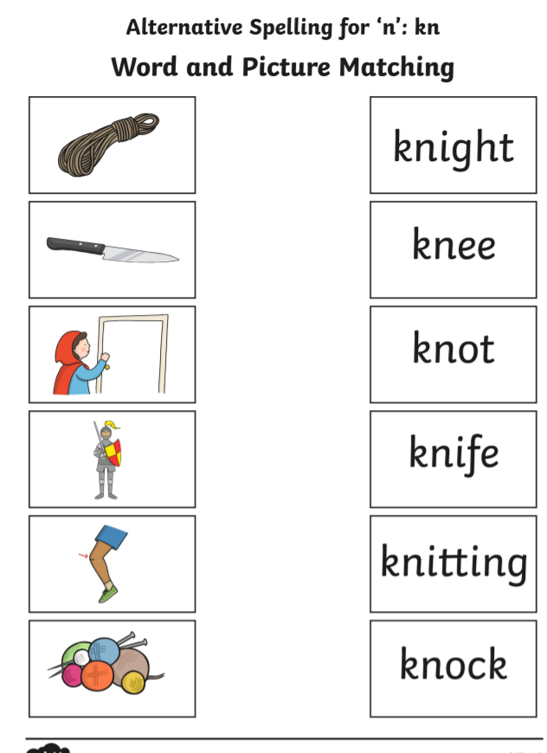
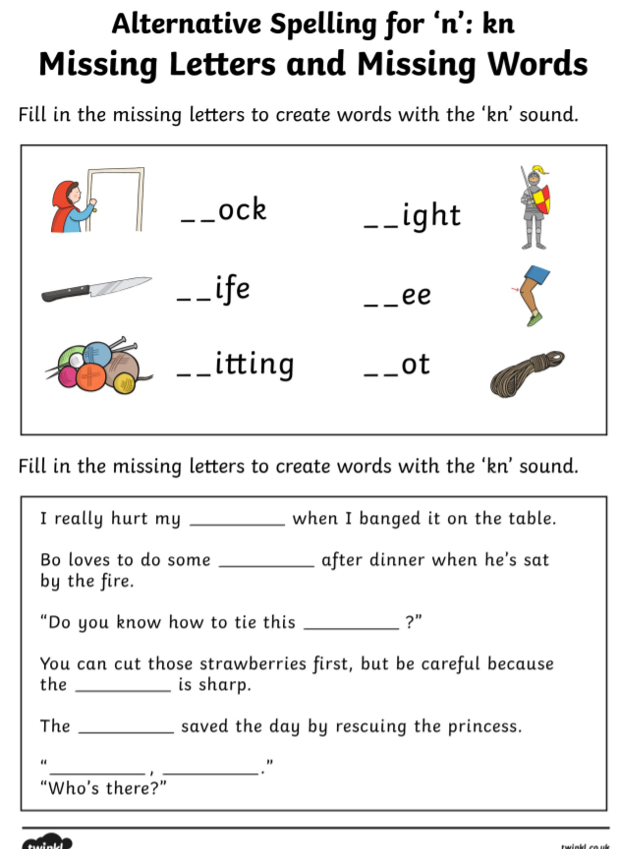

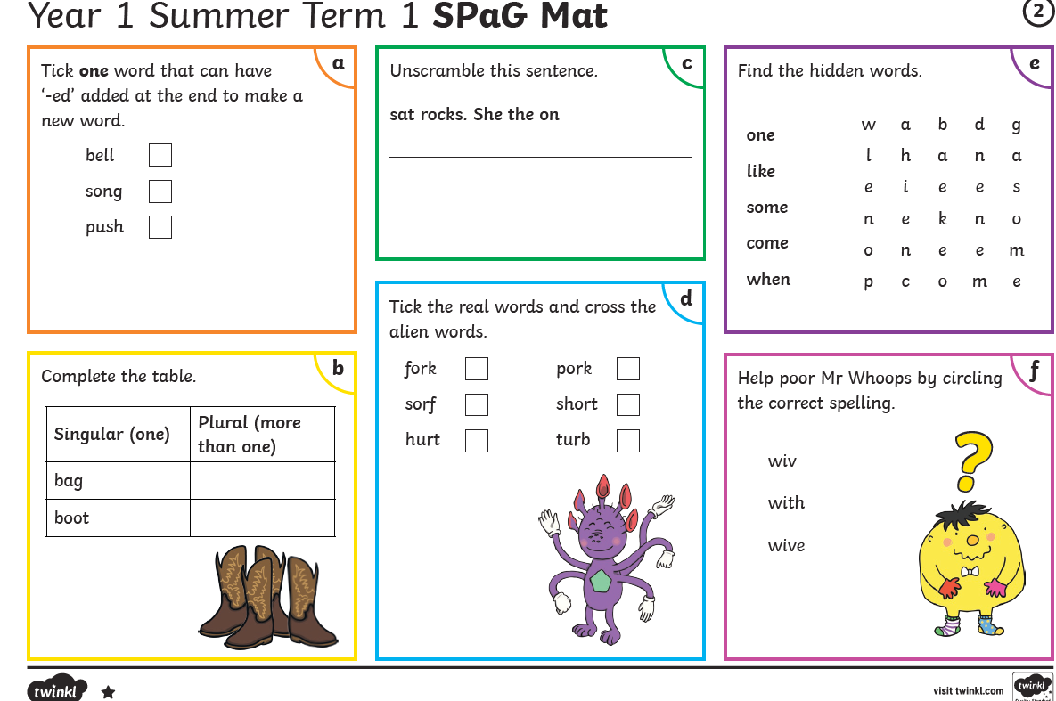
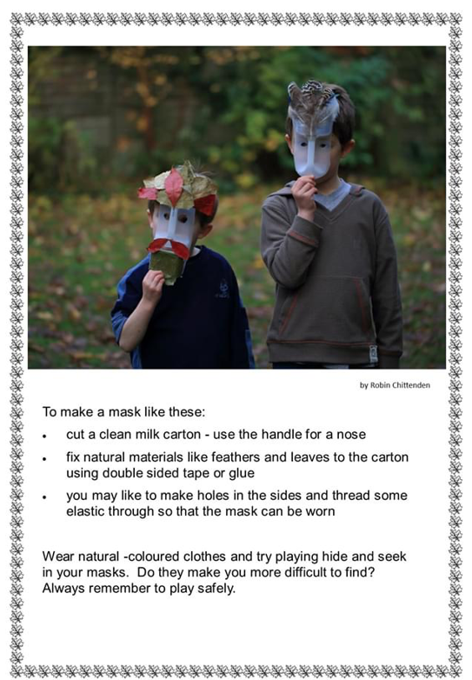
Be careful there are no sharp edges!

