Maths  **Please also encourage your child to access Mathletics daily on top of or to help the work set** | Monday | This week we have maths investigations based on geometry.  Watch a recap here: https://www.bbc.co.uk/bitesize/guides/zx9qh39/revision/2  All Maths work is at the bottom of the sheets:  Remember extension work on this area can be found on Mathletics.  LO: Can I calculate missing angles?
 | Tuesday | LO: Can I calculate missing angles in quadrilaterals?
English  **Please also encourage your child to read daily either independently or to an adult. | Monday | As the Year 6 unit book is finished, I have found two writing exercises you might enjoy:  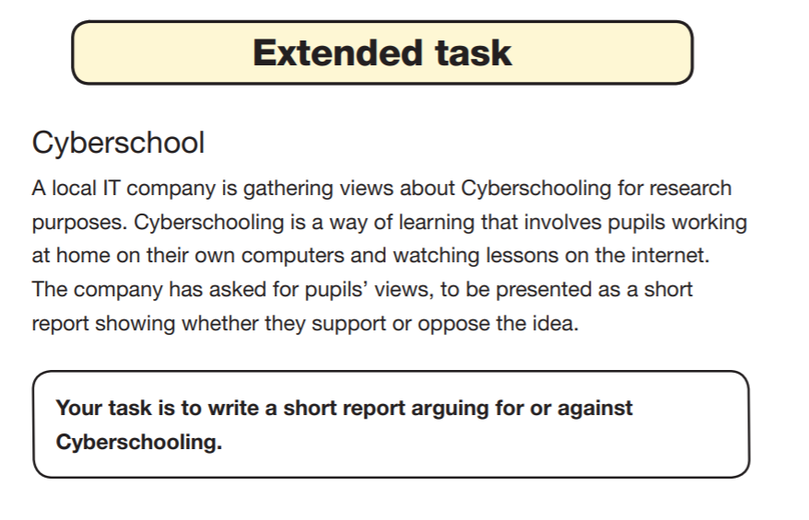  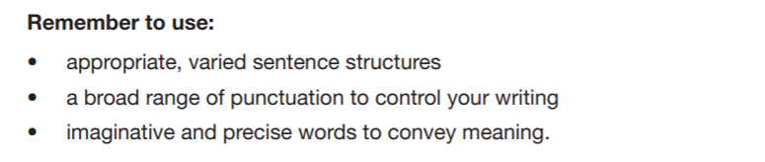
 | Tuesday | 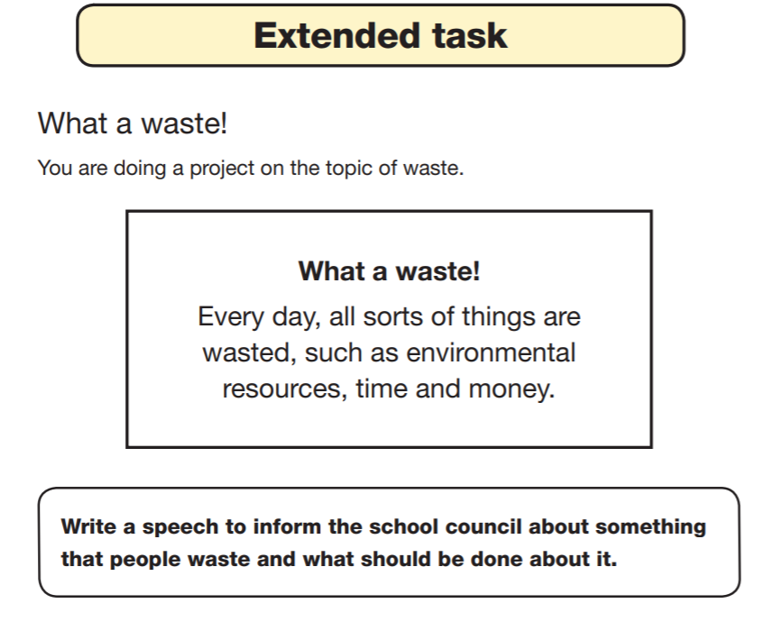  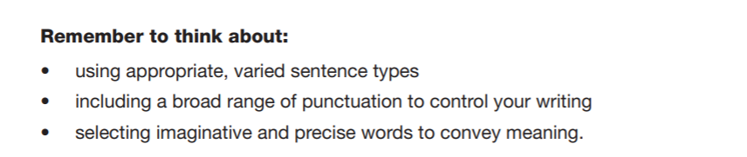
Topic/Science | Topic | We are continuing with our Americas Topic.  The Amazon Rainforest which is situated in South America is home to a vast number of unique creatures.  Can you remember learning about any creatures, while you were in Rowan Class?  You task is to complete an information page about a creature from the Amazon Rainforest, try to research a new creature you are unfamiliar with.  I have included an example below and a template you could use as a research guide:  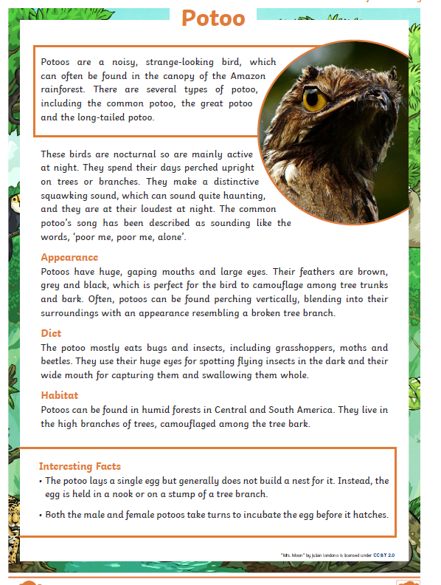  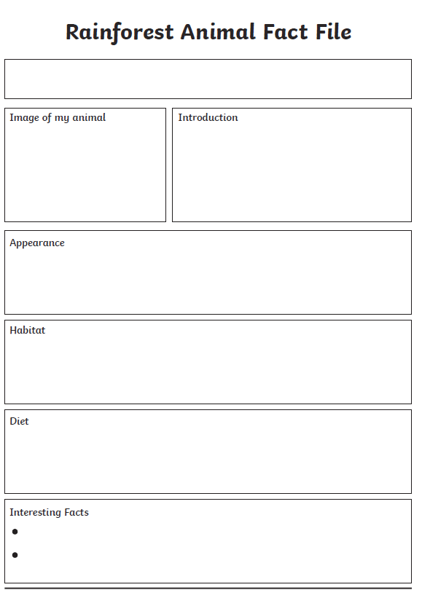
 | Science | We are ending our solar system and space topic, watch:  https://www.bbc.co.uk/bitesize/topics/zdrrd2p/articles/zyjcdmn watch all the clips and read the information.  LO: Can I make outer space in my kitchen?  On your poster explain your understanding of the video.  Remember you can draw pictures and diagrams too.  You can research it further if you wish.
PE | Activity 1 | Joe Wicks workout (Joe is reducing his videos to Monday’s, Wednesday’s and Saturday’s).
 | Activity 2 | Cosmic Kids Yoga
 | Activity 3 | Real PE at home – online learning resources Real PE at home includes an online programme which supports families to be active, play and learn together. Here are the details to access real PE at home:  The website address is: home.jasmineactive.com  Parent email: parent@lyngcofepr-1.com  Password: lyngcofepr
Art/Crafts | Activity 1 | 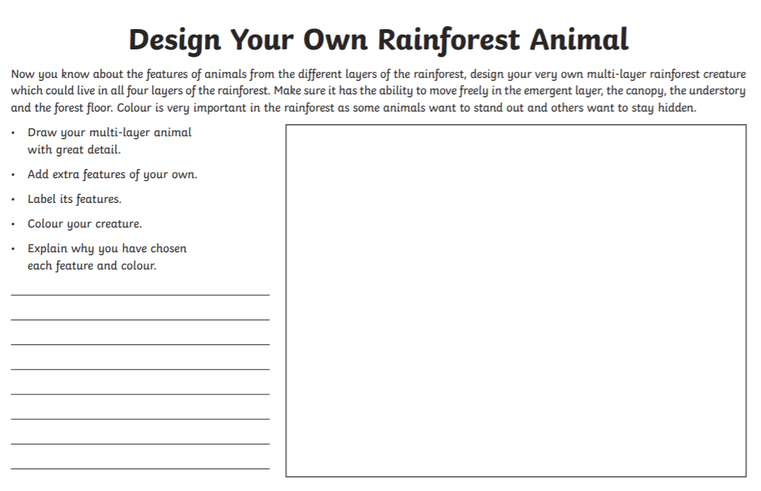
 | Activity 2 | As it is the end of term, also the end of a very different year, your task is to create a booklet or poster of your end of year memories.  Look at the page below for some inspiration.  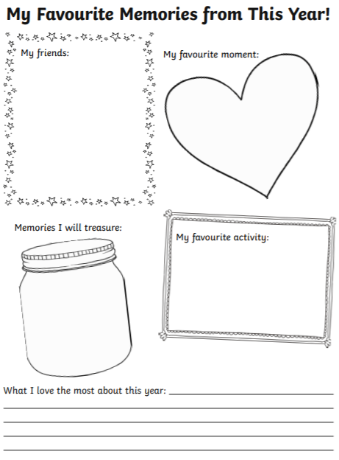

Maths below:

Monday’s work:
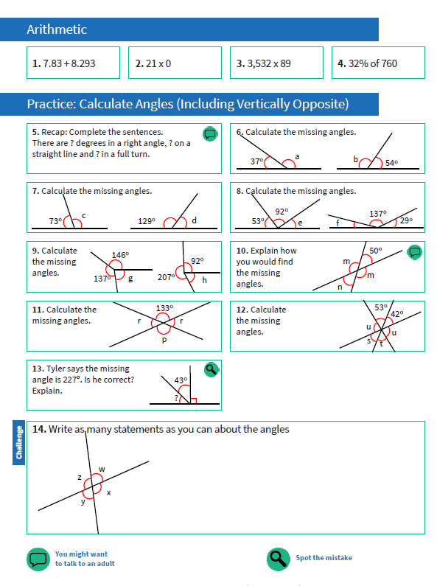
Tuesday’s work:
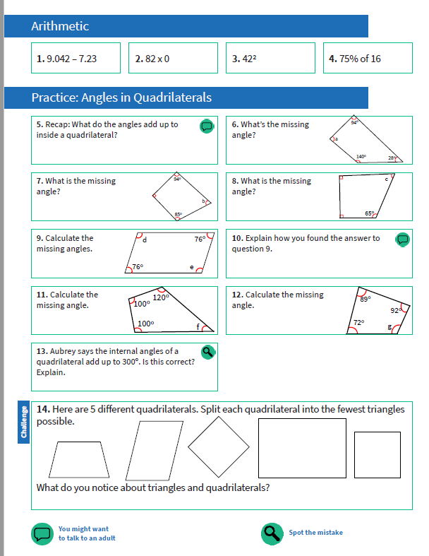

I’m wishing you all a safe and happy break before I see you again in September and of course good luck to all our leaving Year 6’s you will all be missed.
