Maths  **Please also encourage your child to access Mathletics daily on top of or to help the work set** | Monday | This week we have maths investigations based on solving maths problems.  All Maths work is at the bottom of the sheets:  Remember extension work on this area can be found on Mathletics.  LO: Can I investigate the beans and bags investigation?
 | Tuesday | LO: Can I investigate the Maze 100 investigation?
English  **Please also encourage your child to read daily either independently or to an adult. | Monday | https://www.talk4writing.com/wp-content/uploads/2020/06/Y5-Wizards.pdf  Wonderful Wizards by Maria Richards  This is the third unit of English work to last three weeks, each day I have selected the pages to complete so that you can work  through the booklet. It will be similar to our English lessons, in that we used an author’s work to base our learning around.  Today page16 and 17. It is of course, up to you, if you’d like to finish this unit. If you do, I love to see any of your work, via the class email.
 | Tuesday | It would be lovely if you could write to me via the class email to say what your favourite things are, at school?  - What you looking forward to about returning to school?  - What are you looking forward about being a Year 6?  - What are your feelings about returning?  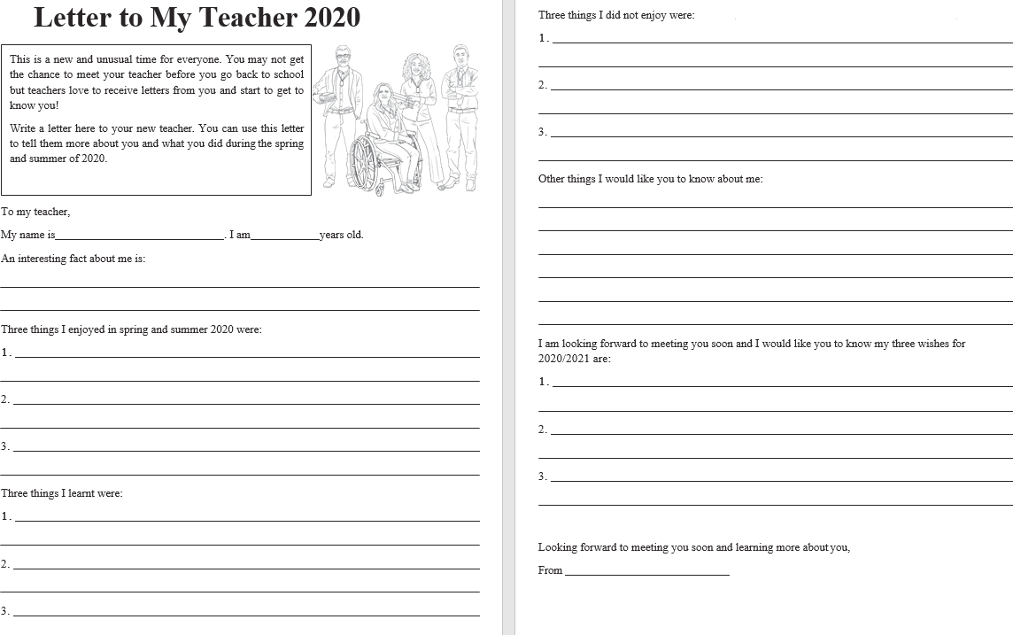
Topic/Science | Topic | We are continuing with our Americas Topic.  The Amazon Rainforest which is situated in South America is home to a vast number of unique creatures.  Can you remember learning about any creatures, while you were in Rowan Class?  You task is to complete an information page about a creature from the Amazon Rainforest, try to research a new creature you are unfamiliar with.  I have included an example below and a template you could use as a research guide:  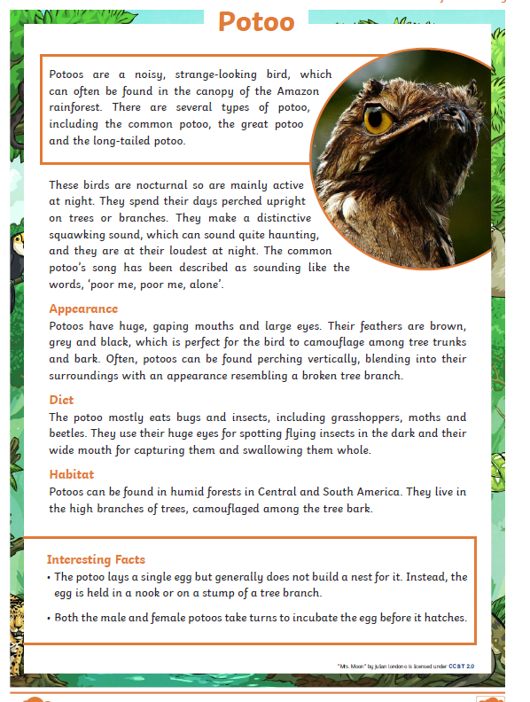  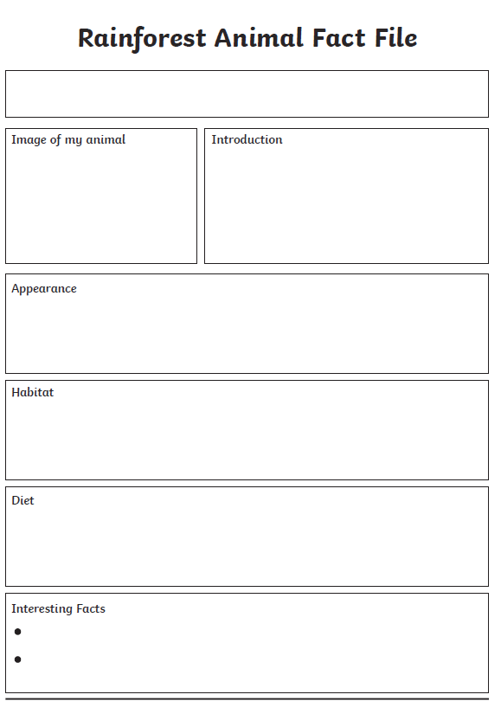
 | Science | We are ending our solar system and space topic, watch:  https://www.bbc.co.uk/bitesize/topics/zdrrd2p/articles/zyjcdmn watch all the clips and read the information.  LO: Can I make outer space in my kitchen?  On your poster explain your understanding of the video.  Remember you can draw pictures and diagrams too.  You can research it further if you wish.
PE | Activity 1 | Joe Wicks workout (Joe is reducing his videos to Monday’s, Wednesday’s and Saturday’s).
 | Activity 2 | Cosmic Kids Yoga
 | Activity 3 | Real PE at home – online learning resources Real PE at home includes an online programme which supports families to be active, play and learn together. Here are the details to access real PE at home:  The website address is: home.jasmineactive.com  Parent email: parent@lyngcofepr-1.com  Password: lyngcofepr
Art/Crafts | Activity 1 | 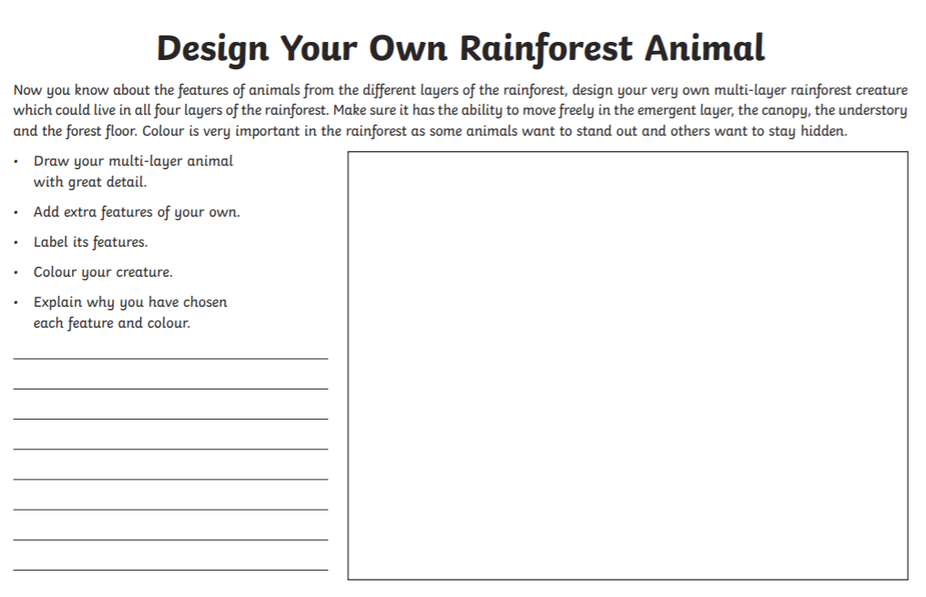
 | Activity 2 | As it is the end of term, also the end of a very different year, your task is to create a booklet or poster of your end of year memories.  Look at the page below for some inspiration.  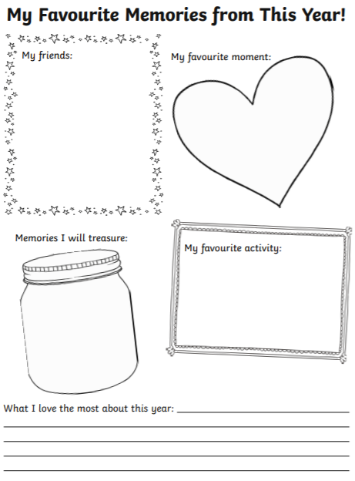

Maths below:

Monday’s work:

Beads and Bags
This is an investigation to help you think mathematically.
This challenge involves three beads and lots of bags.
There are as many bags as you need.
Find a way to put the beads into some of the bags.
Find another different way to put the beads into some of the bags.
How many different ways can you make?
Have you tried putting a bag into another bag?
Can you record your ways?
How do you know you've got them all?
Can you give your recording to a friend to see if they can re-make your way?
Can you record your ways without pictures?
Can you record using numbers?
Does your partner always make the way you expect?
Can you refine your recording so that your partner always gets it right?

Tuesday’s work:

Maze 100
In this maze there are numbers in each of the cells. You go through adding all the numbers that you pass. You may not go through any cell more than once.
Can you find a way through in which the numbers add to exactly 100?

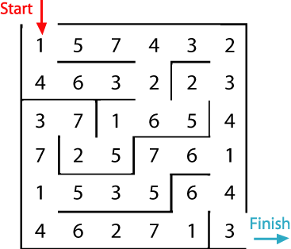
What is the lowest number you can make going through the maze?
What is the highest number you can make going through the maze? (Remember you may not go through any cell more than once.)
You could print off this sheet which contains two copies of the maze.

I’m wishing you all a safe and happy break before I see you again in September and of course good luck to all our leaving Year 6’s you will all be missed.
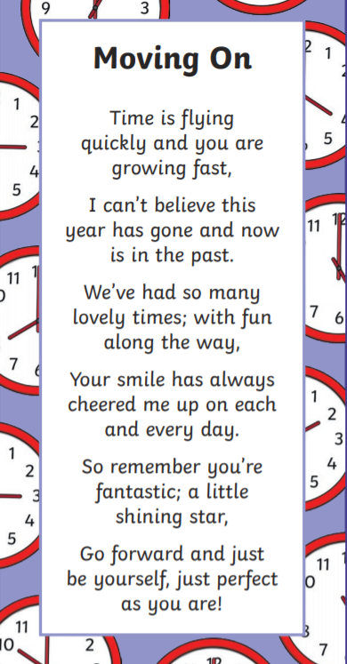
See you in September Year 5’s.

