Maths  **Please also encourage your child to access Mathletics daily on top of or to help the work set** | Monday | This week we have maths investigations based on translating shapes.  Watch for an introduction: https://www.bbc.co.uk/bitesize/topics/z2dqrwx/articles/zcjs97h  All Maths work is at the bottom of the sheets:  Remember extension work on this area can be found on Mathletics.  LO: Can I translate shapes?
 | Tuesday | LO: Can I translate shapes?
 | Wednesday | LO: Can I describe translations?
 | Thursday | LO: Can I describe translations?
 | Friday | LO: Can I investigate the reflection investigation?
English  **Please also encourage your child to read daily either independently or to an adult. | Monday | https://www.talk4writing.com/wp-content/uploads/2020/06/Y5-Wizards.pdf  Wonderful Wizards by Maria Richards  This is a new unit of English work to last three weeks, each day I have selected the pages to complete so that you can work  through the booklet. It will be similar to our English lessons, in that we used an author’s work to base our learning around.  Today pages 1-3
 | Tuesday | Pages 4-5
 | Wednesday | Page 6
 | Thursday | Page 7
 | Friday | Pages 8-9
Topic/Science | Topic | We are continuing with our Americas Topic.  Watch: https://www.bbc.co.uk/bitesize/topics/zq6svcw/articles/zbqyy4jwatch all the clips on this link and read the information about the games the Ancient Maya played.  This week, we are learning about the games the Maya played. Use the information you have read and watched to create a poster. You can complete some of your own research too, if you wish.  LO: Can I explain what games the ancient Mayas played?  This will be the fourth part of your own investigation topic about the Maya people.
 | Science | We are starting to revise our solar system and space knowledge, watch:  https://www.bbc.co.uk/bitesize/topics/zdrrd2p/articles/zqrvbk7Have a go at the quiz.  LO: Can I explain which planets are the gas ones?  On your poster explain your understanding of the video. You can research it further if you wish.
PE | Activity 1 | Joe Wicks workout (Joe is reducing his videos to Monday’s, Wednesday’s and Saturday’s)
 | Activity 2 | Cosmic Kids Yoga
 | Activity 3 | Real PE at home – online learning resources Real PE at home includes an online programme which supports families to be active, play and learn together. Here are the details to access real PE at home:  The website address is: home.jasmineactive.com  Parent email: parent@lyngcofepr-1.com  Password: lyngcofepr
Art/Crafts | Activity 1 | 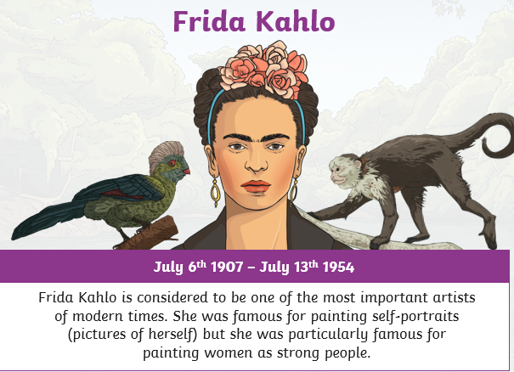  Frida Kahlo was a Mexican artist, you first task is based on her portrait work:  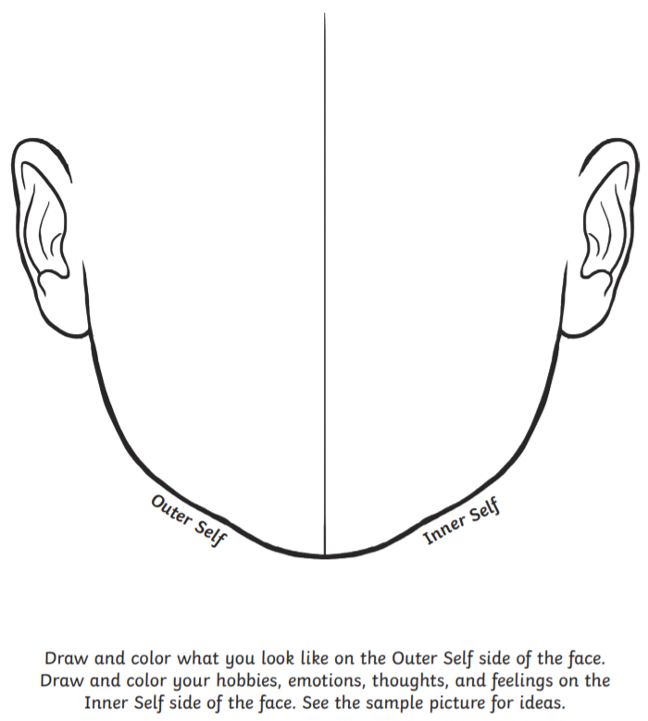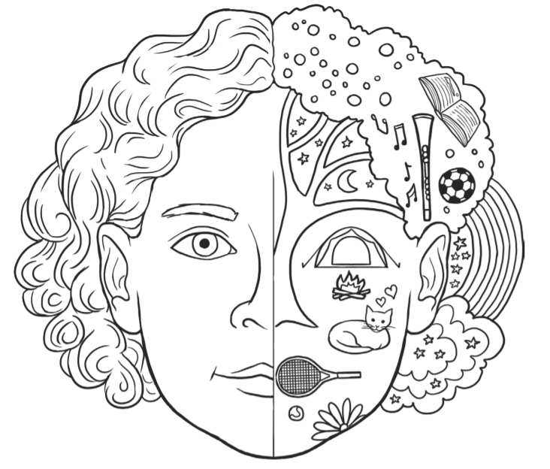
 | Activity 2 | 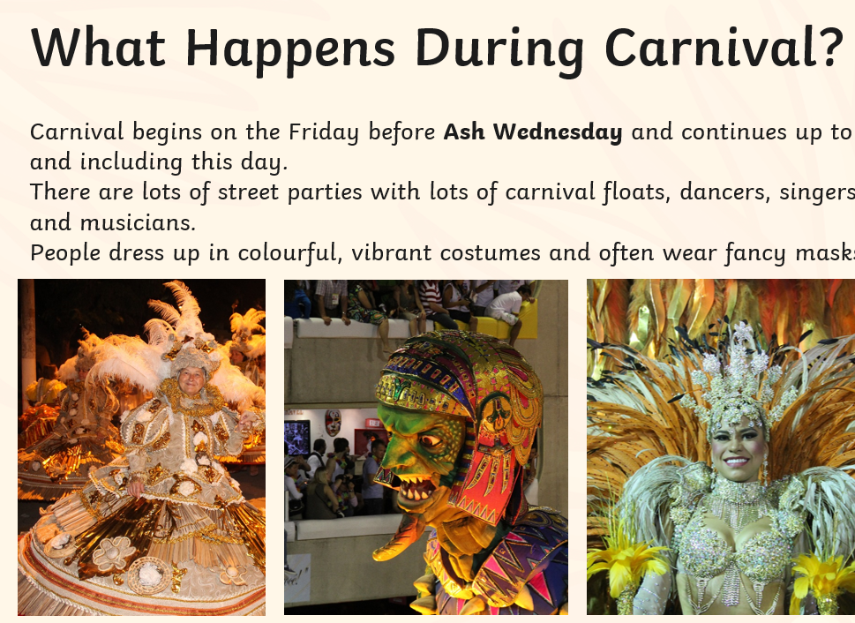  Carnival is a celebration which happens at Easter in Brazil in South America. Your task is to design a Carnival Outfit, it should be very bright and colourful, it could be based on an animal.

Maths below:

Monday’s work:
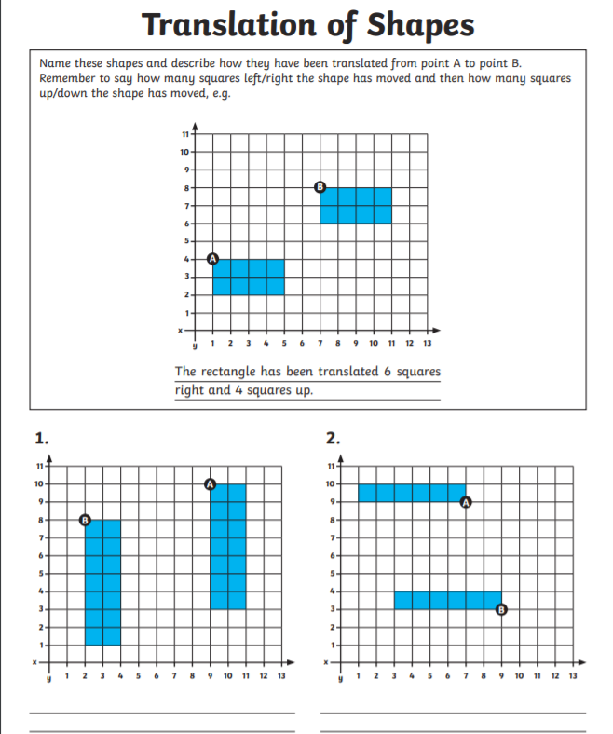
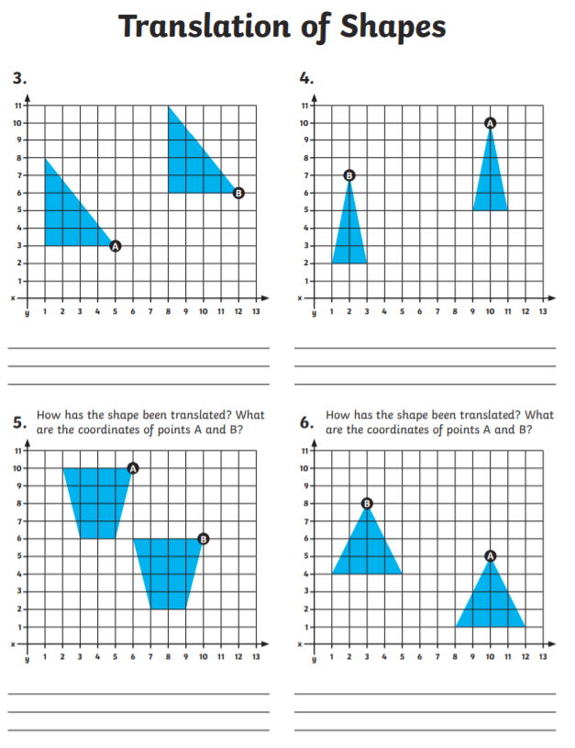Extension: if you have squared paper draw some of your own translations
And calculate the movement.

Tuesday’s work:
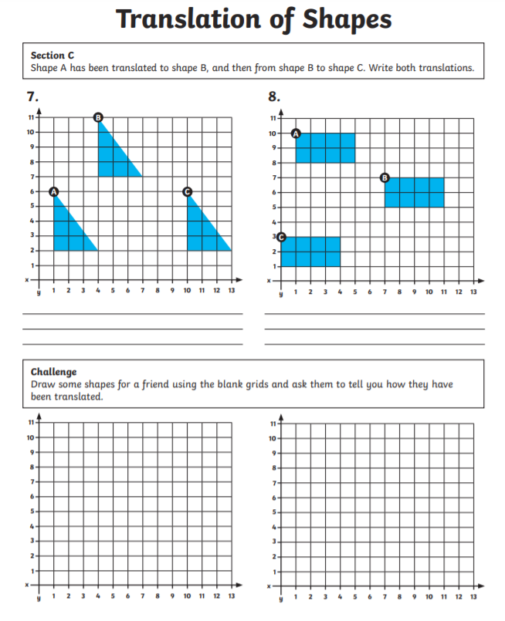
Wednesday’s work:
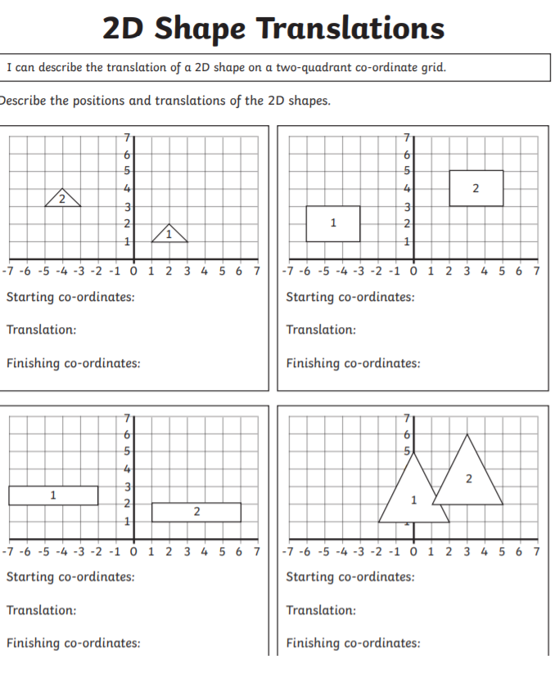
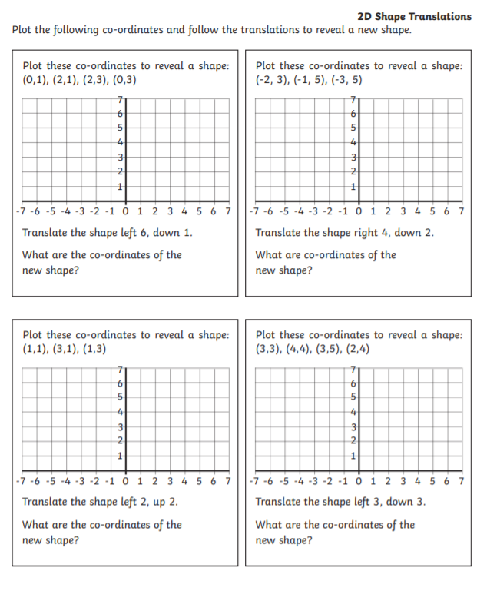
Thursday’s work:

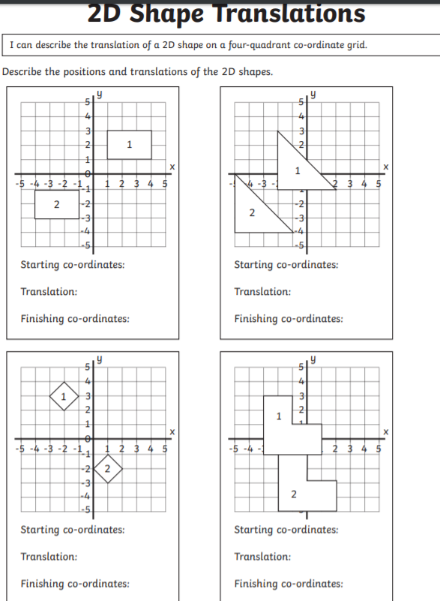
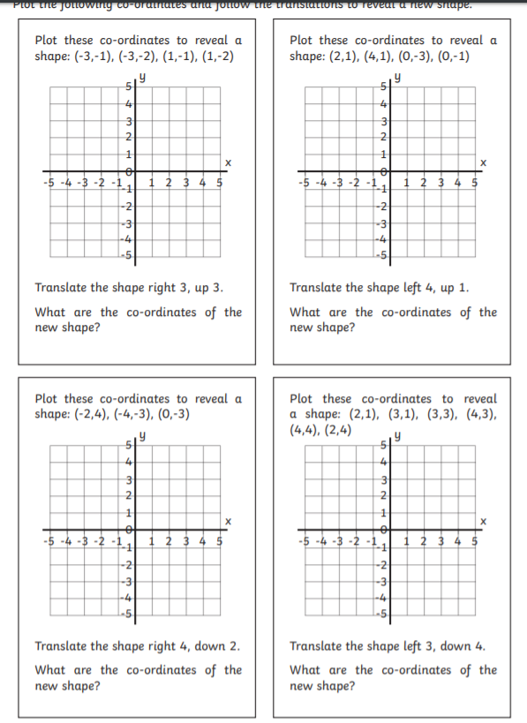
Friday’s work:

If you have some coloured cubes or Lego and a mirror have a go at this investigation:

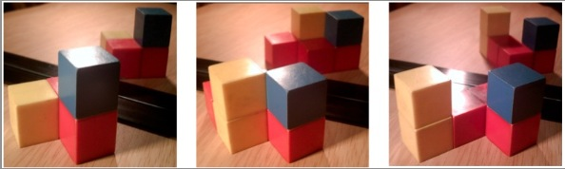
Well, that's three photos of three different ways of putting some blocks together. But there's a mirror behind the black strip. In the mirror you can see the reflections.
Now here are some more pictures but only the reflection is shown and you have to place blocks that will make this reflection.
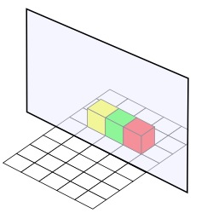
There's a grid to help you.
Here's another for you to try.
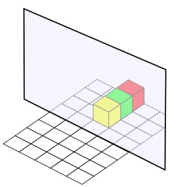
Now here are two that will probably need more careful thinking.
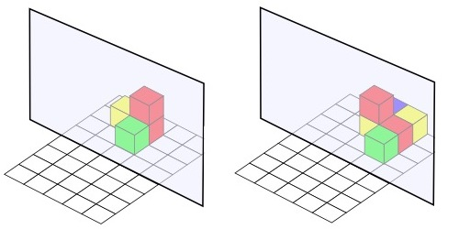
So, one of your group makes a model, maybe something like this;
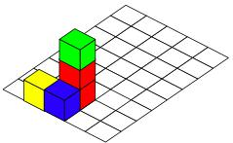
Others in the group now have to make the image that would be seen in the mirror.
You therefore make it like the one being the mirror, as here;
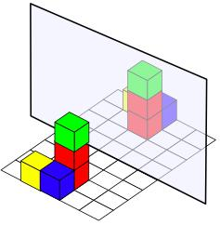
Now it's over to you, remember to use a variety of colours in your models and the reflections must show the correct colour positions.
Have a go at making 3D drawings of them.

