Hello everybody,
Hope you have all had a good week and are all staying safe.
This week, we had a surprise visitor into that classroom during lunchtime. Can you guess which animal it was?
It was a pigeon, so now we’ve had ducks, a cat and a pigeon all trying to get into Oak class.
We were lucky, Seb was very brave and managed to pick the pigeon up and place him in the woodland glade.
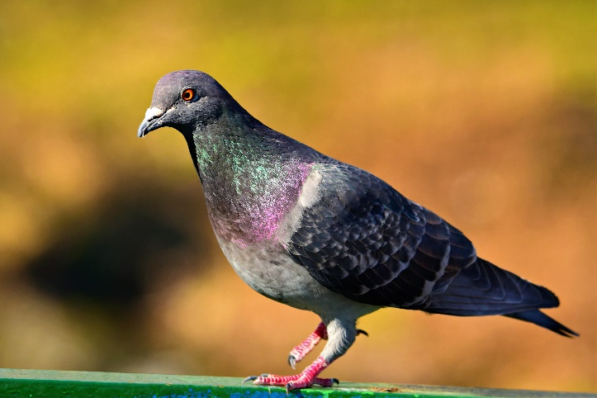
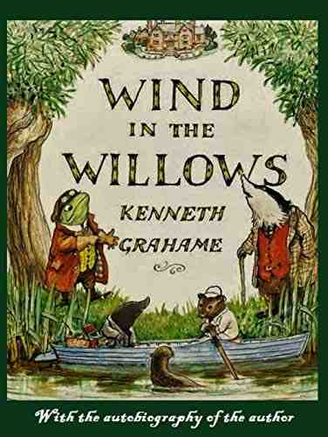
Although Oak won’t be able to have a traditional leavers assembly, we are still practising our drama and singing skills, in preparation for high school drama.
We are enjoying learning some songs and reading through the script of ‘Wind in the Willows’. We are still having some real fun.

Anna has drawn you a lovely picture, of her new favourite animal, ‘rats’, and he looks friendly!
Remember, we love to hear from you too, you can send us a message via the class email.
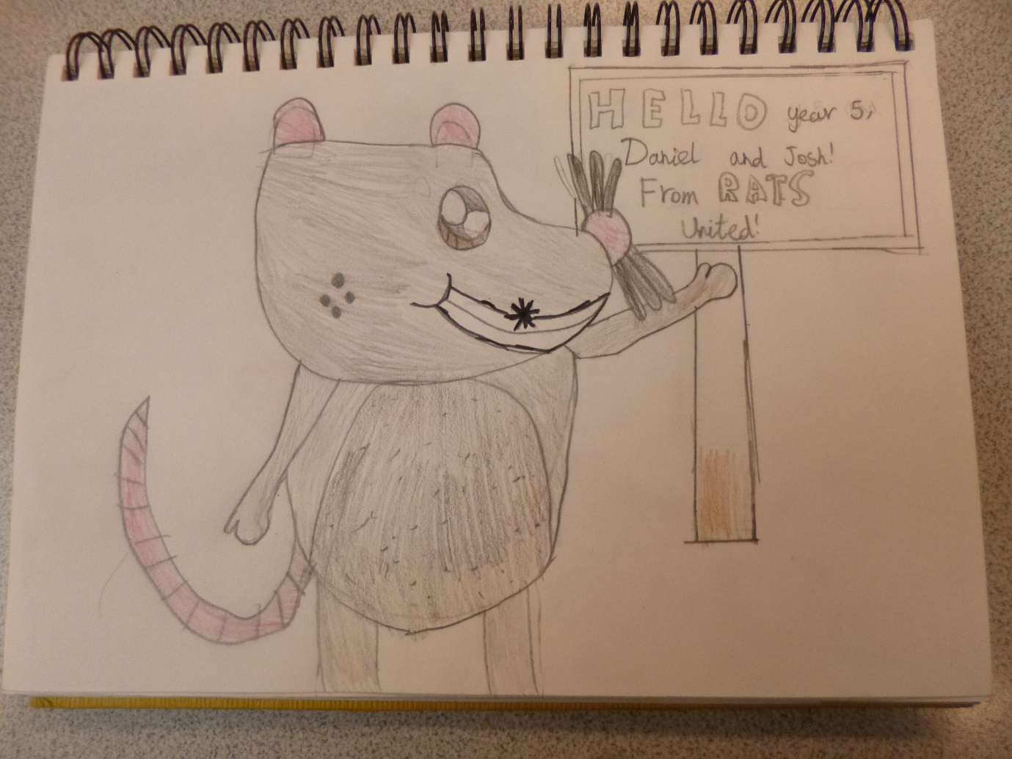
From Miss Wharton and the Year 6’s.

