Maths – see the attached pictures for an example of how to solve the problems.  **Please also encourage your child to access Mathletics daily on top of the work set** | Monday | Daily practise of a times table of your choice – choose a table that you find tricky.  Please complete page 1 of Y4 Maths Part 1.
 | Tuesday | Daily practise of a times table of your choice – choose a table that you find tricky.  Please complete page 2 of Y4 Maths Part 1.
 | Wednesday | Daily practise of a times table of your choice – choose a table that you find tricky.  Please complete page 3 of Y4 Maths Part 1.
 | Thursday | Daily practise of a times table of your choice – choose a table that you find tricky.  Please complete page 1 of Y4 Maths Part 2.
 | Friday | Daily practise of a times table of your choice – choose a table that you find tricky.  1 round of Maths Frame times tables check. Note down your score.  Please complete either page 2 or page 3 (page 3 is more of a challenge) of Y4 Maths Part 2… or if you fancy it, both!
Spellings | Throughout the week | Please recap the tricky words learnt from Autumn 1 – Spring 2  Ideas: Use in sentences, find meanings in a dictionary, use an online word search generator to create a word search.  Autumn 1 Autumn 2 Spring 1 Spring 2  accident believe strange reign interest various possible grammar woman women promise therefore opposite ordinary perhaps pressure particular calendar popular position possess possession purpose potatoes different exercise regular complete remember sentence separate special thought weight
English  **Please also encourage your child to read daily either independently or to an adult or older sibling** | Monday | Have a think about the questions on page 2.  Read the story on pages 3-5  Complete the task and answer the questions on page 18.
 | Tuesday | Read the story on pages 3-5  Complete the task and answer the questions on page 19.
 | Wednesday | Read the story on pages 3-5  Using page 20, create the main characters that will be in your story.
 | Thursday | Read the story on pages 3-5  Using page 21, choose and describe the setting or settings of your story.
 | Friday | Read the story on pages 3-5  Complete pages 22-23, thinking about vocab and your adjective and verb choices.
Topic/PSCHE | Topic | This week, I would like you to research and create a poster about Finland  You will need to include information on the capital city, currency, the physical geography (e.g. rivers, mountains, landscape) and the human geography (e.g. tourist sites, population) and any other good facts you find.  Can you try to include some information about the Northern Lights?  https://www.highlightskids.com/explore/science-questions/what-are-the-northern-lights#:~:text=The%20northern%20lights%20(called%20the,molecules%20cannot%20hold%20the%20energy.  https://easyscienceforkids.com/all-about-the-northern-lights/  Other ways of presenting this information could be making a PowerPoint, leaflet or advert for the country – try to do something you haven’t done already!
 | Science | Complete the cola and Mentos science experiment.  Think about what state of matter the coke was in before, and what it changed to after the experiment.  What about the Mentos too?  Were there any other states of matter present?
PE | Activity 1 | Joe Wicks workout
 | Activity 2 | Cosmic Kids Yoga
 | Activity 3 | Real PE:  The website address is: home.jasmineactive.com  Parent email: parent@lyngcofepr-1.com  Password: lyngcofepr
Art/Crafts | Activity 1 | Create a picture inspired by the Northern Lights. You could use paint, pencil or chalk.  If you use chalk, you could do it outside on the patio if the weather is nice!  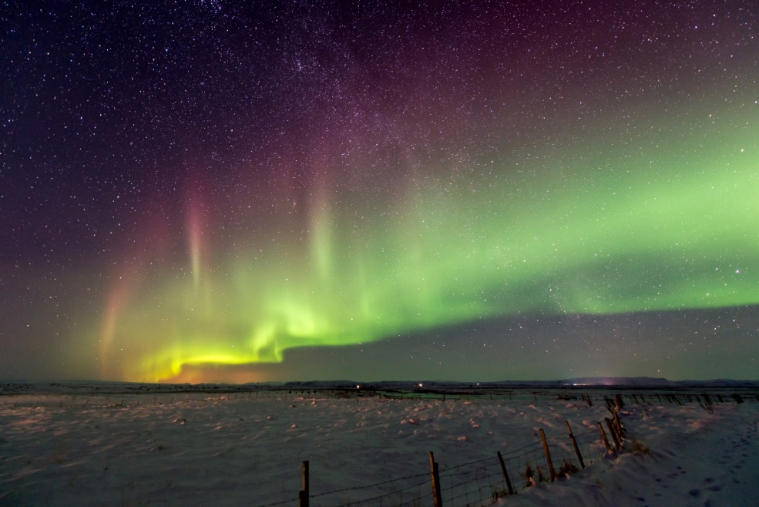
 | Activity 2 | Design and make your own flag of Finland.

