Maths – see the attached pictures for an example of how to solve the problems.  **Please also encourage your child to access Mathletics daily on top of the work set** | Monday | Daily practise of a times table of your choice – choose a table that you find tricky.  Complete day 1 of Rapid Reasoning  And  Complete one of the maths problems below.
 | Tuesday | Daily practise of a times table of your choice – choose a table that you find tricky.  Complete day 1 of Rapid Reasoning  And  Complete one of the maths problems below.
 | Wednesday | Daily practise of a times table of your choice – choose a table that you find tricky.  Complete day 1 of Rapid Reasoning  And  Complete one of the maths problems below.
 | Thursday | Daily practise of a times table of your choice – choose a table that you find tricky.  Complete day 1 of Rapid Reasoning  And  Complete one of the maths problems below.
 | Friday | Daily practise of a times table of your choice – choose a table that you find tricky.  Complete day 1 of Rapid Reasoning  And  Complete one of the maths problems below.
Spellings | Throughout the week | Please recap the tricky words learnt from Autumn 1 – Spring 2  Ideas: Use in sentences, find meanings in a dictionary, use an online word search generator to create a word search.  Autumn 1 Autumn 2 Spring 1 Spring 2  accident believe strange reign interest various possible grammar woman women promise therefore opposite ordinary perhaps pressure particular calendar popular position possess possession purpose potatoes different exercise regular complete remember sentence separate special thought weight
English  **Please also encourage your child to read daily either independently or to an adult or older sibling** | Monday | Read the story on pages 3-5  Complete the activities about inverted commas on p. 24-25
 | Tuesday | Read the story on pages 3-5  Think about spy codes and gadgets on p. 26-27
 | Wednesday | Spend the next couple of days planning your story.  On p. 31 there are a couple of ideas of how your story could go – have a read and take those as inspiration.  Use the planning tools on p. 28 – 30 to help map out your story.  Take your time!
 | Thursday
 | Friday | Use today as an opportunity to write a first draft of your story.  Read through your completed work and think of three targets you need to work on for the final draft next week.  Use this as an opportunity to include all those good story writing features you know:  Inverted commas, paragraphs, fronted adverbials, complex sentences, excellent vocab, similes!
Topic | Topic | This week, I would like you to research and create a poster about Iceland  You will need to include information on the capital city, currency, the physical geography (e.g. rivers, mountains, landscape) and the human geography (e.g. tourist sites, population) and any other good facts you find.  Can you try to include some information about the volcano Eyjafjallajökull? It erupted in 2010 which left me stuck at Disneyland in Florida for nearly a month!  https://primaryfacts.com/3168/eyjafjallajokull-facts/  https://kids.kiddle.co/Eyjafjallaj%C3%B6kull  Other ways of presenting this information could be making a PowerPoint, leaflet or advert for the country – try to do something you haven’t done already!
 | Science | Can you make the volcano errupt?!  This is very similar to the experiment we did last week.  https://www.nhm.ac.uk/discover/how-to-make-a-volcano.html  Follow the link to the Natural History Museum website and see if you can create your own erupting volcano!
PE | Activity 1 | Joe Wicks workout
 | Activity 2 | Cosmic Kids Yoga
 | Activity 3 | Real PE:  The website address is: home.jasmineactive.com  Parent email: parent@lyngcofepr-1.com  Password: lyngcofepr
Art/Crafts | Activity 1 | Can you make the volcano errupt?!  This is very similar to the experiment we did last week.  https://www.nhm.ac.uk/discover/how-to-make-a-volcano.html  Follow the link to the Natural History Museum website and see if you can create your own erupting volcano!
 | Activity 2 | Design and make your own flag of Iceland.

Maths problems

There are three dice, each of them with faces labelled from 1 to 6.
When the dice are rolled they can be combined in six different ways to make a three-digit number.
For example, if I roll a 2 and a 4 and a 5, I can combine them to make 245, 254, 425, 452, 524 or 542.
Now round each of these numbers to the nearest 100:
245 rounds to 200, 254 rounds to 300, 425 rounds to 400, 452 rounds to 500, 524 rounds to 500 and 542 rounds to 500.
Repeat for other rolls of the dice.
Can each of the six numbers round to the same multiple of 100?
Can each of the six numbers round to a different multiple of 100?
Ash, Si, Sami and Mani are playing a game.
Each of them writes down a statement that describes a set of numbers.
Ash writes "Multiples of five".
Si writes "Triangular numbers".
Sami writes "Even, but not multiples of four".
Mani writes "Multiples of three but not multiples of nine".
Can you find some two-digit numbers that belong in two of the sets?
Can you find some two-digit numbers that belong in three sets?
What is the smallest number that belongs in all four sets?
How could you describe the pattern of the numbers that satisfy both Ash's and Sami's statements?
How about the numbers that satisfy both Ash's and Mani's statements?
Can you describe patterns for other pairs of statements?
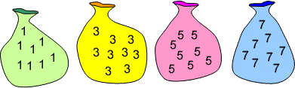
This is a game for two players.
Each bag has unlimited 1s, 3s, 5s or 7s in it.
Aim of the game:
To be the player to add the final number to the 'running' total to make 37.
How to play:
1. Decide who is going first.
2, Player 1 chooses one of the numbers from the bags above (1, 3, 5 or 7).
3. Player 2 then chooses a number from one of the bags and adds this onto player 1's number to make a 'running' total.
4. Player 1 then has another turn and adds that number onto the 'running' total.
5. Play continues like this with each player choosing a number and adding it onto the 'running' total.
Things to think about:
How many numbers did you use altogether in the game?
Have another go. How many numbers did you use this time?
What is the largest amount of numbers you could use to reach 37?
What is the smallest amount of numbers you could use to reach 37?
Can you use all the different amounts of numbers in between the largest and the smallest to reach 37?
What do you notice? Can you explain this?
Fran says "I need to go first in order to win."
Do you agree with Fran? Why or why not?
The year is 2020!

If the answer is 2020, what could the question be? Try to use +, -, x and ÷.
Double or halve?
- Decide on a target number. This is the total that both players are trying to make.
- Player 1 throws the dice. S/he can choose whether to double the number shown or halve the number shown.
- Player 2 throws the dice. In the same way, s/he can choose whether to double the number shown or halve the number shown. Player 2 adds his/her number onto Player 1's number to make a running total.
- Play continues like this with each player rolling the dice, halving or doubling the number and adding the result onto the running total.
- The winner is the player who reaches the agreed target exactly.
Here are some questions to think about:
Must each player always take a turn?
Does it matter if you go first or second?
Are there any particularly good numbers to choose as your target?
Look at these statements and decide whether they happen always, sometimes or never:
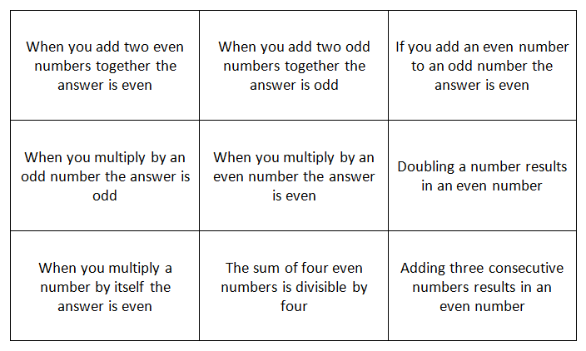
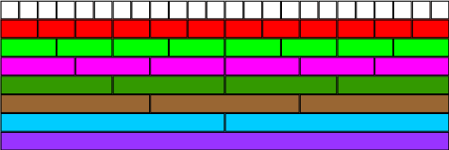

Using the image above, how many different ways can you find of writing 1/2?

From the picture, what equivalent fractions for 1/3 can you find?

Again, using the image of the fraction wall, how else could you write 3/4?

What other fractions do you know that are the same as 1/2?

Find some other fractions which are equivalent to 3/4.

Can you find any "rules" for working out equivalent fractions?

