Maths | Monday | This week we will be recapping addition. We will be exploring different ways and then in future you can choose the way which suits you best.  Remember there are some top tips for adding:  - It is easier to have the biggest number first.  - The answer will always be bigger than the number you started with.  - You can use what you know about place value and number facts to help you.  - You can check an answer by subtracting.  Today use a 100 square (see below). Try  14 + 5 =  Remember put your finger on the first number then count on carefully but don’t count the number you started on!  Now try  25 + 12 =  Use what you know about 10 more and 1 more to add using a shortcut.  So for 25 + 12 first break the number into 1 ten and 2 ones. Then add 1 ten by moving down a square and 2 then add 2 ones by moving across to squares to the right. Do the worksheet below.  Additional challenge: work out the sums mentally.
Maths | Tuesday | Today we will add using an empty number line.  First try 34 + 12 =  Look at the number you are adding on i.e. 12. 12 can be added on as  1 ten and 2 ones.  +10 +1 +1  34 44 45 46  Now try the sums below using an empty number line.  Additional challenge: try adding hundreds.
Maths | Wednesday | Today we will be adding by partitioning using what you know about tens and ones.  For example:  23 + 14 =  20 3 10 4 first break the numbers into tens and ones  20 + 10 = 30 then add the tens  3 + 4 = 7 next add the ones  30 + 7 = 37 next add the tens and ones answers  Try the worksheet below.  Additional challenge: estimate your answer first by rounding to the nearest ten.  e.g. 23 nearest ten is 20  14 nearest ten is 10  20 + 10 = 30 so the answer should be around 30  Remember numbers ending in 1,2,3,4 round to the ten below. Numbers ending in 5,6,7,8, or 9 round to the next ten.
Maths | Thursday | Today we will be using what we know about addition to work out missing number problems.  When we see a sum e.g. 16 + = 20 we don’t add 16 + 20 and put the answer in the box! We have to work out what the number is by counting on.  Start at 16. Count on until you get to 20 and then stop. How many did you count on? 4. So the missing number is 4? Use your hundred square to help you or work out mentally by adding on the ones and then the tens.  Additional challenge: Can you check your answer by subtracting?
Maths | Friday | Challenge day!  https://nrich.maths.org/188/index  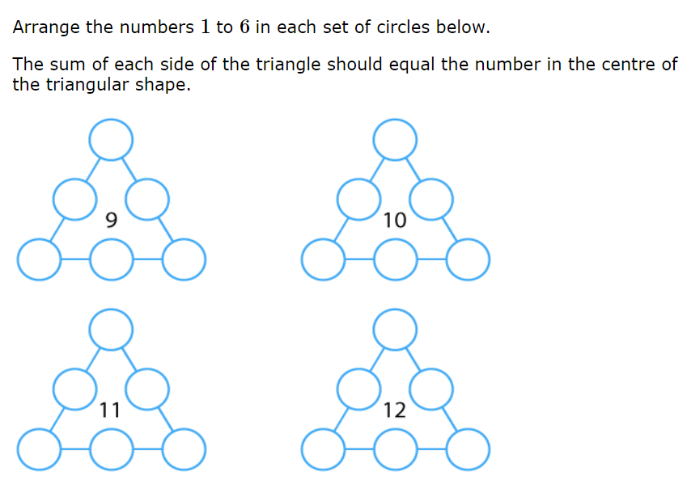  Or strike it out https://nrich.maths.org/6589  Additional challenge: write your own problem.
English  **Please also encourage your child to read daily | Monday | Last week we started a new non-fiction unit called ‘Rainbows, rainbows everywhere.’  First of all look to the topic work below. Start your topic work now by finding out about the birds which live in Kenya. Use the link listed in the topic section or find your own.  As you research the birds of Kenya fill in the top of page 11 of your rainbows pack.  Now prepare for writing by reading the writing challenge at the bottom of page 11. Start to think about the facts you have found out about birds in Kenya.
English  **Please also encourage your child to read daily | Tuesday | Now use the planning sheet on page 12 to plan out your writing. Remember this is just a plan!
English  **Please also encourage your child to read daily | Wednesday | Today and tomorrow write a fact file about birds in Kenya. You may choose several birds or just one.  Use the writing challenge help sheet on page 13 to help you.
English  **Please also encourage your child to read daily | Thursday | Continue your fact file from the previous day. You may want to add an illustration.  Send it to me if you can.
English  **Please also encourage your child to read daily | Friday | Today either continue or read one of your own books.
Sentences | Monday | This week we will find out about different types of sentences. Today statements.  Statements are the most common type of sentence. They tell the reader a fact or idea about a single topic.  This week you have been reading statements in your English unit on Rainbows and your topic work on Kenyan birds.  Watch https://www.bbc.co.uk/bitesize/articles/z97r2nb  Read through your fact file and check that your statements start with a capital letter and finish with a full stop.  Can you write another 3 statements about anything!
Sentences | Tuesday | Another type of sentence is a command. A command is an instruction and is used when telling someone to do something.  Watch https://www.bbc.co.uk/bitesize/topics/zrqqtfr/articles/z8strwx  They start with a ‘bossy’ verb (imperative verb)  Do the activity on the same page to highlight the imperative verbs.
Sentences | Wednesday | Yesterday we found out about commands.  Commands are instructions.  Look at home to find an example of some instructions. It may be a recipe, how to make a model or how to play a game.  Read the instructions and make a list of all the imperative verbs or write your own set of commands e.g. for how to play a game.
Sentences | Thursday | What can you remember about spelling, punctuation and grammar? Try the activity mat below.
Sentences | Friday | Spelling practice – (see spelling box below).
Topic/  Science | Topic 1 | This week we are going to find out about birds that live in Kenya.  Kenya’s national bird is the lilac- breasted roller bird. Look it up: https://en.wikipedia.org/wiki/List_of_birds_of_Kenya.  Can you find out how many different types of birds there are in Kenya?  Watch https://www.youtube.com/watch?v=iFWLMktU7ms and count how many you can see?  Some of the birds are similar to the ones we see in our country e.g. heron. Some fly to our country from Africa. Have you seen swallows yet?  Choose your favourite bird and find out a little more about it. Look carefully at its shapes and colours for your artwork below.  Keep exploring the Tinga Tinga tales https://www.bbc.co.uk/iplayer/episodes/b00wg01c/tinga-tinga-tales
Topic/  Science | Topic 2 | In our ‘Exciting Eggs’ topic we found out that an ostrich egg was very, very big. Find out more about an ostrich by reading the attached booklet.  Create your own factfile linked to your English work. You may want to use the sheet below.  If you prefer you could look up flamingos and then use the picture below to add colour or collage to.
PE | Activity 1 | Joe Wicks workouthttps://www.youtube.com/channel/UCAxW1XT0iEJo0TYlRfn6rYQ
PE | Activity 2 | Cosmic Kids Yoga https://www.youtube.com/user/CosmicKidsYoga
PE | Activity 3 | Real PE see below
Art/Crafts | Activity 1 | If you haven’t already listened to a Tinga Tinga story start by doing that. This one is ‘Why eagles rule the skies’. https://www.bbc.co.uk/iplayer/episode/b00zwcpp/tinga-tinga-tales-series-2-20-why-eagle-rules-the-skies as you watch look carefully at the colours, shapes and patterns.  Tinga tinga paintings originated in Tanzania by the artist Edward Saidi Tingatinga in 1968 and then spread to other parts of East Africa. Edward began his work painting under a Baobob tree. His work consisted of bright, bold colours, simplistic designs, inspired by his surroundings.  You might like to find out more  https://art-educ4kids.weebly.com/african-art.html  Today choose your own favourite Kenyan bird and draw the outline in pencil. Keep for another day.
Art/Crafts | Activity 2 | Take your bird outline and start to fill it in with lots of colourful patterns to create your own Tinga tinga style picture.

Weekly spellings
Look out for a swallow.
Recap spelling from Spring term 1

find kind
mind behind
both cold
told every
everybody water
half
REAL P.E.
The website address is: home.jasmineactive.com
Parent email: parent@lyngcofepr-1.com
Password: lyngcofepr

Additional maths challenges:
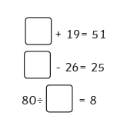
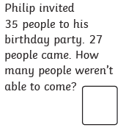
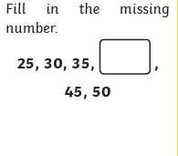

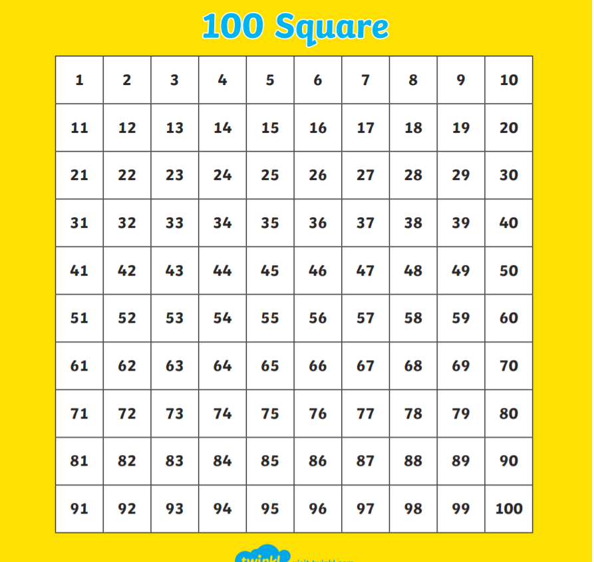

Monday: Can I add using a 100 square?

34 + 13 = 43 + 24 = 34 + 29 =

42 + 15 = 45 + 23 = 46 + 35 =

63 + 16 = 52 + 34 = 52 + 39 =

57 + 11 = 46 + 41 = 45 + 48 =

35 + 12 = 27 + 45 = 236 + 151 =

Tuesday : Can I add using an empty number line?

Easy
32 + 15 =

23 + 16 =

Meduim
31 + 35 =

54 + 45 =

Harder

145 + 123 =

361 + 234 =

Wednesday : Can I add using partitioning?

26 + 13 = 35 + 14 =

20 6 10 3

20 + 10 = 30

6 + 3 = 9

30 + 9 = 39

34 + 25 = 54 + 32 =

Thursday : Can I work out a missing number addition problem? .

12 + = 18 23 + = 34

16 + = 20 45 + = 67

21 + = 29 39 + = 71

153 + = 167


