Maths | Monday | This week we will be recapping addition. We will be exploring different ways and then you can choose the way which suits you best.  First watch https://www.bbc.co.uk/bitesize/topics/zwv39j6/articles/z8hyfrd  Try the first activity.  Addition can also be called plus, adding, more than.  When 2 numbers are added the answer always gets BIGGER! Always check your answer to make sure it is!  Today we will add using a 100 square (see below). Try  14 + 5 =  Remember put your finger on the first number then count on carefully but don’t count the number you started on!  Now try  29 + 8 =  Remember to start a new line as you count past 29.  Now try  25 + 12 =  Remember to count carefully as the second number gets bigger.  Now try the sums below using a 100 square, they start easy and get harder! Do the black ones.  Additional challenge: Use what you know about 10 more and 1 more from last week to add using a shortcut.  So for 25 + 12 first break the number into 1 ten and 2 ones. Then add 1 ten by moving down a square and 2 then add 2 ones by moving across to squares to the right. Do the purple and red sums.
Maths | Tuesday | Today we will add using an empty number line.  We will try  23 + 6 =  First draw a line across a piece of paper. Look at the number you are adding on i.e.6. This is 6 ones(no tens)  At the left hand side write 23. Then make 6 jumps to represent the 6 ones and label as below.  +1 +1 +1 +1 +1 +1  23 24 25 26 27 28 29  Now try 34 + 12 =  Look at the number you are adding on i.e. 12. 12 can be added on as 12 ones or better still as 1 ten and 2 ones. +10 +1 +1  34 44 45 46  Now try the sums below using an empty number line.
Maths | Wednesday | Think about which way of adding that you liked best. Was it the 100 square or empty number line?  Today practise adding using the way you prefer.  Write some sums of your own. Remember don’t go above 100!  Additional challenge: check your addition sums by subtracting e.g if 15 + 3 = 18 18 - 3 = 15
Maths | Thursday | Today we will be using what we know about addition to work out missing number problems.  When we see a sum e.g. 6 + = 10 we don’t add 6 + 10 and put the answer in the box! We have to work out what the number is by counting on.  Start at 6. Count on until you get to 10 and then stop. How many did you count on? 4. So the missing number is 4? Use your hundred square to help you.  Additional challenge: Can you work out the missing number mentally using what you know about numbers?
Maths | Friday | Challenge day!  Try the challenges on BBC Bitesize https://www.bbc.co.uk/bitesize/articles/z6rrn9q  And try the rest of the activities and quiz https://www.bbc.co.uk/bitesize/topics/zwv39j6/articles/z8hyfrd  Additional challenge: Write your own challenge and give to a grown up to work out!
English  **Please also encourage your child to read daily | Monday | Last week we started a new story called ‘Sayeeda the Pirate Princess’.  This week we are going to look at a poem which is also a song. Read it first on page 9.  Then join in https://www.bbc.co.uk/teach/school-radio/nursery-rhymes-when-i-was-one-i-sucked-my-thumb/zhbyt39
English  **Please also encourage your child to read daily | Tuesday | Look at the treasure chest on page 10.  If you had a treasure chest what would you put in it?  Make a list of 6 things. You might like to draw them and label them.
English  **Please also encourage your child to read daily | Wednesday | Today read the diary on page 11 about an adventure. What do you notice is missing from the writing?  Yes, there are not capital letters and full stops.  Remember a capital letter is needed at the start of a sentence and also for someone’s name or the name of a place. A sentence stops when an idea is completed and a new one starts. Then we put a full stop.  Ask a grown up to help you spot where the capital letters and full stops should be.  Additional challenge: write your own mini adventure.
English  **Please also encourage your child to read daily | Thursday | Today use the lines on page 12 to copy out the adventure or part of the adventure in your very best handwriting. Can you put in all the missing capital letters and full stops?
English  **Please also encourage your child to read daily | Friday | Today read or listen to another pirate story. Here’s one you could use: The Pirate Cruncher by Jonny Duddle. https://www.youtube.com/watch?v=Ro5S_UdvWkI  Additional challenge: Look out for words that are new and exciting. Can you spot any rhyming words?
Phonics and handwriting | Monday | Recap g sound. Read these words: goat gate together  Notice what sound g is making in each word.  Look round your house or garden.  How many more words beginning with g can you find?  Can you find other words which have g in them?  Make a list.
Phonics and handwriting | Tuesday | Yesterday the words we looked at had a g in them.  Read these words which also have a g. What do you notice?  gem gym ginger  If a g is followed by e, i or y it makes a j sound.  How many words where g = j can you spot in the sheet below? Write some of those words.
Phonics and handwriting | Wednesday | Yesterday we found out that g can make a j sound. Can you remember the spelling rule?  Read these words: badge fudge ledge  What 3 letters are making the j sound now? Yes it is ……. dge .
Phonics and handwriting | Thursday | What can you remember about spelling, punctuation and grammar? Try the activity mat below.
Phonics and handwriting | Friday | Spelling practice – (see spelling box below)
Topic/  Science | Topic 1 | This week we are going to find out about birds and insects that live in Kenya.  Kenya’s national bird is the lilac- breasted roller bird. Look it up: https://en.wikipedia.org/wiki/List_of_birds_of_Kenya.  Can you find out how many different types of birds there are in Kenya?  Watch https://www.youtube.com/watch?v=iFWLMktU7ms and count how many you can see?  Some of the birds are similar to the ones we see in our country e.g. heron. Some fly to our country from Africa. Have you seen swallows yet?  Choose your favourite bird and find out a little more about it. Look carefully at its shapes and colours for your artwork below.  Keep exploring the Tinga Tinga tales https://www.bbc.co.uk/iplayer/episodes/b00wg01c/tinga-tinga-tales
Topic/  Science | Topic 2 | In our ‘Exciting Eggs’ topic we found out that an ostrich egg was very, very big. Find out more about an ostrich by reading the attached booklet.  You can talk about what you have found out or create your own factfile. You may want to use the sheet below.  If you prefer you could look up flamingos and then use the picture below to add colour or collage to.
PE | Activity 1 | Joe Wicks workouthttps://www.youtube.com/channel/UCAxW1XT0iEJo0TYlRfn6rYQ
PE | Activity 2 | Cosmic Kids Yoga https://www.youtube.com/user/CosmicKidsYoga or mindfulness sheet (see below)
PE | Activity 3 | Real PE see below
Art/Crafts | Activity 1 | If you haven’t already listened to a Tinga Tinga story start by doing that. This one is ‘Why eagles rule the skies’. https://www.bbc.co.uk/iplayer/episode/b00zwcpp/tinga-tinga-tales-series-2-20-why-eagle-rules-the-skies as you watch look carefully at the colours, shapes and patterns.  Tinga tinga paintings originated in Tanzania by the artist Edward Saidi Tingatinga in 1968 and then spread to other parts of East Africa. Edward began his work painting under a Baobob tree. His work consisted of bright, bold colours, simplistic designs, inspired by his surroundings.  You might like to find out more  https://art-educ4kids.weebly.com/african-art.html  Today choose your own favourite Kenyan bird and draw the outline in pencil. Keep for another day.
Art/Crafts | Activity 2 | Take your bird outline and start to fill it in with lots of colourful patterns to create your own Tinga tinga style picture.

Weekly spellings
Look out for a swallow.
Recap spelling from Spring term 2

today ask
put push
pull full
says were
REAL P.E.
The website address is: home.jasmineactive.com
Parent email: parent@lyngcofepr-1.com
Password: lyngcofepr

Additional maths challenges:
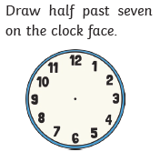
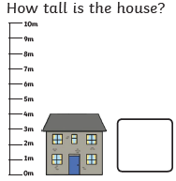
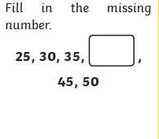

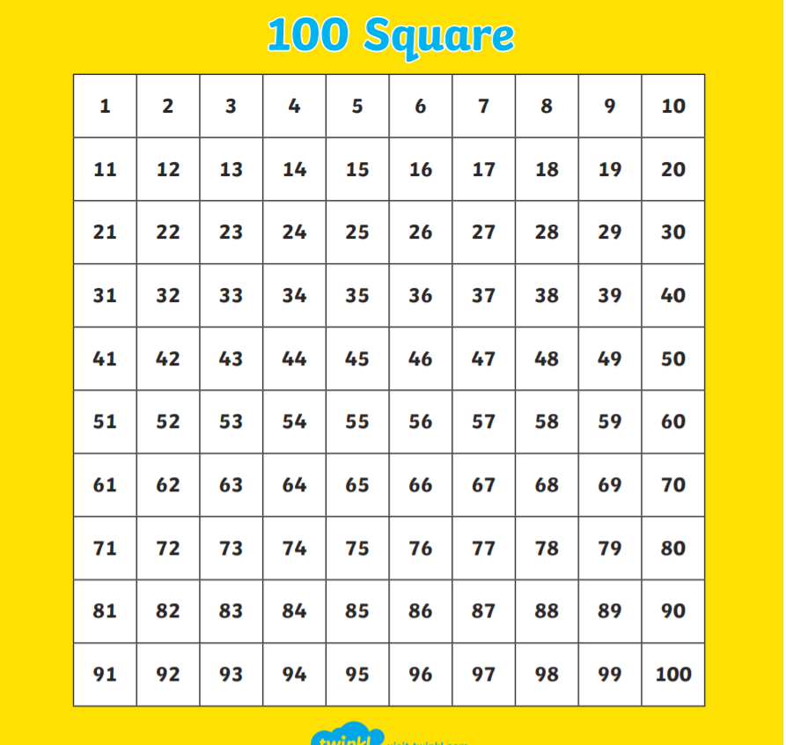

Monday: Can I add using a 100 square?

10 + 6 = 23 + 12 = 34 + 23 =

12 + 3 = 45 + 13 = 46 + 21 =

23 + 5 = 32 + 14 = 52 + 34 =

27 + 8 = 46 + 16 = 45 + 43 =

35 + 9 = 67 + 18 =

Tuesday : Can I add using an empty number line?

Easy
12 + 5 =

23 + 6 =

Meduim
21 + 13 =

34 + 15 =

Harder

45 + 23 =

61 + 34 =

Wednesday : Can I work out a missing number addition problem? Use the 100 square to help you.

12 + = 18 23 + = 34

16 + = 20 32 + = 45

21 + = 29 45 + = 67

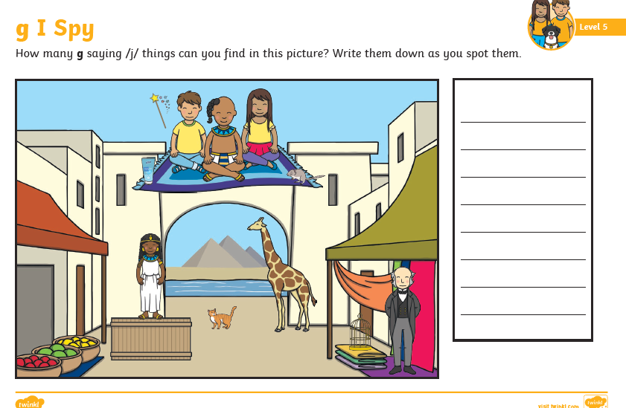

twinkl

