Maths  **Please also encourage your child to access Mathletics daily on top of or to help the work set** | Monday | This week we have a generalised revision sessions about all our maths working:  All Maths work is at the bottom of the sheets:  LO: Can I solve the percentage questions?
 | Tuesday | LO: Can I solve the percentage questions?
 | Wednesday | LO: Can I solve the percentage questions?
 | Thursday | LO: Can I solve the percentage questions?
 | Friday | LO: Can I solve the percentage questions?
English  **Please also encourage your child to read daily either independently or to an adult. | Monday | https://www.talk4writing.co.uk/wp-content/uploads/2020/05/Y6-Gadgets.pdf  The Gadgets Workbook by James Waller  This is the third unit of English work, to last three weeks, each day I have selected the pages to complete so that you can work  through the booklet. It will be similar to our English lessons, in that we used an author’s work to base our learning around.  Today: write an advert for a gadget (you choose).
 | Tuesday | Write an advert for a real life gadget (you choose).
 | Wednesday | Write an advert to persuade someone to become a spy.
 | Thursday | Activity 13: Turn your writing into a radio advert.
 | Friday | Continue and finish activity 13.
Topic/Science | Topic | We are continuing with our Americas Topic.  Watch: https://www.bbc.co.uk/bitesize/topics/zq6svcw/articles/zs2ph39 watch all the clips on this link and read the information about what remains of the ancient Maya.  This week, we are learning about what remains of the ancient Maya. Use the information you have read and watched to create a poster. You can complete some of your own research too, if you wish.  LO: Can I explain what remains of the ancient Mayas?  This will be the third part of your own investigation topic about the Maya people.
 | Science | We are starting to revise our solar system and space knowledge, watch:  https://www.bbc.co.uk/bitesize/topics/zdrrd2p/articles/ztsdj6f  Have a go at the quiz.  LO: Can I explain which planets are the rocky ones?  On your poster explain your understanding of the video. You can research it further if you wish.
PE | Activity 1 | Joe Wicks workout (Joe is reducing his videos to Monday’s, Wednesday’s and Saturday’s)
 | Activity 2 | Cosmic Kids Yoga
 | Activity 3 | Real PE at home – online learning resources Real PE at home includes an online programme which supports families to be active, play and learn together. It includes a programme. Here are the details to access real PE at home:  The website address is: home.jasmineactive.com  Parent email: parent@lyngcofepr-1.com  Password: lyngcofepr
Art/Crafts | Activity 1 | It’s thought that the Maya invented the concept of 'zero'. This meant that they were able to do complex calculations, which allowed them to create very detailed and accurate calendars. They used these calendars for farming – perhaps that’s why they were so good at it!  Your first task, this week is to create your own calendar, you don’t have to complete all the days, but think about drawing a series of 12 pictures, one for each month of our calendar.  An extra challenge would be linking these pictures to any of your previous learning about the Mayas.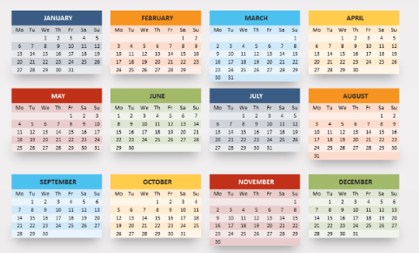
 | Activity 2 | The Maya enjoyed creating books with animal skin covers. Can you make your own mini Mayan book and draw an animal skin cover?  You could draw some Mayan art inside.  LO: Can I make a Mayan mini book?

Maths below:

Maths below:

Monday’s work:
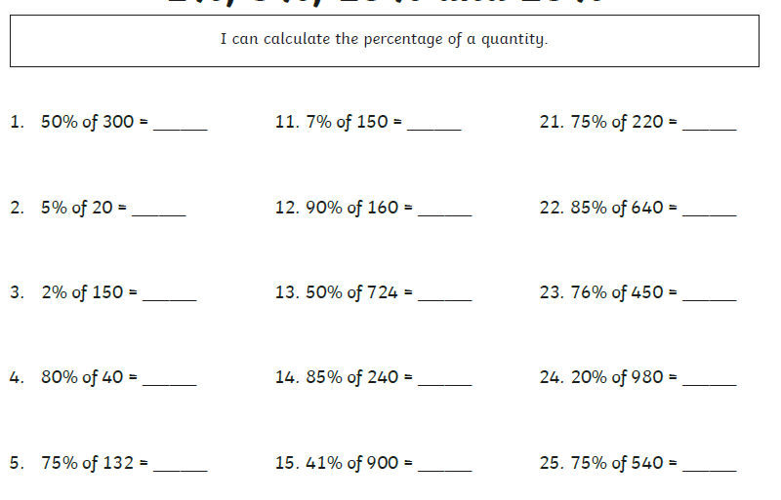

Tuesday’s work:
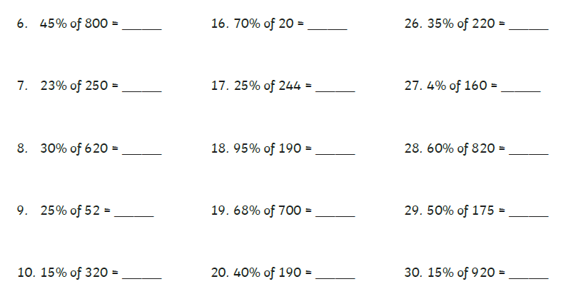
Wednesday’s work:
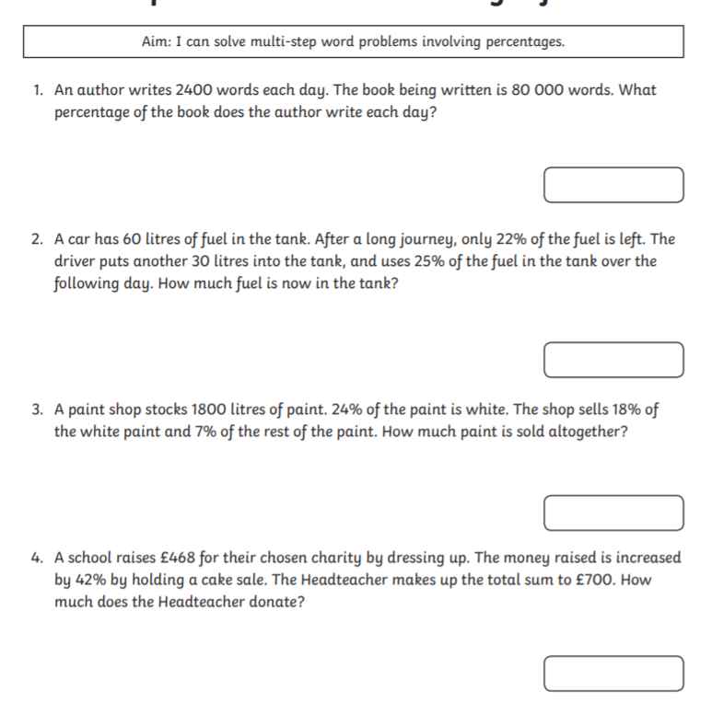
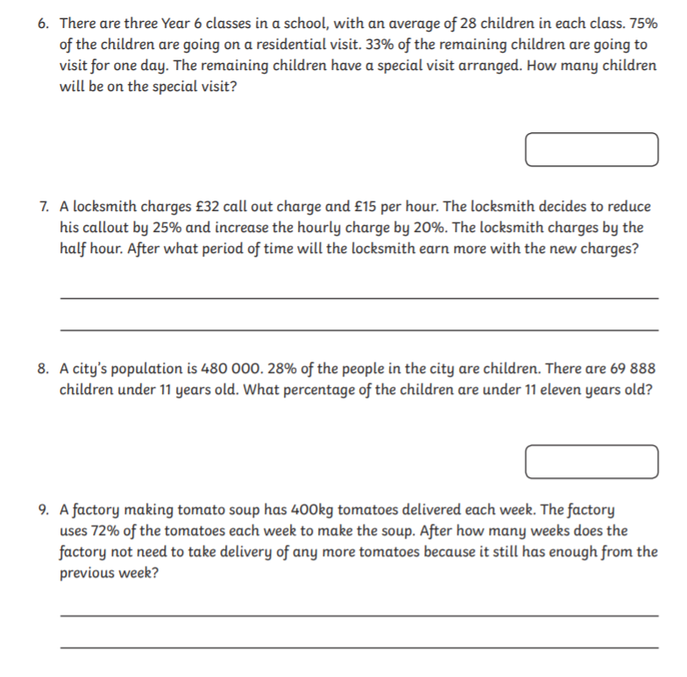
Thursday’s work:
Tim and Beth both have a string of flags. They have red flags, white flags, blue flags, and union jacks.
They both counted how many of each colour they had.
Tim's flags are 50% blue, 35% red, 10% white and 5% union jacks.
Beth's flags are 40% blue, 32% red, 20% white and 8% union jacks.
They both have as few flags as is possible with those percentages.
Who has the most flags?
Who has the most red flags?
Who has the most blue flags?
How many union jacks do they have between them?

If instead you know that Tim and Beth have 10 union jacks between them how many flags do they have altogether?

Friday’s work:
In Mathland TV a political commentator summed up an election result as follows.

A Labour majority of 1729 last time has been turned into a Conservative majority of 1654 in this election and the conservative candidate has obtained 38% of the poll. Labour has taken second place. The Liberal Democrat has obtained only 14% of the poll and has been beaten into fourth place by the SNP candidate who has 50 more votes than the Liberal Democrat.
Given that there were just four candidates and that the figures quoted were exact find the number of votes polled for each candidate.

