Maths  **Please also encourage your child to access Mathletics daily on top of or to help the work set** | Monday | This week we have maths investigations based on division calculations  Watch for an introduction: https://www.bbc.co.uk/bitesize/topics/z36tyrd/articles/zgxdfcw  All Maths work is at the bottom of the sheets:  LO: Can I solve short division with remainders, calculations?
 | Tuesday | LO: Can I complete a speed division and multiplication quiz?
 | Wednesday | LO: Can I solve the short division calculations?
 | Thursday | LO: Can I solve the short division with remainders calculations?
 | Friday | LO: Can I solve the short division with remainders calculations?
English  **Please also encourage your child to read daily either independently or to an adult. | Monday | https://www.talk4writing.co.uk/wp-content/uploads/2020/05/Y5-One-Chance.pdf  One Chance by Dean Thompson  This is the third unit of English work to last three weeks, each day I have selected the pages to complete so that you can work  through the booklet. It will be similar to our English lessons, in that we used an author’s work to base our learning around.  Today pages 20-21
 | Tuesday | Pages 22-23
 | Wednesday | Page 24-26
 | Thursday | Pages: continue your own story
 | Friday | Pages: finish and review your own story
Topic/Science | Topic | We are continuing with our Americas Topic.  Watch: https://www.bbc.co.uk/bitesize/topics/zq6svcw/articles/zs2ph39 watch all the clips on this link and read the information about what remains of the ancient Maya.  This week, we are learning about what remains of the ancient Maya. Use the information you have read and watched to create a poster. You can complete some of your own research too, if you wish.  LO: Can I explain what remains of the ancient Mayas?  This will be the third part of your own investigation topic about the Maya people.
 | Science | We are starting to revise our solar system and space knowledge, watch:  https://www.bbc.co.uk/bitesize/topics/zdrrd2p/articles/ztsdj6f  Have a go at the quiz.  LO: Can I explain which planets are the rocky ones?  On your poster explain your understanding of the video. You can research it further if you wish.
PE | Activity 1 | Joe Wicks workout (Joe is reducing his videos to Monday’s, Wednesday’s and Saturday’s)
 | Activity 2 | Cosmic Kids Yoga
 | Activity 3 | Real PE at home – online learning resources Real PE at home includes an online programme which supports families to be active, play and learn together. It includes a programme. Here are the details to access real PE at home:  The website address is: home.jasmineactive.com  Parent email: parent@lyngcofepr-1.com  Password: lyngcofepr
Art/Crafts | Activity 1 | It’s thought that the Maya invented the concept of 'zero'. This meant that they were able to do complex calculations, which allowed them to create very detailed and accurate calendars. They used these calendars for farming – perhaps that’s why they were so good at it!  Your first task, this week is to create your own calendar, you don’t have to complete all the days, but think about drawing a series of 12 pictures, one for each month of our calendar.  An extra challenge would be linking these pictures to any of your previous learning about the Mayas.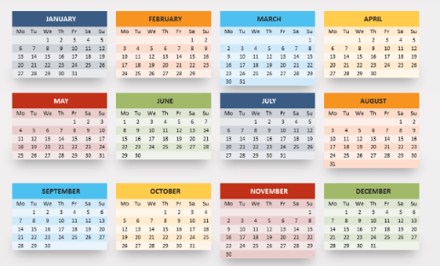
 | Activity 2 | The Maya enjoyed creating books with animal skin covers. Can you make your own mini Mayan book and draw an animal skin cover?  You could draw some Mayan art inside.  LO: Can I make a Mayan mini book?

Maths below:

Monday’s work:
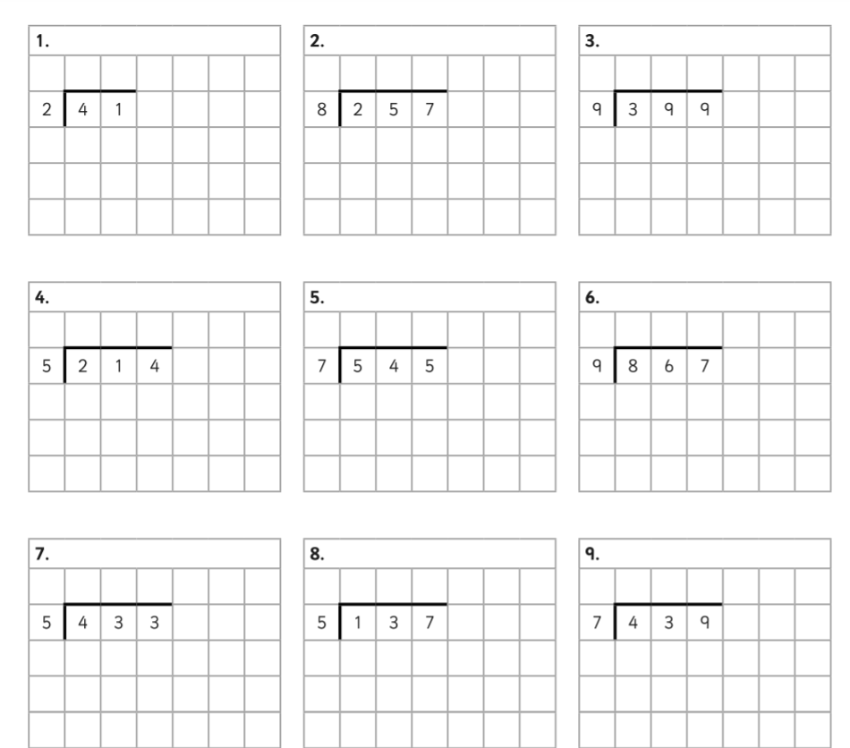

Tuesday’s work:
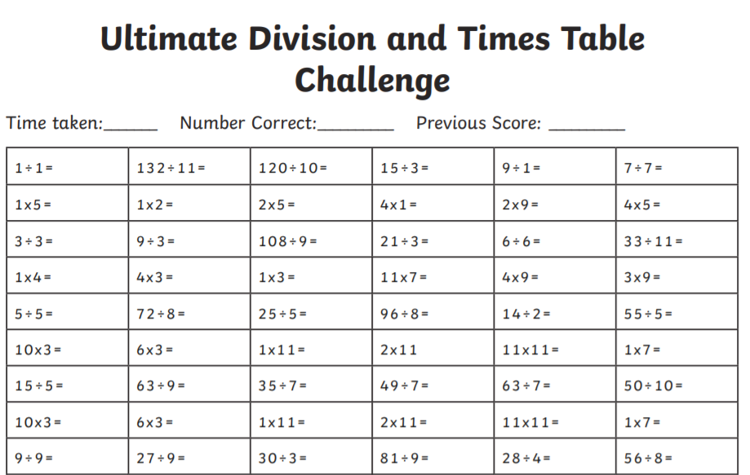
Wednesday’s work:
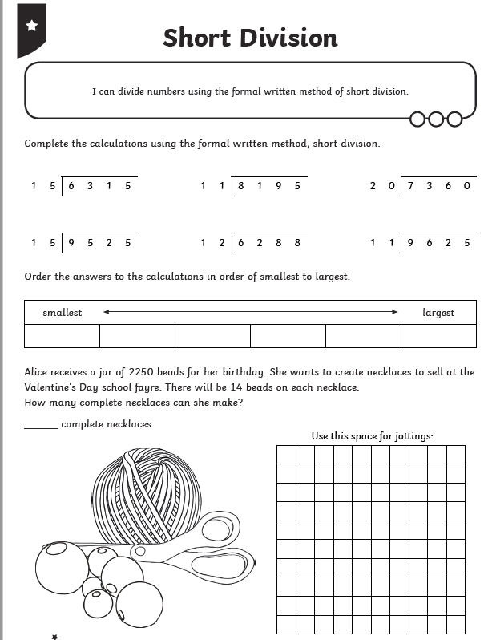
Thursday’s work:
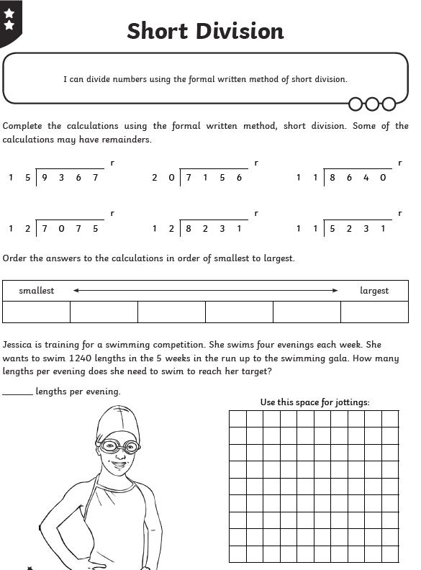

Friday’s work:
