Maths  **Please also encourage your child to access Mathletics daily on top of or to help the work set** | Monday | This week we have maths revision based on past papers.  All Maths work is at the bottom of the sheets:  LO: Can I solve the calculations?
 | Tuesday | LO: Can I solve the calculations?
 | Wednesday | LO: Can I solve the calculations?
 | Thursday | LO: Can I solve the calculations?
 | Friday | LO: Can I check my understanding of my work, this week?
English  **Please also encourage your child to read daily either independently or to an adult. | Monday | https://www.talk4writing.co.uk/wp-content/uploads/2020/05/Y6-Gadgets.pdf  The Gadgets Workbook by James Waller  This is the second unit of English work to last three weeks, each day I have selected the pages to complete so that you can work  through the booklet. It will be similar to our English lessons, in that we used an author’s work to base our learning around.  Today page 12
 | Tuesday | Page 13 over two days
 | Wednesday | Page 13 over two days
 | Thursday | Page 14 Activity 11, Re-read. Polish and improve.
 | Friday | Present your advert to an adult, sibling or audience.
Topic/Science | Topic | We are continuing with our Americas Topic.  Watch: https://www.bbc.co.uk/bitesize/topics/zq6svcw/articles/zg2htv4 watch all the clips on this link and read the information about what life was like for the ancient Mayas.  This week, we are learning about what life was like for the ancient Mayas. Use the information you have read and watched to create a poster. You can complete some of your own research too, if you wish.  LO: Can I start to learn what life was like for the ancient Mayas?  This will be the second part of your own investigation topic about the Maya people.
 | Science | We are starting to revise our solar system and space knowledge, watch:  https://www.bbc.co.uk/bitesize/topics/zdrrd2p/articles/ztsqj6f  LO: Can I explain what the solar system is?  On your poster explain your understanding of the video. You can research it further if you wish.
PE | Activity 1 | Joe Wicks workout
 | Activity 2 | Cosmic Kids Yoga
 | Activity 3 | Real PE at home – online learning resources Real PE at home includes an online programme which supports families to be active, play and learn together. It includes a programme. Here are the details to access real PE at home:  The website address is: home.jasmineactive.com  Parent email: parent@lyngcofepr-1.com  Password: lyngcofepr
Art/Crafts | Activity 1 | 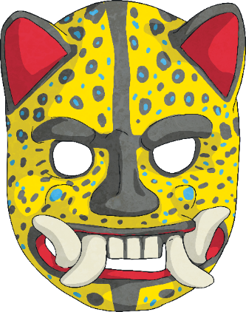  Masks played a central role in Maya culture. They were made for a variety of occasions and purposes. In fact, they were even used to decorate temples.  Event Masks  Masks were often inspired by animals; they were vibrant and colourful.  The Mayas believed that animals represented the spirits. For example, many Maya often associated strong  kings with jaguars.  Your task is to draw your own Event mask.
 | Activity 2 | The Mayan’s used mask as a way of expressing themselves.  Your second task, this week, is to design a mask that expresses you.  You could draw your family, pets or hobbies on it.  Or you could make it one complete design.  I’d love to see your ideas and creations via the class e-mail, if you’d like to share.

Maths below:
Monday’s work:
Complete this arithmetic paper, with workings out on paper:
http://satspapers.org/SATs%20papers/2016%20onwards/2019mathssats/STA198216e_2019_ks2_mathematics_Paper1_arithmetic.pdf
Tuesday’s work:
Use mathletics to revise any areas you found tricky from yesterday’s paper.

Wednesday’s work:
Complete, with workings out on paper: http://satspapers.org/SATs%20papers/2016%20onwards/2019mathssats/STA198217e_2019_ks2_mathematics_Paper2_reasoning.pdf

Thursday’s work:
Complete, with workings out on paper:
http://satspapers.org/SATs%20papers/2016%20onwards/2019mathssats/STA198218e_2019_ks2_mathematics_Paper3_reasoning.pdf

Friday’s work:
Use mathletics to revise any areas you found tricky from Wednesday’s and Thursday’s papers.
Or, let Miss Wharton know, via class email.
Have an add up, and let me know how you got on via the class email.

