Maths  **Please also encourage your child to access Mathletics daily on top of or to help the work set** | Monday | This week we have maths investigations based on multiplication calculations  Watch for an introduction: https://www.bbc.co.uk/bitesize/articles/zjbyvk7  All Maths work is at the bottom of the sheets:  LO: Can I solve the column multiplication calculations?
 | Tuesday | LO: Can I solve the column multiplication calculations?
 | Wednesday | LO: Can I solve the column multiplication calculations?
 | Thursday | LO: Can I solve the column multiplication calculations?
 | Friday | LO: Can I solve the multiplication investigation?
English  **Please also encourage your child to read daily either independently or to an adult. | Monday | https://www.talk4writing.co.uk/wp-content/uploads/2020/05/Y5-One-Chance.pdf  One Chance by Dean Thompson  This is the second unit of English work to last three weeks, each day I have selected the pages to complete so that you can work  through the booklet. It will be similar to our English lessons, in that we used an author’s work to base our learning around.  Today page 12
 | Tuesday | Pages 13-14
 | Wednesday | Page 15
 | Thursday | Pages 16-17
 | Friday | Pages 18-19
Topic/Science | Topic | We are continuing with our Americas Topic.  Watch: https://www.bbc.co.uk/bitesize/topics/zq6svcw/articles/zg2htv4 watch all the clips on this link and read the information about what life was like for the ancient Mayas.  This week, we are learning about what life was like for the ancient Mayas. Use the information you have read and watched to create a poster. You can complete some of your own research too, if you wish.  LO: Can I start to learn what life was like for the ancient Mayas?  This will be the second part of your own investigation topic about the Maya people.
 | Science | We are starting to revise our solar system and space knowledge, watch:  https://www.bbc.co.uk/bitesize/topics/zdrrd2p/articles/ztsqj6f  LO: Can I explain what the solar system is?  On your poster explain your understanding of the video. You can research it further if you wish.
PE | Activity 1 | Joe Wicks workout
 | Activity 2 | Cosmic Kids Yoga
 | Activity 3 | Real PE at home – online learning resources Real PE at home includes an online programme which supports families to be active, play and learn together. It includes a programme. Here are the details to access real PE at home:  The website address is: home.jasmineactive.com  Parent email: parent@lyngcofepr-1.com  Password: lyngcofepr
Art/Crafts | Activity 1 | 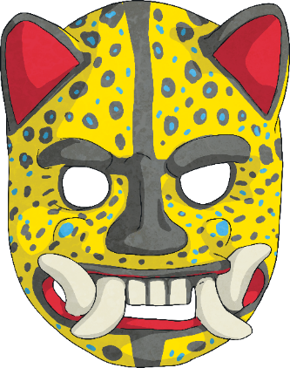  Masks played a central role in Maya culture. They were made for a variety of occasions and purposes. In fact, they were even used to decorate temples.  Event Masks  Masks were often inspired by animals; they were vibrant and colourful.  The Mayas believed that animals represented the spirits. For example, many Maya often associated strong  kings with jaguars.  Your task is to draw your own Event mask.
 | Activity 2 | The Mayan’s used mask as a way of expressing themselves.  Your second task, this week, is to design a mask that expresses you.  You could draw your family, pets or hobbies on it.  Or you could make it one complete design.  I’d love to see your ideas and creations via the class e-mail, if you’d like to share.

Maths below:

Monday’s work:
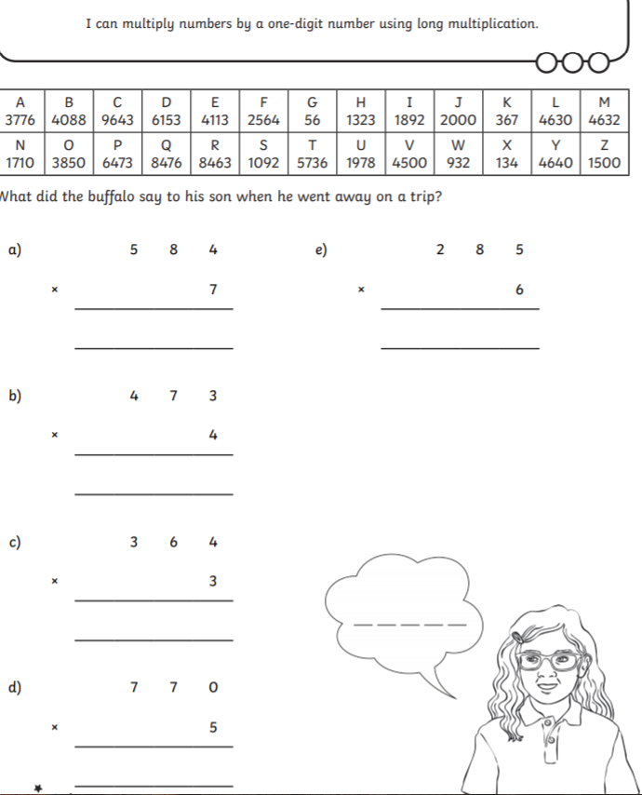 Extension: complete all the sheets from the link above day 1.

Tuesday’s work:
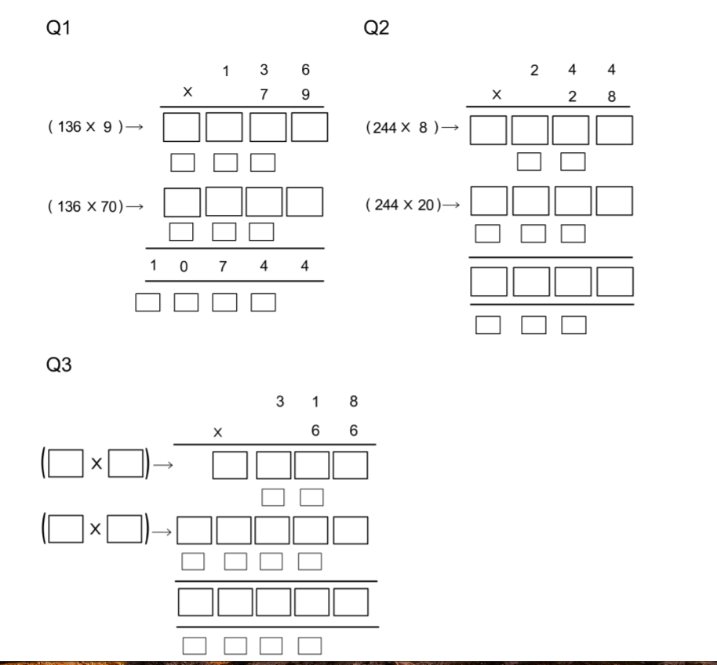Extension: complete all the sheets from the link above day 2.

Wednesday’s work:
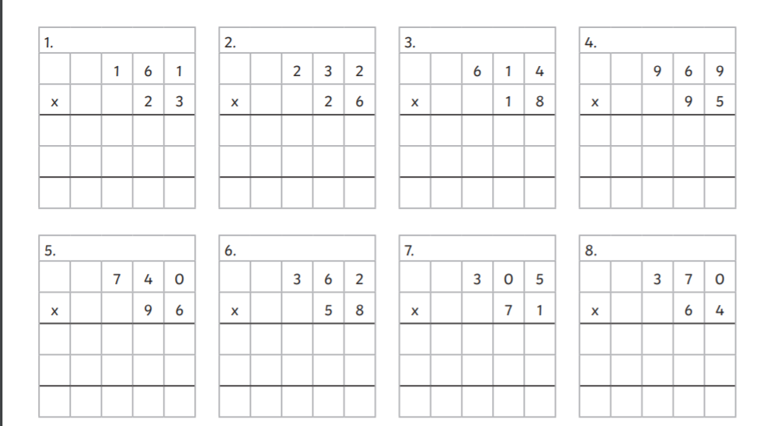
Thursday’s work:

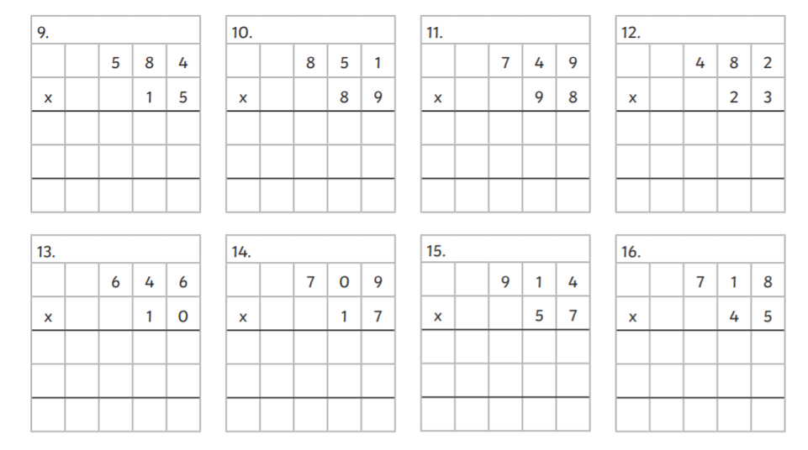
Friday’s work:
This is your chance to follow some numbers and see where they go!
A simple rule is all you need.
My first suggestion is to add the digits together then multiply (times) by 2.
The first number that I chose happened to be 56.
So, let's start:
We add the 5 and 6, 5+6=11
We multiply the 11 by 2, 2×11=22, and that's the first part of the journey.
So, where now?
We carry on with this rule:
We add the 2 and 2, 2+2=4
We multiply the 4 by 2, 4× 2=8, and that's the second part the journey.
Now, 8+ 0=8 and 8× 2=16 and that was the third part.
And, 1+6=7, and 7× 2=14
Do the same to 14 and we get 10
10 leads to 2, 2 leads to 4, 4 leads to 8 and we are back to where we got to in the second part of the journey.
If we went on and on and wrote down where we got to after each part we would see something like:
56,22,8,16,14,10,2,4,8,16,14,10,2,4,8,...
After exploring that journey it's time to start somewhere new, for example 11 which goes along like this;:
11,4,8,16,14,10,2,4,8,...
Oh! So we are on the same bit as before, a circular bit that goes 2,4,8,16,14,10 and then back to the 2 again.
Now a new starting place, 96.
This goes like this:
96,30,6,12,6,12,6,..
Oh! So we now have a smaller circular bit of the journey that goes 6,12 then back to the 6.
I explored further trying to start with each number from 1 to 99.
Then I tried similar, but different rules.
I found I needed a big piece of plain paper and used arrows to show the journeys. Here are just some bits of them to tempt you to go further:
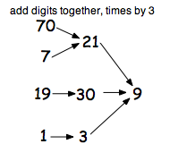and 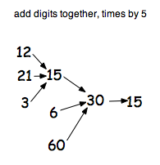

There are 99 starting points to try and I've only show you 8 on each of the two above so there are lots more to explore!

Decide on the rules you will use and investigate what happens with different starting points.
You might invent your own way of recording your findings.

I’d love to hear how you got on.

