Hello everybody,
Hope you have all had a good week and are all staying safe.
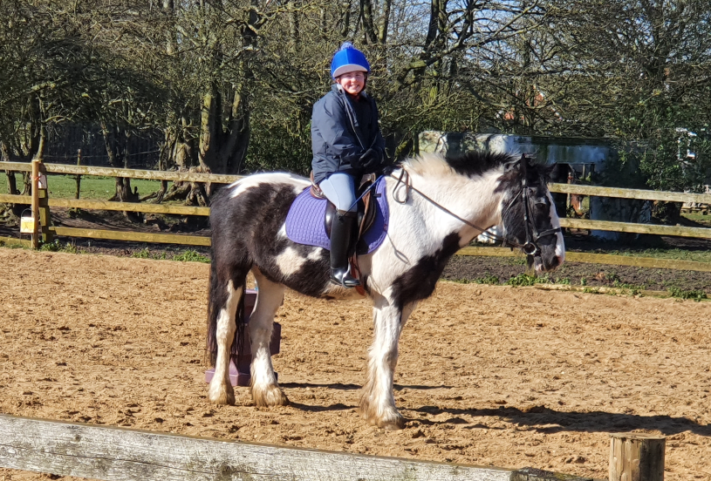
This week, Fran emailed in this lovely picture of her riding George.

We have been keeping fit in class everyday too. We were completing P.E with Joe every morning, but Joe has now reduced his timetable, so we are completing Cosmic Yoga on a Tuesday and Thursday.
We would love to hear from you, via the class email if you have been doing any P.E or sports too.
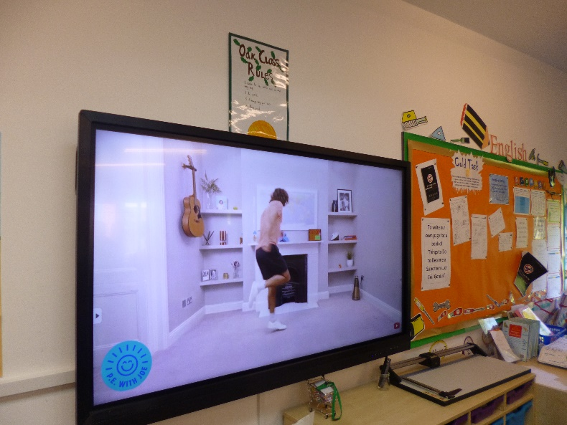

Daniel has been emailing us some excellent quizzes, we have really enjoyed- thank you Daniel.
We are also enjoying the sunshine this week, let us know what you have been up to.
From Miss Wharton and the Year 6’s.

