Dear Oak,
Another week has passed here in Oak class and we hope you and your families are keeping well.
We thought we’d report on some news, we would love to hear from you guys on the Oak email address: oak@lyng.norfolk.sch.uk
On Monday we celebrated Anna’s birthday. Look at her amazing birthday cake, which she kindly emailed some pictures of. Remember you can share any pictures you’d like, too.
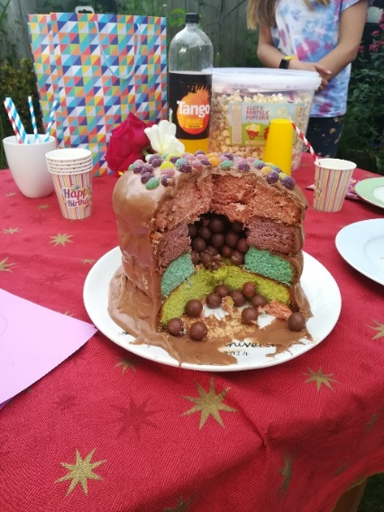
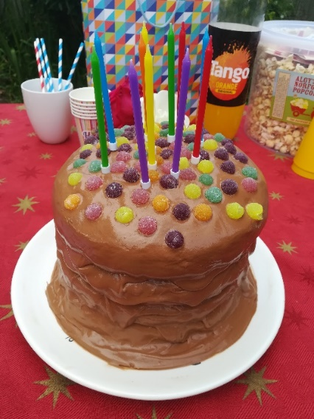

Like you, we have started to learn about Space and planets, in science. A great program to help with this is ‘The Planets’ which can be found on BBC iplayer. Professor Brian Cox explores the dramatic lives of the eight majestic planets/worlds that make up our solar system.
Here is the link: https://www.bbc.co.uk/iplayer/episodes/p07922lr/the-planets

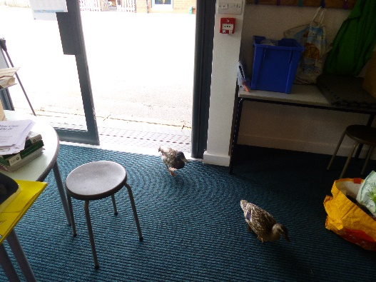
We also had some visitors to Oak class, they didn’t stay long when they saw the maths we were doing!

Take Care and we hope to hear from you soon.
Oak Class

