Hi Rowan Class and parents,
I hope you are all having a good week! I’ve enjoyed once again seeing all of your great home learning, highlights being Sweden posters and even a keyboard rendition of Mamma Mia!
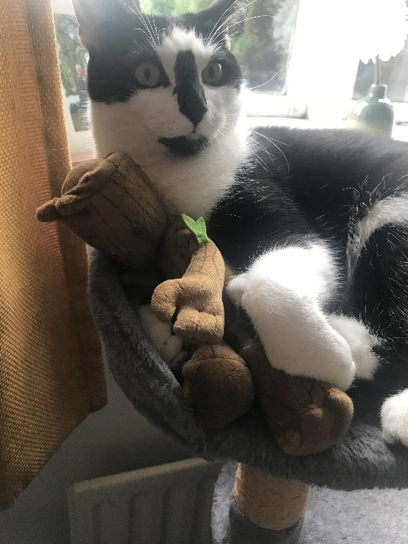
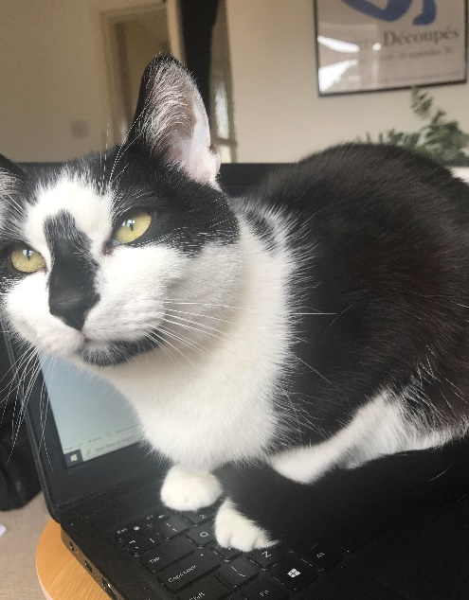
This week Rupert has decided to ‘help’ me with my planning, but I think he’s being more of a hindrance than a help!
He is still enjoying playing with Baby Groot too!

This week, Miss Dorr joined Mrs. Warnes and I in our hub! It’s been so lovely to work with her and she’s really enjoying seeing how some of the pupils she worked with in Willow are getting on now, in our class and through the Rowan email address.
I’m so happy that the bad weather has finally gone and we are seeing some more sunny days! It’s important that we spend more time outdoors as it’s an excellent way to relax and recharge. Perhaps some of your home learning could be done outside.
If you are looking for inspiration on activities that you can do outside, Mrs. Warnes can recommend The Wildlife Trust’s initiative called ’30 Days Wild’. Sign up to receive your free back of activities you can do outdoors!
https://action.wildlifetrusts.org/page/59240/petition/1?supporter.questions.409397=home
Best wishes,
Miss Cartwright.

