Dear Rowan class and parents,

I hope you have all had a good week enjoying the glorious sunshine! We’ve been outside lots at school making the most of the weather and doing some of our learning in the Woodland Glade!
I know you have been enjoying your weekly Rupert update, so here he is on his cat tower having a sunbathe.

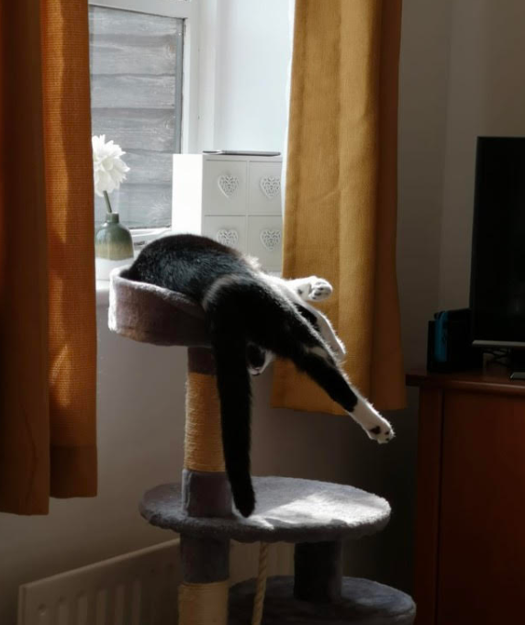

This week in class there have been lots of conversations about Bam Bam the deer! Some of you have already met Bam Bam (including Mrs. Warnes!) and have sent me photos. I saw him on my way home getting stroked on the bridge! Has anybody else seen him about? He’s becoming a bit of a local celebrity!
Maybe you could write a story or draw a picture about Bam Bam?

Take care everybody. Do keep sending me your home learning!
Miss Cartwright

