Maths  **Please also encourage your child to access Mathletics daily on top of the work set** | Monday | Daily practise of the 12 times table.  Tenths as fractions as decimals – this video might be useful https://www.youtube.com/watch?v=yWcNQkmpYVk  Scroll down for this week’s maths!
 | Tuesday | Daily practise of the 12 times table.  x and ÷ 10 and 100 – this video is useful https://www.youtube.com/watch?v=pbPLPUqwhZ4  Scroll down for this week’s maths!
 | Wednesday | Daily practise of the 12 times table.  Comparing decimals – see poster below.  Scroll down for this week’s maths!
 | Thursday | Daily practise of the 12 times table.  + and – fractions – see poster below.  Scroll down for this week’s maths!
 | Friday | Daily practise of the 12 times table.  Parents – test your child on their 11s today! 0-12 x 12 in a random order.  Fractions of an amount. – these videos are useful:  https://www.youtube.com/watch?v=sQjfEOTZYgE and https://www.youtube.com/watch?v=s454_fPJwPs  Scroll down for this week’s maths!
English  **Please also encourage your child to read daily either independently or to an adult or older sibling** | Monday | Using the plan you made last week, begin writing your wishing story.  You will need to think about:  - Paragraphs  - Sentence openers  - Where commas go  Can you think of 3 things you want to achieve when writing your story? E.g:  - Ambitious vocabulary  - Fronted adverbials  - Complex sentences
 | Tuesday | Continue to write your wishing story.
 | Wednesday | Try to finish your wishing story today – read it and think of 3 things you want to improve on for tomorrow.
 | Thursday | Read your wishing story again – improve the 3 things you identified yesterday.
 | Friday | Complete the tasks on page 25-26  Design a front cover for your wishing story.
Topic/Computing | Topic | https://www.bbc.co.uk/bitesize/topics/ztyr9j6/articles/ztqbr82  Read the information and watch the clips about what life was like as a Viking.  - Draw a picture of a Viking house and label the different parts of their living space  - Create a poster showing the social structure of Viking life with the King at the top, then the jarl, then the karl and then the thrall at the bottom.
 | Computing | https://www.thinkuknow.co.uk/globalassets/thinkuknow/documents/thinkuknow/parents/pdf/thinkuknow-8-10s-home-activity-sheet-2.pdf  If needed, watch Episode 1: Block Him Right Good, Alfie again with your child at www.thinkuknow.co.uk/8_10/watch/.  - Look at Resource Sheet 1: Alfie’s profile. Alfie has taken some important steps to make sure that he is safe when he is making videos and posting them online.  - Ask your child to write down four steps Alfie has taken, either on the Resource Sheet or on paper.  - Once completed, discuss your child’s answers and identity any missed steps.  Ask your child what they remember about Episode 1 of Play Like Share.  Ask your child:  - Who wrote a mean comment about Alfie?  - Who ‘liked’ the comment?  - Why wasn’t this a kind thing to do?  - Explain when we write or post something online, we must always think about how we might make other people feel.  - What positive words could Ellie, Alfie and Sam use to describe each other?  Using Resource Sheet 2: Being kind online, ask your child to write as many positive words and phrases as they can think of next to each character, using any clues in the video to help. Alternatively, your child can draw pictures of each character and add positive words to describe them.
PE | Activity 1 | Joe Wicks workout
 | Activity 2 | Cosmic Kids Yoga
 | Activity 3 | Real PE:  The website address is: home.jasmineactive.com  Parent email: parent@lyngcofepr-1.com  Password: lyngcofepr
Art/Crafts | Activity 1 | Design a ‘Thank You NHS and Key Workers’ poster to put up in one of your windows.
 | Activity 2 | If you have not completed your Viking long ship model, please continue with this.  If you have completed the model, you can have a go at making a marble run game (scroll down for the instructions)

Monday
Option 1 | Option 2
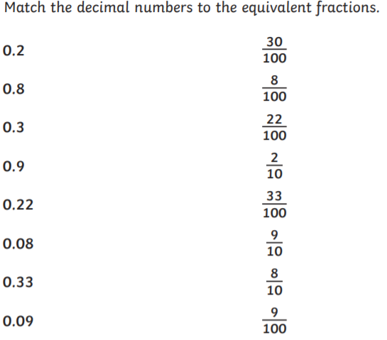 | 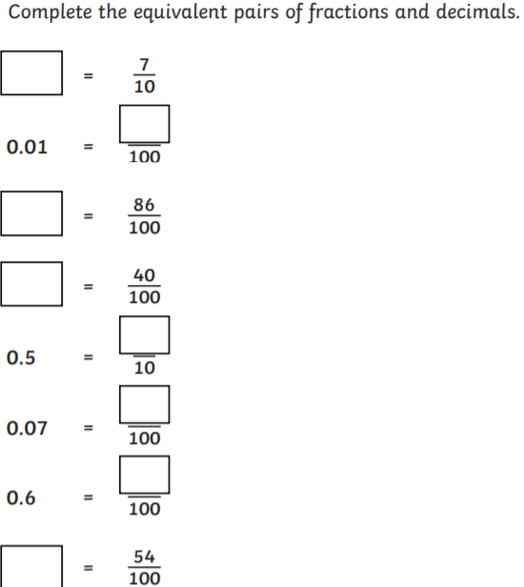

Tuesday
Option 1 | Option 2
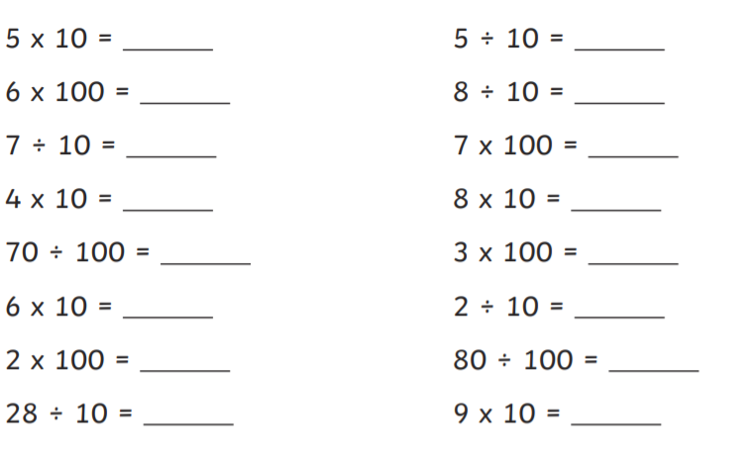 | 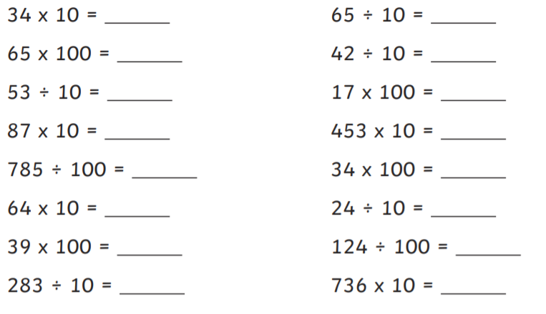
Wednesday
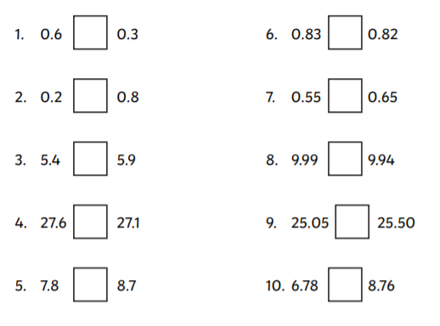

Thursday
Option 1 | Option 2
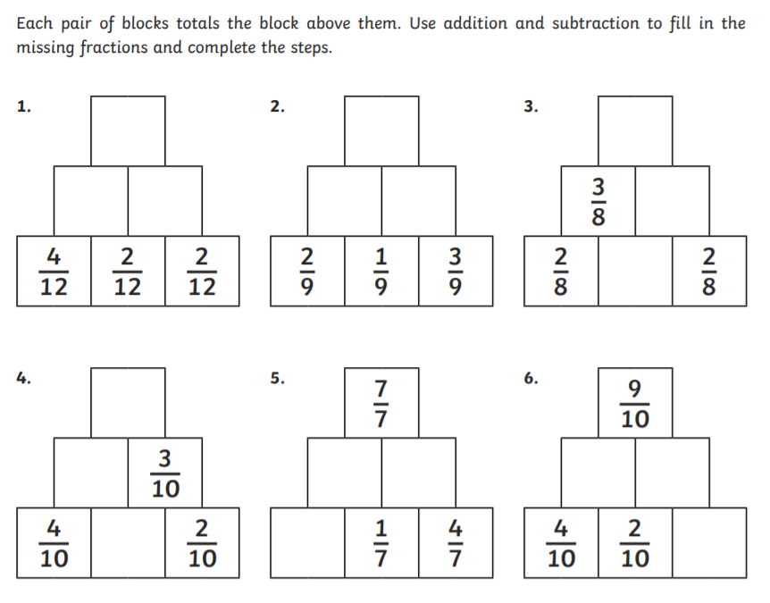 | 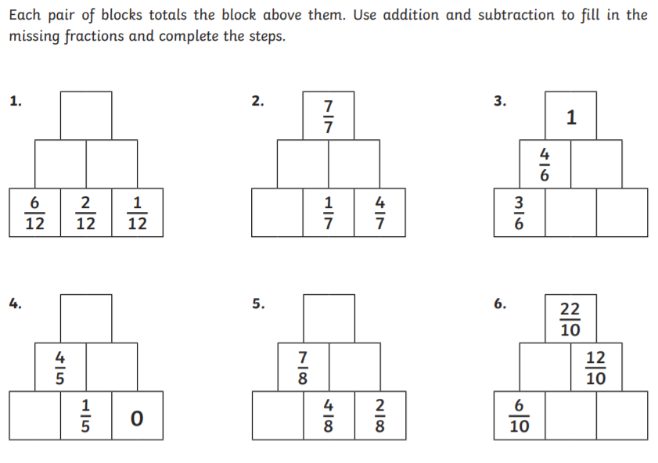
Friday
Option 1 | Option 2
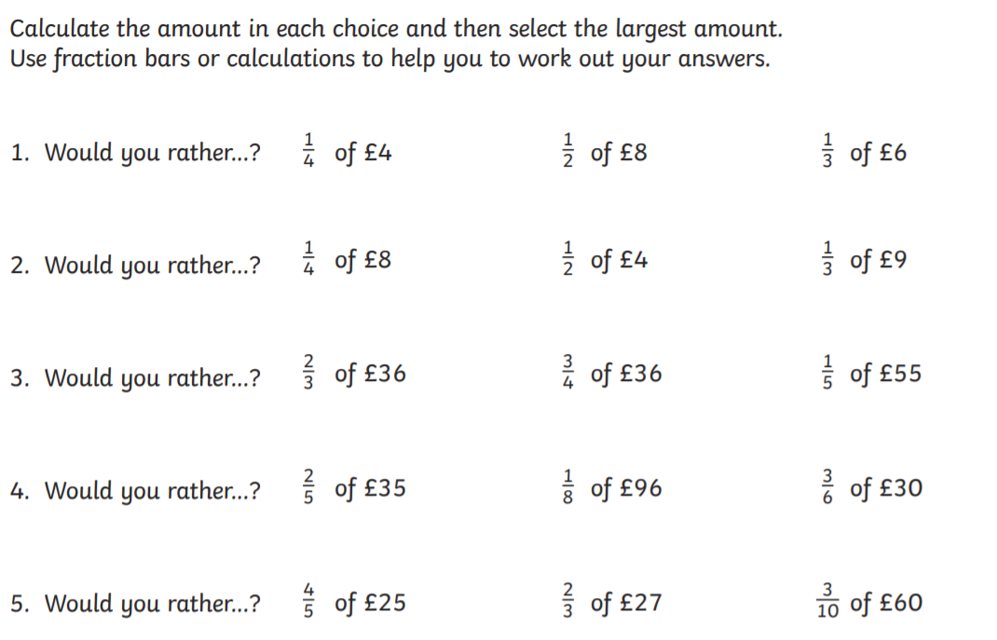 | 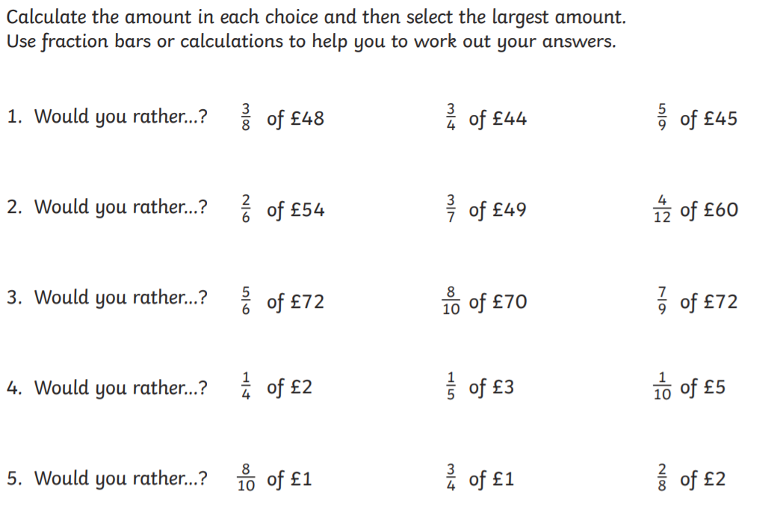

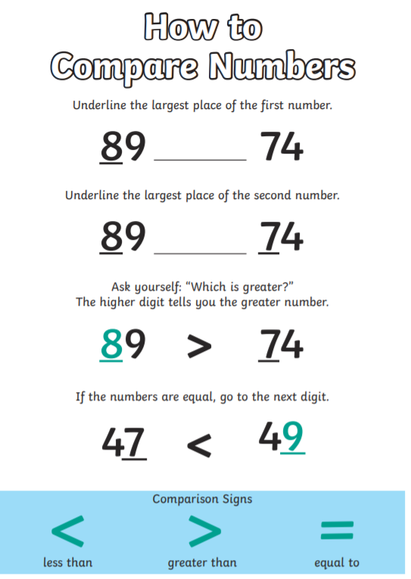
$\frac{2}{3}$ Top number = numerator
Bottom number = denominator

