Maths – see the attached pictures for an example of how to solve the problems.  = easier  = standard  = harder  **Please also encourage your child to access Mathletics daily on top of the work set** | Monday | Daily practise of the 12 times tables  Adding fractions. – see poster below  Scroll down for this week’s maths!
 | Tuesday | Daily practise of the 12 times tables.  Subtracting fractions – see poster below.  Scroll down for this week’s maths!
 | Wednesday | Daily practise of the 12 times tables.  Ordering fractions – this video might be useful https://www.youtube.com/watch?v=C1dGmnS7g-4  Scroll down for this week’s maths!
 | Thursday | Daily practise of the 12 times tables.  Tenths – this video might be useful https://www.youtube.com/watch?v=yWcNQkmpYVk&t=154s  Scroll down for this week’s maths!
 | Friday | Daily practise of the 12 times tables.  Parents – test your child on their 11s today! 0-12 x 12 in a random order.  Comparing fractions. – see poster below and this video: https://www.youtube.com/watch?v=C1dGmnS7g-4  Scroll down for this week’s maths!
English  **Please also encourage your child to read daily either independently or to an adult or older sibling** | Monday | Using the plan you made last week, begin writing your Troll information sheet.  You will need to think about:  - Lay out of your information sheet.  - Headings and subheadings.  - Title of your Trolls information sheet.  Can you think of 3 things you want to achieve when writing your story? E.g:  - Capital letters and full stops  - Adverbs  - Expanded noun phrases
 | Tuesday | Continue to write your Troll information sheet.
 | Wednesday | Try to finish your Troll information sheet today – read it and think of 3 things you want to improve on for tomorrow.
 | Thursday | Read your Troll information sheet again – improve the 3 things you identified yesterday.
 | Friday | Complete the tasks on page 17-18  Design a front cover for your Trolls information text.
Topic/Computing | Topic | https://www.bbc.co.uk/bitesize/topics/ztyr9j6/articles/ztqbr82  Read the information and watch the clips about what life was like as a Viking.  - Draw a picture of a Viking house and label the different parts of their living space  - Create a poster showing the social structure of Viking life with the King at the top, then the jarl, then the karl and then the thrall at the bottom.
 | Computing | https://www.thinkuknow.co.uk/globalassets/thinkuknow/documents/thinkuknow/parents/pdf/thinkuknow-8-10s-home-activity-sheet-2.pdf  If needed, watch Episode 1: Block Him Right Good, Alfie again with your child at www.thinkuknow.co.uk/8_10/watch/.  - Look at Resource Sheet 1: Alfie’s profile. Alfie has taken some important steps to make sure that he is safe when he is making videos and posting them online.  - Ask your child to write down four steps Alfie has taken, either on the Resource Sheet or on paper.  - Once completed, discuss your child’s answers and identity any missed steps.  Ask your child what they remember about Episode 1 of Play Like Share.  Ask your child:  - Who wrote a mean comment about Alfie?  - Who ‘liked’ the comment?  - Why wasn’t this a kind thing to do?  - Explain when we write or post something online, we must always think about how we might make other people feel.  - What positive words could Ellie, Alfie and Sam use to describe each other?  Using Resource Sheet 2: Being kind online, ask your child to write as many positive words and phrases as they can think of next to each character, using any clues in the video to help. Alternatively, your child can draw pictures of each character and add positive words to describe them.
PE | Activity 1 | Joe Wicks workout
 | Activity 2 | Cosmic Kids Yoga
 | Activity 3 | Real PE:  The website address is: home.jasmineactive.com  Parent email: parent@lyngcofepr-1.com  Password: lyngcofepr
Art/Crafts | Activity 1 | Design a ‘Thank You NHS and Key Workers’ poster to put up in one of your windows.
 | Activity 2 | If you have not completed your Viking long ship model, please continue with this.  If you have completed the model, you can have a go at making a marble run game (scroll down for the instructions)

Monday
Option 1 | Option 2
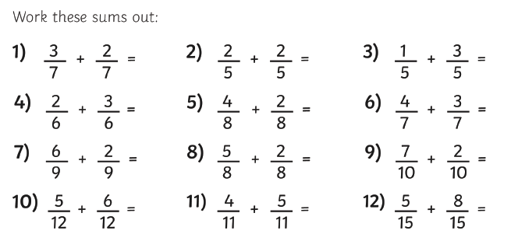 | 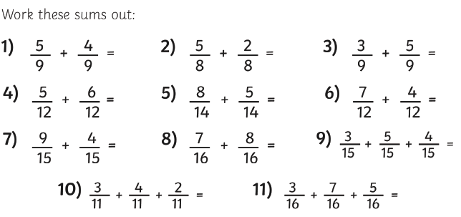

Tuesday – enjoy the addition of frogs today
Option 1 | Option 2
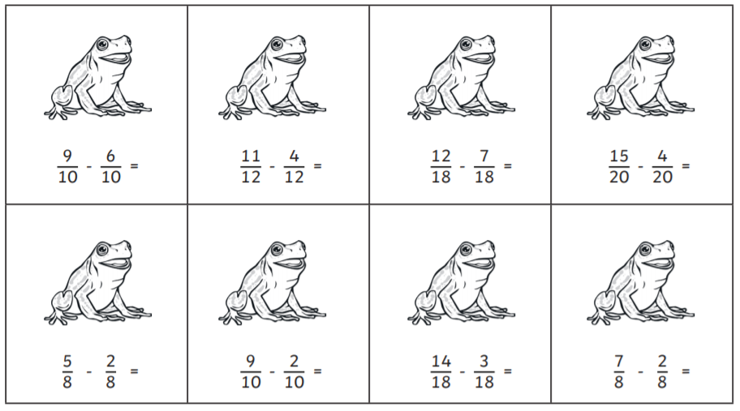 | 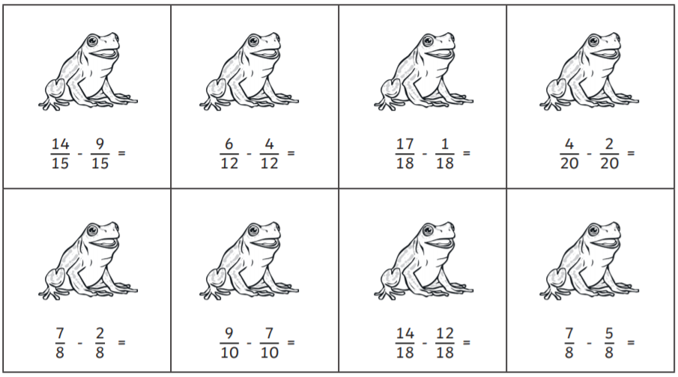

Wednesday
Option 1 | Option 2
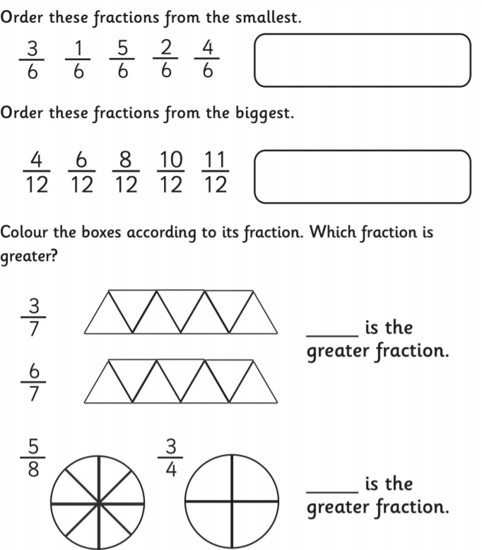 | 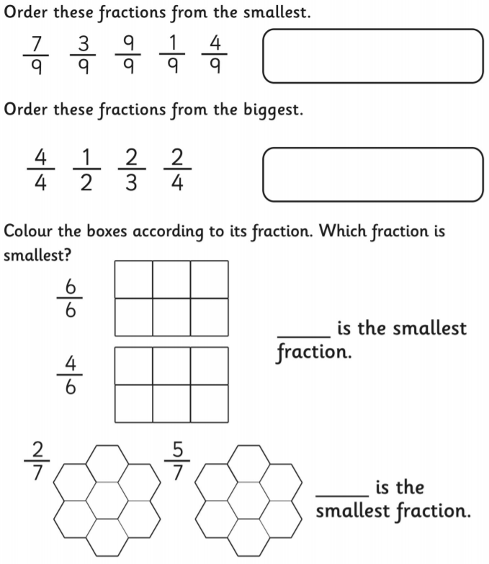

Thursday
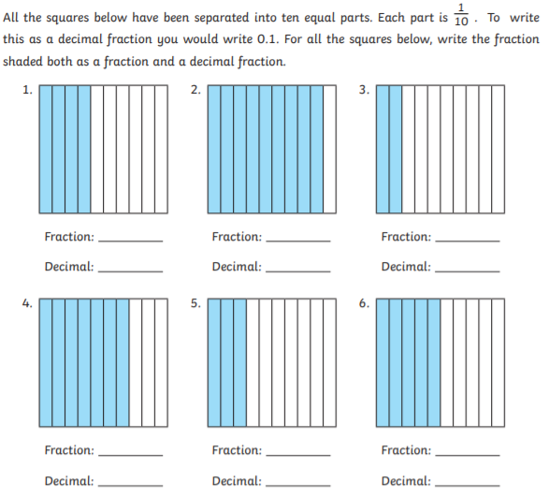

Friday
Option 1 | Option 2
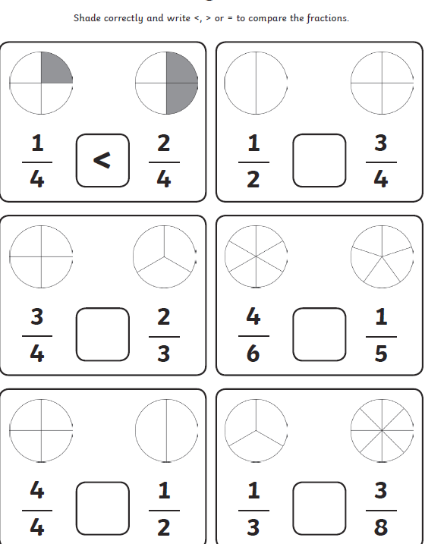 | 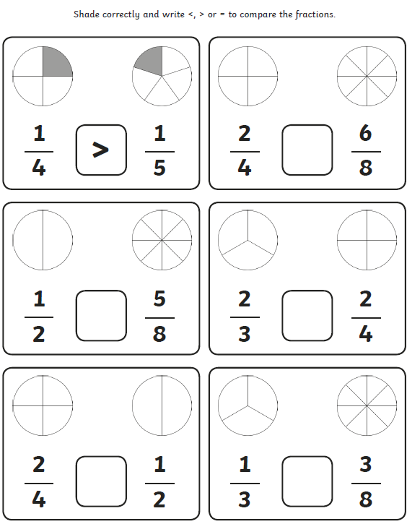

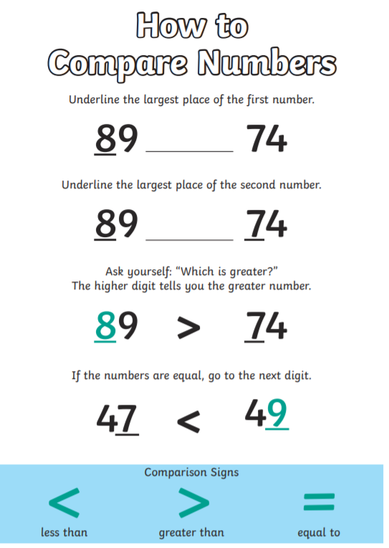
$\frac{2}{3}$ Top number = numerator
Bottom number = denominator
