Maths | Monday | Look round your house or garden for containers which would hold a liquid. Collect 3 different size containers. The amount each container can hold is called its capacity.  We can measure accurately by using standard units of measurement called litres (l) and millilitres (ml). Look at some containers around the house and read what it says on the front e.g. milk 2 litres.  If you have a litre jug in your kitchen ask a grown up to help you use it to measure some bigger containers e.g. a bucket. Be careful litre jugs are sometimes made of glass.  This activity would be best done outside or somewhere that doesn’t matter if it gets wet!  Additional challenge: remember this fact- there are 1000ml in a litre.
Maths | Tuesday | This activity would be best done outside or somewhere that doesn’t matter if it gets wet!  Look again at a litre jug if you have one. Notice that the smaller marks are millilitres. Find some smaller containers e.g. a cup, a yoghurt pot, a small bucket. Now fill them to the top with water. Next tip them carefully into the litre jug. Stand the jug on a level surface and read the scale to show the amount. It may be easier to read to the nearest 100ml.  Additional challenge: read the measurement exactly by working out the scale.
Maths | Wednesday | Today practice reading scales. What do these jugs contain? Look carefully!  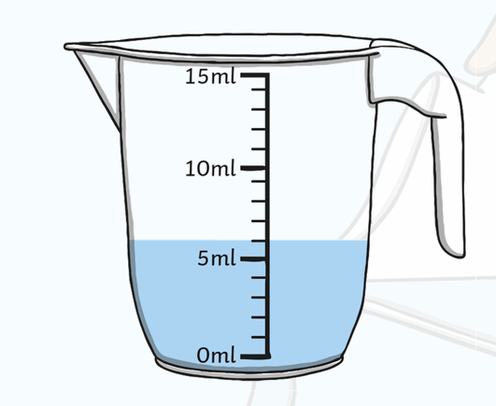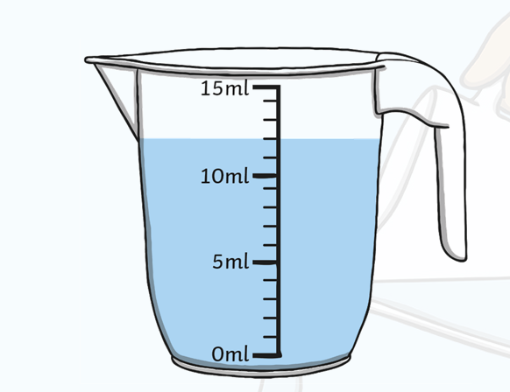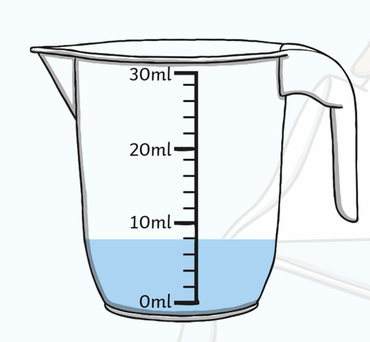  Additional challenge:  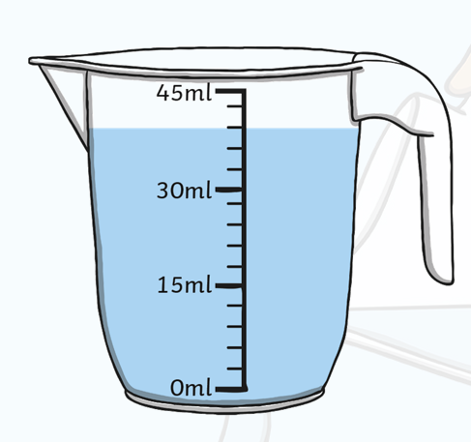
Maths | Thursday | Now complete the worksheets below. Choose your level of challenge
Maths | Friday | Challenge day: Choose at least one challenge.  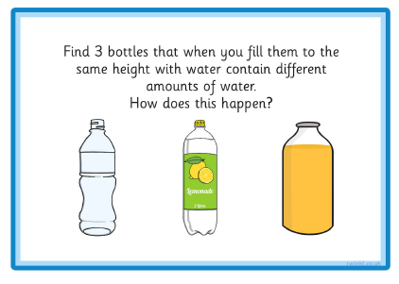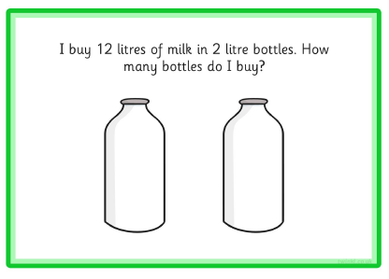  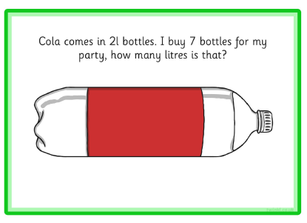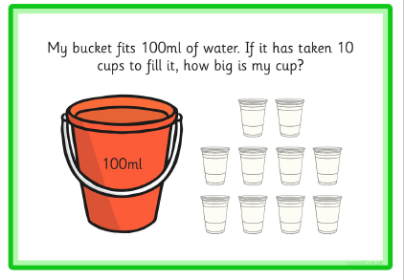
English  **Please also encourage your child to read daily | Monday | Use ‘The Magical Teaching Box’ pack from the previous week.  Listen to the poem ‘The Magic Box’ https://www.bbc.co.uk/bitesize/clips/zkpmhyc  Then read the same poem on page 14 with someone at home.  What is in the magic box?  The poem says My box is fashioned from….. What does this mean?  What adjectives does the poet use to describe the box?  Complete the sheet on page 15  Additional challenge: make your own special box.
English  **Please also encourage your child to read daily | Tuesday | Using the special box you have made or find another container then walk round your house or garden and put in it things that are special to you. If the object won’t fit, write or draw it on a piece of paper.  Use what you have collected to help you write a list. You could write your own list or complete the sheet on page 17. Then organise your thoughts into the first 3 lines of a poem – use page 17 to help you.
English  **Please also encourage your child to read daily | Wednesday | If you have made a box look at it carefully. What does it look like? If you haven’t made a box imagine what your special box would look like. You may want to draw a picture.  Then write the final verse of your poem using the bottom of page 18 to help you.
English  **Please also encourage your child to read daily | Thursday | Now reflect on this unit of work. Apollo, god of knowledge wants to know how you got on. Complete page 19
English  **Please also encourage your child to read daily | Friday | You are at the end of this unit of work. Today choose one of the following tasks to do:  Re read the story.  Find another story or poem in your own collection to read.  Think about the story of Pandora. Is it the same, in any way, to any other story you have read?  Draw a picture of the story.  Create a storyboard to re tell the story.  Write your own version of the story.  Additional challenge: retell the story in only 50 words. You may like to print or make a grid with 50 squares to help you.
Grammar and spelling | Monday | This week we are going to recap what we know about some different types of punctuation. Today: capital letters and full stops.  Watch https://www.youtube.com/watch?v=BNog8C2FRqU. Focus on capital letters  Try the activity https://www.bbc.co.uk/games/embed/small-town-superheroes?exitGameUrl=http%3A%2F%2Fbbc.co.uk%2Fbitesize%2Farticles%2Fzncgvk7  Click on PUNCTUATION then capital letters.
Grammar and spelling | Tuesday | Today full stops  Try the activity https://www.bbc.co.uk/games/embed/small-town-superheroes?exitGameUrl=http%3A%2F%2Fbbc.co.uk%2Fbitesize%2Farticles%2Fzncgvk7  Click on PUNCTUATION then full stops.
Grammar and spelling | Wednesday | Today: question marks?  To refresh your memory watch, https://www.bbc.co.uk/bitesize/articles/z7b72sg  Try the activity https://www.bbc.co.uk/games/embed/small-town-superheroes?exitGameUrl=http%3A%2F%2Fbbc.co.uk%2Fbitesize%2Farticles%2Fzncgvk7  Click on PUNCTUATION then question marks.
Grammar and spelling | Thursday | Today exclamation marks!  Watch https://www.bbc.co.uk/bitesize/topics/z8x6cj6/articles/z3dcmsg  Highlight the exclamation on the same page and then try the quiz.
Grammar and spelling | Friday | spelling practice – recap some of the words you have learnt already (see spelling box below)
Topic/  Science | Topic 1 | This week we are travelling away from the U.K. to the continent of Europe. The U.K. is part of Europe. Europe is made up of many countries, one of them is France. Find out more about France by watching the learn section of https://www.bbc.co.uk/bitesize/articles/zktjqp3. Do you know any French words?  Next find out more about The Eiffel Tower by listening to the Go Jetters Funky Facts animation.
Topic/  Science | Topic 2 | Watch the second Go Jetters Funky Facts animation to find out more about Europe https://www.bbc.co.uk/bitesize/articles/zktjqp3  If you have an atlas or with a grown up help online try and find out some of the names of other countries in Europe.
PE | Activity 1 | Joe Wicks workouthttps://www.youtube.com/channel/UCAxW1XT0iEJo0TYlRfn6rYQ
PE | Activity 2 | Cosmic Kids Yoga https://www.youtube.com/user/CosmicKidsYoga
PE | Activity 3 | Real PE see below
Art/Crafts | Activity 1 | Make your own model of the Eiffel Tower out of what you can find at home or in the garden. Use what you have learnt about measuring to find out how tall your model is. Who can make the tallest? Maybe challenge your friends or family.
Art/Crafts | Activity 2 | Go on a mini-beast hunt.  First watch https://www.bbc.co.uk/bitesize/articles/zrvfy9q  How many different creatures can you find? Don’t forget to look under stones and underneath leaves. Remember to put them back where you found them. Now can you draw or make a model of one. Look below to some which have been made out of Lego.  Additional challenge: write a fact file for one of the mini beasts you found.

Weekly spellings
How many mini-beasts can you find in your house and garden?
pretty beautiful

father hour

REAL P.E.
The website address is: home.jasmineactive.com
Parent email: parent@lyngcofepr-1.com
Password: lyngcofepr

Additional maths challenges:

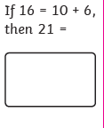
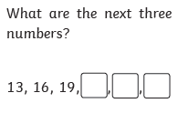
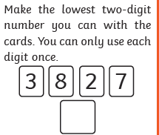

Draw any line up to 20cms.
Now draw a line that is 3 cms longer.

Practise 2, 5 and 10 times and recall the facts in any order.

Easy
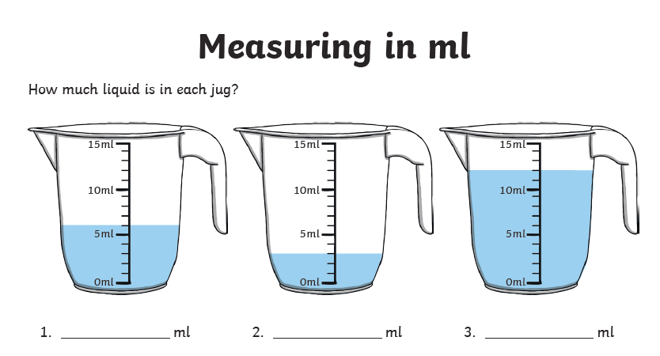

Meduim

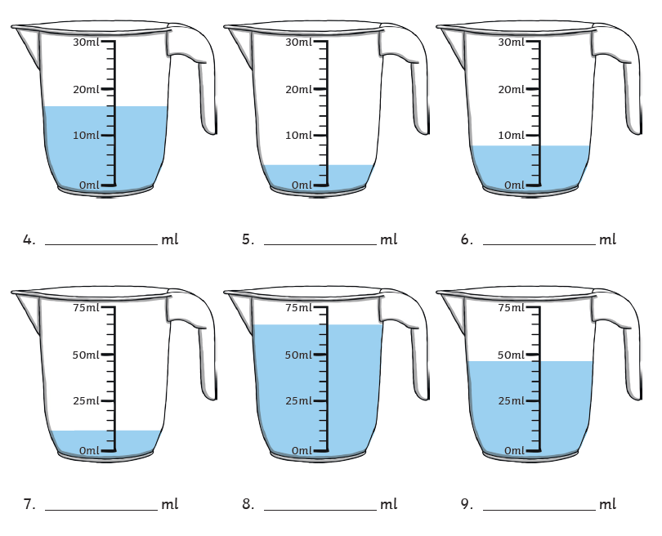

Challenge


