Maths | Monday | Look around your house for 3 things that that can hold a liquid (this is called capacity) e.g. a plastic cup, an empty milk container, a plastic squash bottle. Now estimate by looking at them. Which one would hold the least amount of water? Which one would hold the most? Order the three containers from least amount to greatest amount of water.  (keep your containers for Tuesday)  Use the words least, greatest, more than, less than e.g. The milk container holds the greatest amount. It holds more than the plastic cup. Now complete the sheet below.  Additional challenge:  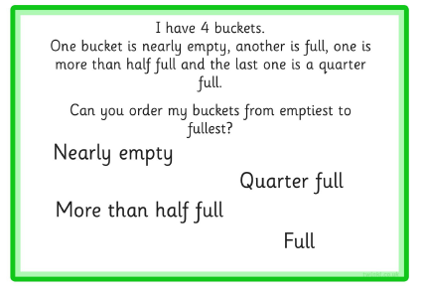
Maths | Tuesday | Now enjoy measuring capacity. This activity would be best done outside or somewhere that doesn’t matter if it gets wet! Measure the capacity of your containers using a smaller container e.g. an egg cup, a bottle top, a small yogurt pot. Do this by filling up your smaller container carefully to the top, then tip into the bigger container, taking care not to spill any! Do this as many times as you need to until the bigger container is full. How many units e.g. cups, did it take to fill the larger container? Do this for all 3 containers. Was your ordering on Monday correct? You may like to record what you have found out e.g the bottle was 6 yogurt pots  Additional challenge:  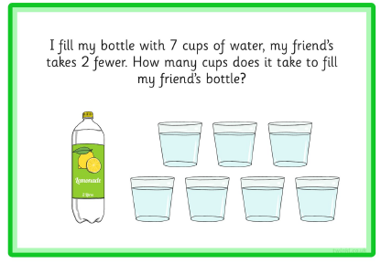
Maths | Wednesday | Capacity can be measured more accurately by using standard units of measurement called litres (l) and millilitres (ml). Look at some containers around the house and read what it says on the front e.g. milk 2 litres.  If you have a litre jug in your kitchen ask a grown up to help you use it to measure some bigger containers e.g. a bucket. Be careful litre jugs are sometimes made of glass.  Additional challenge: 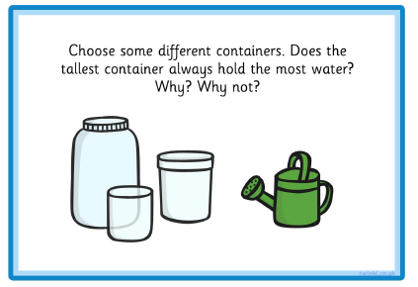
Maths | Thursday | Look again at the measuring jug can you see the smaller marks which show millilitres?  Today measure the capacity of some smaller containers in millilitres. First find some smaller containers. Then fill the containers to the top. Next tip the water into the measuring jug. Finally read the measurement to the nearest 100 ml.  Additional challenge:  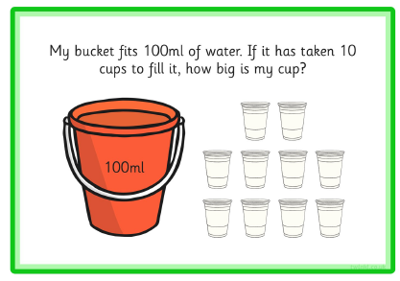
Maths | Friday | Challenge day: Choose a challenge: ENJOY!  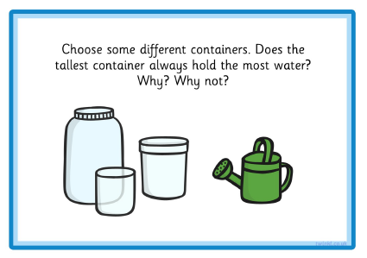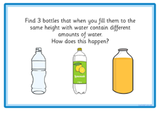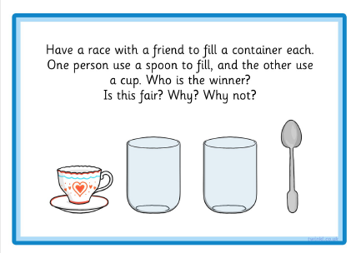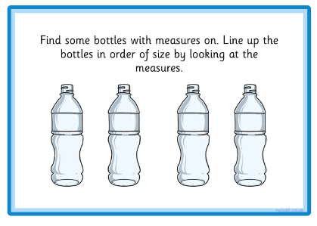
English  **Please also encourage your child to read daily | Monday | Read the fact file on page 13. Answer these questions:  How many legs does a spider have?  What do spiders eat?  Would you find most spiders on top of a stone? Explain your answer.  Additional challenge: Can you find out any other facts about spiders?
English  **Please also encourage your child to read daily | Tuesday | Go on a mini-beast hunt (see link with arts and crafts activity 2 below). Look out for spiders! Remember where you went and what you saw.  Additional challenge: Make a list of the mini-beasts you saw and where you saw them or take photos.
English  **Please also encourage your child to read daily | Wednesday | Recap your mini-beast hunt from Tuesday. Now complete page 14.  Additional challenge: check your sentences.
English  **Please also encourage your child to read daily | Thursday | Pick your favourite mini-beast. Now write a fact file about it. You could design your own or use the grid on page 15.
English  **Please also encourage your child to read daily | Friday | If you would like to why not celebrate the end of this unit of work by making or decorating spider biscuits or by making your own spider.  Here are some ideas:  https://www.activityvillage.co.uk/bottle-top-spider  https://www.activityvillage.co.uk/handprint-spider-craft  https://www.activityvillage.co.uk/toilet-roll-spider  https://www.activityvillage.co.uk/spidery-finger-prints  or even a Lego spider…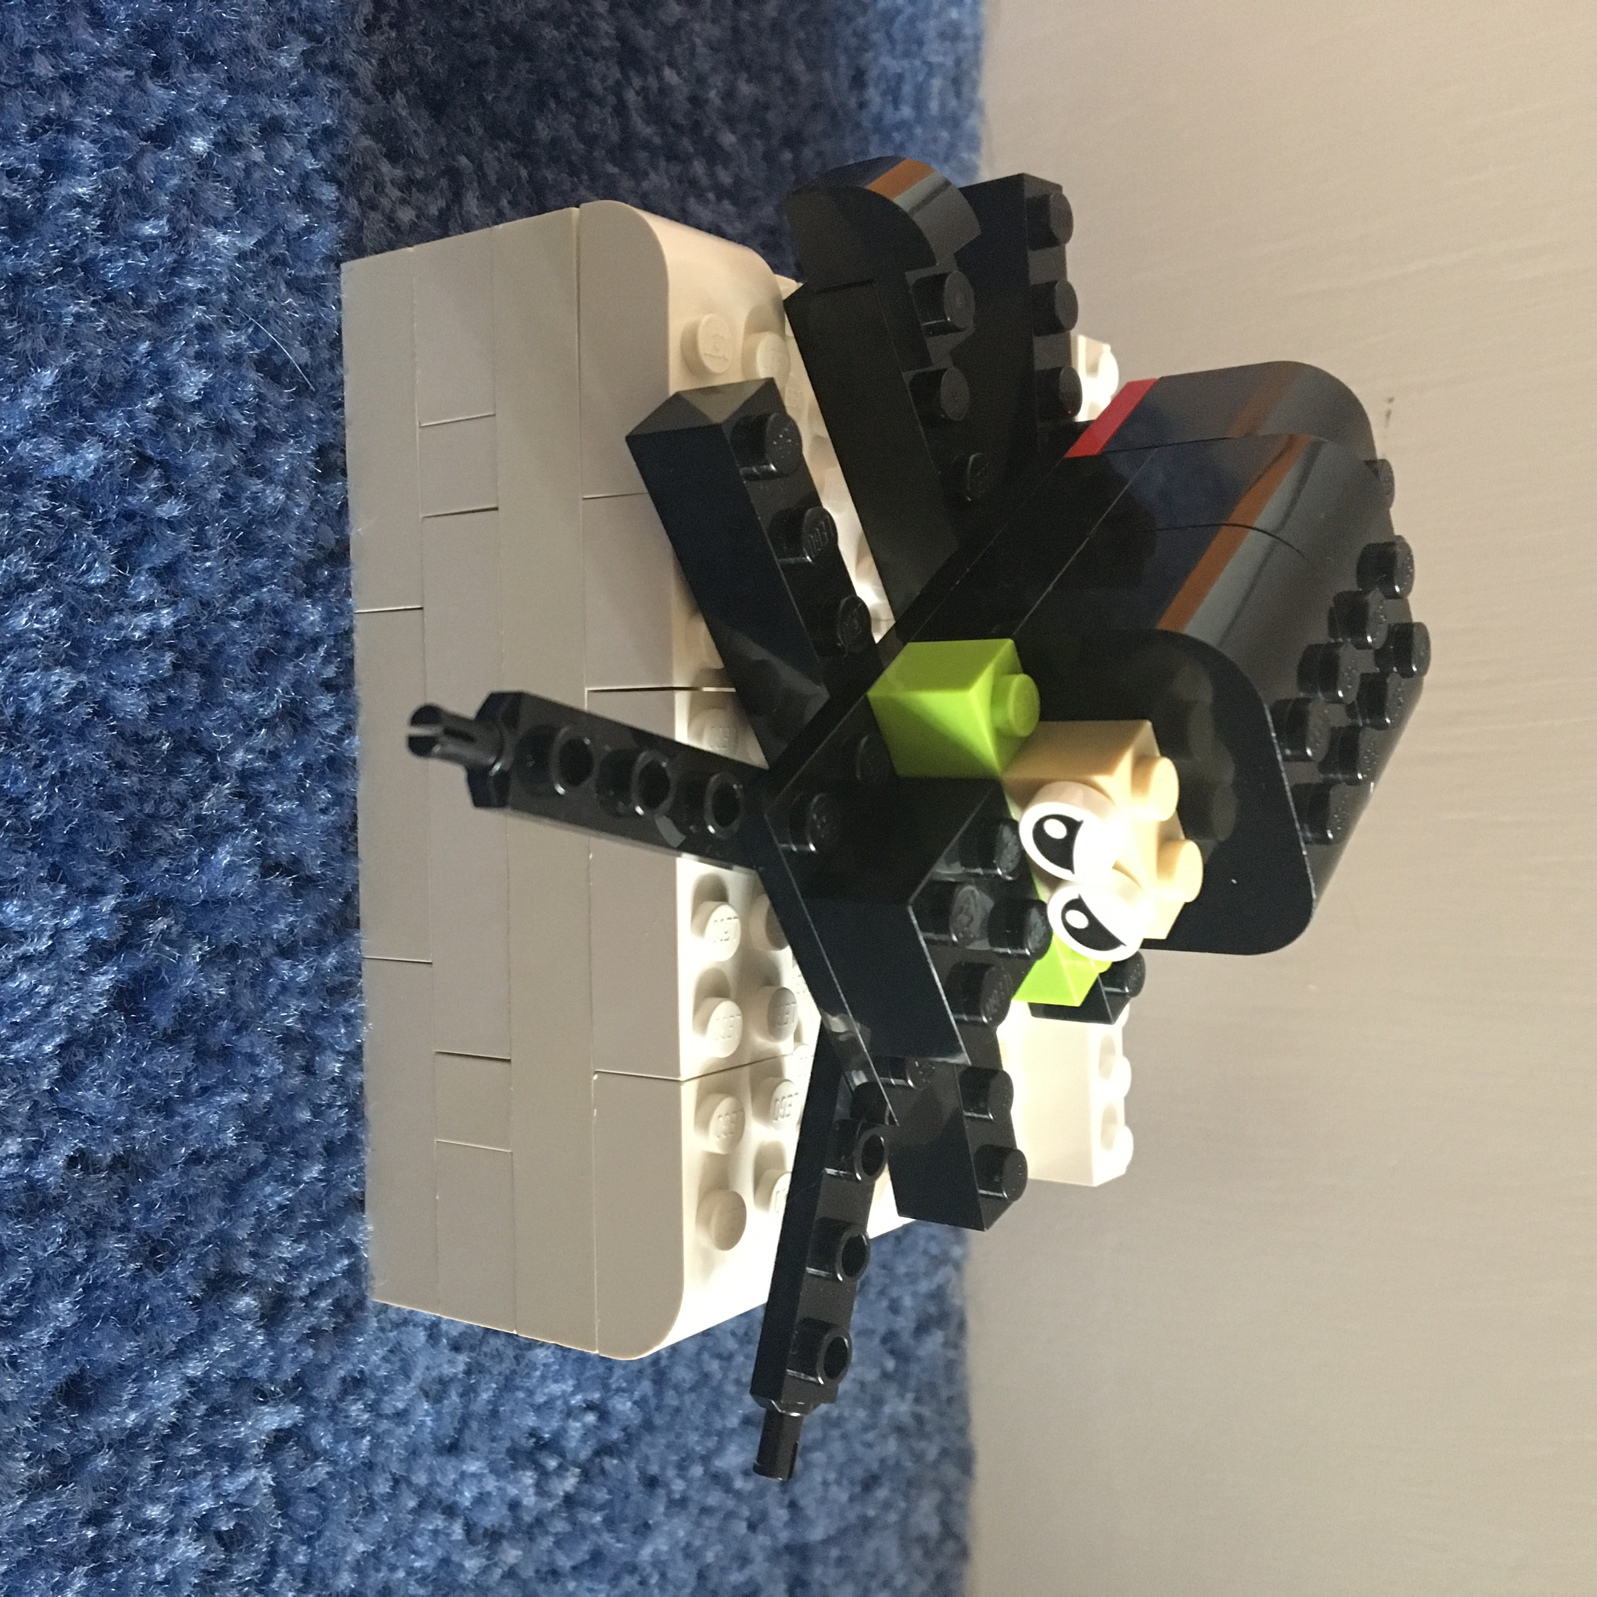
Phonics | Monday | Recap oa sound. The oa sound can also be also made by using the digraph ow.  Play the game below by throwing a dice and reading the line of words.
Phonics | Tuesday | The oa sound can also be made using the digraph oe.  Read the sentence and draw a picture: The geckoes played dominoes with their toes!
Phonics | Wednesday | Some words are spelt using the o-e sound (the o is in the middle and the e is at the end of the word- this is called a split digraph).  Can you find all the o-e words in the picture below? Write them in the boxes and then check your answers (see below).
Phonics | Thursday | Now test yourself! Can you write the spellings of the words using what you have learnt this week, (see sheet below)? When you have finished check your answers.
Phonics | Friday | spelling practice – recap some of the words you have learnt already (see spelling box below)
Topic/  Science | Topic 1 | This week we are travelling away from the U.K. to the continent of Europe. The U.K. is part of Europe. Europe is made up of many countries, one of them is France. Find out more about France by watching the learn section of https://www.bbc.co.uk/bitesize/articles/zktjqp3. Do you know any French words?  Next find out more about The Eiffel Tower by listening to the Go Jetters Funky Facts animation.
Topic/  Science | Topic 2 | Watch the second Go Jetters Funky Facts animation to find out more about Europe https://www.bbc.co.uk/bitesize/articles/zktjqp3  If you have an atlas or with a grown up help online try and find out some of the names of other countries in Europe.
PE | Activity 1 | Joe Wicks workouthttps://www.youtube.com/channel/UCAxW1XT0iEJo0TYlRfn6rYQ
PE | Activity 2 | Cosmic Kids Yoga https://www.youtube.com/user/CosmicKidsYoga
PE | Activity 3 | Real PE see below
Art/Crafts | Activity 1 | Make your own model of the Eiffel Tower out of what you can find at home or in the garden. Use what you have learnt about measuring to find out how tall your model is. Who can make the tallest? Maybe challenge a friend or someone in your family.
Art/Crafts | Activity 2 | Go on a mini-beast hunt. How many different creatures can you find? Don’t forget to look under stones and underneath leaves. Remember to put them back where you found them. Now can you draw or make a model of one? Look below at some which have been made out of Lego.

Weekly spellings
How many mini-beasts can you find in your house and garden?
our others

love school

REAL P.E.
The website address is: home.jasmineactive.com
Parent email: parent@lyngcofepr-1.com
Password: lyngcofepr

Additional maths challenges:

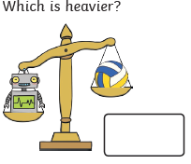
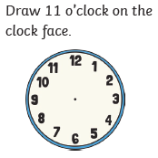
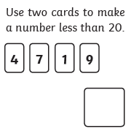
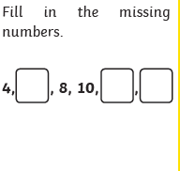

Practise counting in fives.

Monday measuring



